Ethan Wakefield

Candidate No. 3675

King’s School Grantham

Centre No. 26220

7517 Computing Project

Contents
1 Analysis 7
1.1 Background 7
1.2 Investigation 7
1.2.1 Interview 7
1.2.2 System Research 8
1.2.3 Interview 11
1.2.4 Pygame Research 12
1.3 Program Requirements 14
1.4 Data Volumes 15
1.4.1 Whilst Playing A Level (During Runtime) 15
1.4.2 General Storage 16
1.5 Analysis Data Dictionary 16
1.6 Gameplay Loops and Interactions 17
1.7 Finite State Machines and Flowcharts 18
1.7.1 Gameplay Finite State Machine 18
1.7.2 Movement Flowchart 19
1.7.3 Damage Finite State Machine 20
1.7.4 Walker Control Finite State Machine 21
1.7.5 Flyer Control Finite State Machine 22
1.8 Prototype Design 23
1.8.1 Client Feedback 24
1.9 Languages I Will Use 25
2 Design 26
2.1 Design Overview 26
2.1.1 Inputs 26
2.1.2 Processes 27
2.1.3 Outputs 27
2.2 Key Algorithms 28
2.2.1 glob.glob() 28
2.2.2 Collision Detection 28
2.2.3 UI Click Detection 31
2.2.4 “Latching” 31
2.2.5 On Screen Entities 31
2.2.6 Pythagorean Length 32
2.2.7 Enemy States 32
2.2.8 Attack Logic 35
2.2.9 Pathfinding 35
2.2.10 Trace Path Tree 37
2.2.11 Min-Heap Invariant Management 38
2.2.12 Shudder (Crawler Movement) 40
2.2.13 Jiggle (Walker Movement) 41
2.2.14 Walker Vision 42
2.2.15 Kinematics (Walker Acceleration) 44
2.2.16 Mutation 45
2.2.17 Enumeration 45
2.2.18 Garbage Collection 45
2.3 Game States 46
2.4 Data Structures 47
Iterables 47
2.4.1 List 47
2.4.2 Tuple 48
2.4.3 Dictionary 48
2.4.4 Graph 48
2.4.5 Tree 50
2.4.6 Binary Heap (Complete Binary Tree) 51
2.4.7 Queue 53
2.4.8 Priority Queue 54
Big O Notation 54
2.5 Data Requirements 55
2.6 File Organisation and Processing 55
2.7 Table/Record Structures 55
2.7.1 Save.txt 55
2.7.2 Level.csv 56
2.8 Class Structure 56
Main Structure 56
2.8.1 Sprite 59
2.8.2 Platform 59
2.8.3 Combatant 60
2.8.4 Grounded Combatant 60
2.8.5 Finite State Machines 61
2.8.6 Walking Enemy (Walker) 61
2.8.7 Flying Enemy (Flyer) 61
2.8.8 Crawling Enemy (Crawler) 61
2.8.9 Player 62
2.8.10 Consumable 62
2.8.11 Label 62
2.8.12 Button 62
2.8.13 Entry 63
2.8.14 Listbox 63
2.8.15 Scrollbar 63
2.8.16 Textbox 63
Meta Structure 64
2.9.17 MAIN 64
2.9.18 GAME 64
2.9.19 EDITOR 65
UI Container Structure 66
2.8.20 Game UI 67
2.8.21 Editor UI 67
2.9 UI Design 68
2.9.1HOME 68
2.9.2 FILES 68
2.9.3 DELETE 69
2.9.4 TOOLTIPS 70
2.9.5 GAME 71
2.9.6 PAUSED 72
2.9.7 LEVEL SELECT 73
2.9.8 EDITOR 74
2.9.9 Implementations 75
3 Program 80
3.1 File Structure 80
3.2 Drivers 80
3.2.1 MAIN.py 80
3.2.2 GAME.py 82
3.2.3 EDITOR.py 86
3.3 Assets 88
3.3.1 Sprite.py 88
3.3.2 Platforms.py 89
3.3.3 Combatant.py 89
3.3.4 Grounded.py 90
3.3.5 Player.py 91
3.3.6 Walker.py 92
3.3.7 Flyer.py 93
3.3.8 Crawler.py 94
3.3.9 Finite_State_Machine.py 95
3.3.10 Consumables.py 95
3.4 UI 96
3.4.1 Button.py 96
3.4.2 Entry.py 96
3.4.3 Listbox.py 96
3.4.4 Scrollbar.py 97
3.4.5 Textbox.py 97
3.5 UI Screens 98
3.5.1 Home_Screen_UI.py 98
3.5.2 Files_Screen_UI.py 99
3.5.3 Game_Screen_UI.py 99
3.5.4 Control_Screen_UI.py 100
3.5.5 Delete_Screen_UI.py 100
3.5.6 Levels_Screen_UI.py 101
3.5.7 Editor_Screen_UI.py 102
3.5.8 Editor_Tip_Screen_UI.py 103
3.6 Miscellaneous 104
3.6.1 AStar.py 104
3.6.2 Common_Functions.py 105
4 Testing 106
4.1 Testing Approach 106
4.2 Program Requirements 106
4.3 Testing the Game 108
4.4 Testing the UI 114
4.5 Testing the Editor 117
4.6 Test Videos 121
4.6.1 Video Links 121
4.6.2 Video-Document Discrepancies, Errors and Notes 121
5 Evaluation 122
5.1 Overview 122
5.2 Review of Program Requirements 123
5.3 User Feedback 124
5.4 Improvements 125
5.4.1 Suggested Improvements 125
5.4.2 Personal Improvements 127

1 Analysis

1.1 Background

TimBox is a software development company based in Grantham, England. The company was started in 2019 by John Smith and has grown to a size of around twenty employees. TimBox currently creates custom software for other businesses. To celebrate the company’s fifth anniversary, John has decided to start a new branch of TimBox dedicated to developing video games.
John Smith is a family friend who studied graphic design at Boston college before starting TimBox. From this connection, I asked John if I could produce a game demo for the start-up of the new branch – an offer which he happily accepted.
This has led John to request that I make a 2d action-platformer. He wants the game to have a target audience of older children (13-15), so the game should be moderate in difficulty with a high skill ceiling to allow for an older, more experienced secondary audience (16+) to also enjoy the game. As well as standard platformer controls, John would like special movement options to provide multiple ways of beating a level – where the skill ceiling will come in. He would also like the game to feature combat, using a classic movement-oriented style, as opposed to a turn-based system. The game itself will take place in a magical, monster-infested tower, with the player’s goal being to climb up to the top and end its curse. John has stressed his lack of desire for me to make the game to look good, as he will provide assets once the game is complete so I can focus on the game itself.

1.2 Investigation

1.2.1 Interview
To understand what type of game John wanted, I conducted an interview on Thursday 25th of January 2024. The interview went as follows:
“You originally suggested I make a platformer, but what type of platformer would you like?”
John - “I would like the game to be a 2D side-scrolling platformer, broken into levels each representing a floor of the tower. I want the game to feel fast-paced, so it would be beneficial to have each level on a timer which – in conjunction with enemies blocking their path – will force the player to have a reactive playstyle.”
“You also mentioned that the game would include combat, could you elaborate on how you would like that to work?”
John – “I think the combat should be simple, which pairs with the platforming to produce fast-paced levels, whilst also allowing players to easily understand the controls, removing the need for long tutorials to introduce new players.”
“Overall, how difficult would you like the game to be?”
John – “I would like the game to start easy, with little to no monsters so the player can get used to the controls, but the game should progressively get harder in both platforming and monster encounters. The changes in difficulty should be offset by the player gaining new abilities, but I would also like the game to still be possible using only basic controls.”
“Some games have difficulty options, do you think that suits this game?”
John – “I would rather the game gives time for the player to get better, rather than present difficulty options at the start.”
“Finally, do you have any ideas for how enemies will work in the game?”
John – “I want the enemies to act as a blockade to the player’s progress in a level, which cannot be ignored in most cases. I think it would be good to have a variety of enemy types which function differently from one another. For example, one enemy could be flying at the top of the level and swoop down to attack, whereas another sticks to a platformer and slides around its perimeter. It may also be good to include some random factors to each enemy, to make each playthrough feel different, such as altering speed, health, or damage.”
From this first interview, I have identified a few key requirements for my program:
- The game screen should scroll to keep the player on screen.
- Levels are timed.
- Player – Enemy combat should be simple (Click a button to attack)
- Standard Up, Down, Left, Right controls.
- The game should contain a variety of enemies which each function differently.
- Enemies are generated with slight mutations to vary speed, health, and/or damage.
This has led me to research other games like what has been requested, so I can determine how existing systems have fulfilled the given criteria, as well as look into game mechanics which were not brought up in this interview.

1.2.2 System Research

Mario:
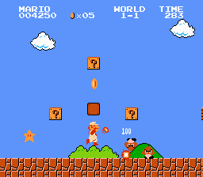
The original Super Mario Bros for the NES contains many of the features that John has requested. In this title, Mario must run to the right of the screen to reach the flag at the end of each level, facing light platforming challenges, and dealing with enemies along his path. Each level consists of a grid of tiles, which get drawn over a background image (in this level it is a sky which acts as the background).
The first feature which is shared is side scrolling. When Mario approaches the final tiles of the screen, the game stops moving Mario to the right, and instead moves the background to the left, preventing Mario from running off the screen. This scrolling is not perfect, however; as the screen will only scroll when Mario runs right, with an invisible wall blocking the left side of the screen. This is because the game loads in two screens worth of tiles whilst you play and replaces the tiles no-longer on screen with tiles from a future screen. While this is more memory efficient than loading in the whole level at once, it drastically reduces the movement options available to the player, something I would like to avoid.
As Mario runs through each level, he can collect one of four power-ups, which act both as a health bar, and a change in move-set. The player starts as small Mario, with only one point of health. By grabbing a Super Mushroom as small Mario, the player becomes Super Mario, becoming taller and gaining an extra health point. By grabbing a Fire Flower, the player becomes the Mario on screen, gaining an extra health point and the ability to throw fire balls, which bounce on the floor until they hit a wall or an enemy. Mario can grab a Star, which (for 10 seconds) makes Mario invincible, faster, and instantly defeat any enemy that makes contact. Finally, the player can grab a 1-Up Mushroom which increases the number of times the player can lose a level before having to reset. Each time Mario is hit, he either becomes small Mario, or dies, forcing the player to retry the level.
This game also has the player on a timer (top right corner), which forces the player to beat the level within three hundred seconds or fail and be sent to the start and must do it again. While three hundred seconds is generous for most Mario levels, every one second left on the timer when the level is beaten earns the player fifty points for their score (top left corner). This incentivises the player to beat each level as quickly as possible, to earn the maximum points possible (even though the score does not affect anything in the game and is purely cosmetic).
Super Mario Bros uses only the four directions as inputs, plus an A and a B button. The direction inputs are used to move left and right, with up and down used to interact with some objects in the environment. The A button is used to jump, and the B button is mapped both to run and to fire projectiles as Fire Mario. This game includes some refinements to how the player moves, to provide a smoother gameplay experience. The game uses a drag factor when moving horizontally, gradually accelerating the player to a top speed when a direction is held or slowly changing direction when the opposite direction is pressed. This effect allows for small adjustments in the player’s position, whilst preventing the player from coming to a halt after running at top speed. There are also improvements to jumping. The first of these is altering jump height based on how long the player holds the A button. The second of these is known as “Coyote time,” where the player has additional frames to perform a jump after falling off an edge. Both Coyote time and drag is minimal – only lasting a few frames – but these slight adjustments provide more realistic and smooth movement.

Mario Maker:
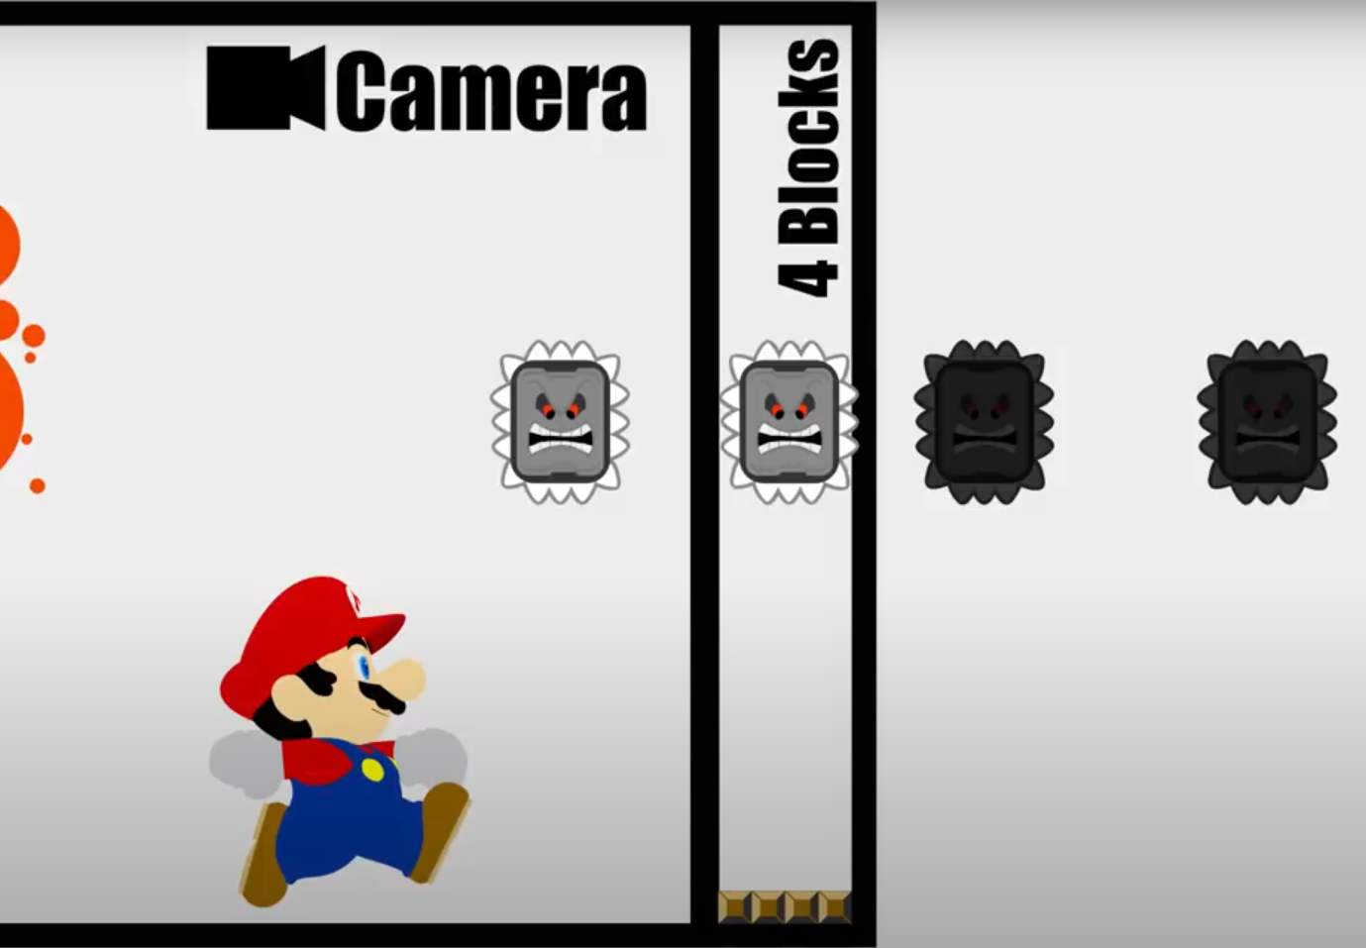(Graphic from “Don’t hit the Run Button” in Super Mario Maker! by Ceave Gaming on YouTube - https://www.youtube.com/watch?v=-FbssndzWjg&t=485s)
Mario Maker is a game engine which lets players create custom Mario levels using a predefined tile set. Their level editor works by selecting the tile you want from a tile palette, then placing it onto a grid which is converted into a level upon pressing play. While the gameplay of Mario levels in Mario Maker is similar to the above, only tiles which are onscreen ±4 tiles area active. This logic will be useful to limit the objects which will be considered during collision detection, as well as ignoring enemies which are off-screen from using processing time to move without being seen.

Castlevania:
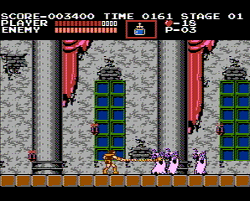
In the original Castlevania, you play as Simon Belmont, who is trying to find and kill Count Dracula in his tower. As the player does so, they must face Dracula’s minions as well as platforming challenges which block their path.
In terms of platforming, Castlevania is a lot simpler than Super Mario Bros, and anything done by Castlevania has already been covered in the Mario section.
The primary reason I have investigated Castlevania is due to its simplistic combat. The player’s main attack is a whip, which will damage enemies which are up to three tiles in front of the player. To prevent the player from rapidly pressing the attack button, the whip (known as the “Vampire Slayer”) has a brief charging period, as well as a short attack animation, which are required to carry out the attack. These animation pauses force the player to space themselves away from monsters to actually carry out the attack. The player also has access to alternative attacks, such as throwing holy water, which burns enemies a few tiles away, or a hand-axe which can be thrown like a boomerang across a longer range than the whip. These alternatives can be collected as you play through the game and provide more flexibility in playstyle.
The main targets of your attacks are monsters which will spawn in small groups, which need to be slain before they can hit you back. While most enemies only need one hit of the whip to be taken out, Others can take up to twelve. The main distinction between each enemy is the actions they can use. Some enemies – such as the zombie - have a basic AI which can only move towards the player (like a slightly more advanced Goomba). Other enemies like the vampire bat fly at the top of the stage before swooping down to attack, requiring you to react quickly, or prioritise dodging the attack. Other enemies move too quickly for the whip to be effectively, and others attack from above (like the vampire bat), requiring the use of the arching hand-axe to be taken down.
Castlevania’s combat system is simple in execution, with the game just checking if an enemy collides with a weapon, and dealing damage accordingly, but the variety of enemies, the number which are on screen at any given time, and the different ways in which they need to be dealt with allows this simple system to be more than enough.

1.2.3 Interview
After looking into these games, I conducted another interview to ask about things I have learned, as well as any points that were not raised in the first interview. I conducted the interview on February 1st, 2024.
In terms of mechanics, John agrees that Mario’s platforming adjustments would be beneficial. The following are questions which were not asked in the first interview:
“Many retro games do not offer the ability to save the game. Is that a feature which you would like to be included?”
John – “Very much so. I want people to be able to pick up the game and play a few levels every day, rather than having to reset every time they play. I would like the game to save after every level, so players can gradually chip away at the game across a few weeks. I would also like the game to have three save files, allowing multiple people to play through the game at their own pace, rather than getting frustrated at the harder levels which they would not have reached yet.”
“In the existing games I researched, the enemies would appear quite frequently. How frequently would you like enemies to appear?”
John – “I would like enemies to appear in small but frequent hordes throughout the level. Whilst some groups can be avoided with good platforming, others should be necessary encounters for the player to progress.”
“Different games handle health in a variety of ways, so how do you want the game to handle health?”
John – “I want the game to use a simple health system: You get hit, you lose some health, and if your health drops below 0, you die. The player should start the game with ten health and five lives. When the player dies, they will get sent back to the start of the level and lose a life. If the player loses all their lives, they should be sent back to where they last saved. The health system should also apply to enemies, who will be removed from the game when their health drops below 0.”
“And how can the player get back health?”
John – “I would like the game to contain healing items which can be used to restore a small amount of health but they should appear infrequently (maybe once or twice) in each level.”
“Some games have different types of platforms other than floor tiles; do you have any which you want in your game?”
John – “Alongside the standard floor tile, I would like the game to have one-way platforms which the player can jump through then land on. I would also like the game to have honey tiles, which stop the player from being able to jump – this can be placed onto floors to make them sticky or appear as walls which slow the player down. Finally, I would like a spike tile which will damage anything that walks into it.”
“Finally, I will be making a level editor to make creating levels a lot easier for me. Should this feature be available to the player?”
John – “That would be a particularly good addition to increase the playtime of the game. This level editor should allow players to create and save their own custom levels, as well as edit any of previously saved levels.”

1.2.4 Pygame Research
I intend to make this project using python, due to its module system and general utility. The pygame library provides a set of functions and classes specifically to make games in python.
The primary function of pygame in this project will be for input and output. I need to accept keyboard presses and mouse clicks as input. This can be done with the pygame.key module and the pygame event system. On that note, pygame provides an event system, which will be used to monitor mouse inputs, but also to exit the application.
The program needs to draw the game to the monitor, done using the pygame.display class. This is a specific implementation of the pygame.surface class, which includes a “flip” function to draw the image to the screen.
The pygame.surface class is just a class to represent an image. It offers auxiliary functions to get the image dimensions, but more importantly, it offers a function to fill the image with a single colour – useful to set a background or to clean the old image – as well as a function to draw a different image onto the surface (called blitting). As one would expect, I will use this class to store the visual elements of the program.
Another important class is the pygame.rect. This just stores the position of the top-left corner, the width, and the height – the dimensions of a rectangle. This is useful, as it provides a system for hitbox, needed to make sure the player does not fall through the floor, and in combat to see if a weapon intersects with the player. To support this, the rect has a set of functions to quickly check for a collision, being the collidepoint(), colliderect(), and collidelist() functions. These check if a point or rectangle would collide with the rect or return the first occurrence of a colliding rectangle in the collidelist() case.
The final aspect of pygame I will be using is the Clock() class. This will be used to ensure that the game runs smoothly at 60 frames per second – stalling the logic until a 60th of a second has passed since the start of the frame. Importantly, this will not call the logic every 60th of a second, but rather, act as a barrier to stall execution, ensuring smooth visual updates.

Demonstrating the research
########################################## SECTION 1 ####################################
import pygame

def reveal_mouse(btn: int):
print(list(pygame.mouse.get_pos())) #Gets the mouse's position
match btn:
case 1: print("1: Left")
case 3: print("3: Right")
case 2: print("2: Middle")

def tick_colour(colour, amount, a) -> list:
colour[a] = min(max(colour[a]+amount,0),255)
return colour

pygame.init() #"Turns on" pygame
screen = pygame.display.set_mode((256,256)) #The screen is a surface object
clock = pygame.time.Clock() #Counts the time elapsed

example_img = pygame.image.load("Example_Img.png").convert() #Loads an image without transparency
transparent_img = pygame.image.load("Transparent_Img.png").convert_alpha() #Loads an image with transparency
transparent_img = pygame.transform.scale(transparent_img, (64,64)) #Resizes an image

running = True
hiding = False
bg_col = [0,0,0]
ex_pos = [0,0]
while running:
pygame.display.flip() #Draws the game to the screen

screen.fill(bg_col) #Fills a surface with a single colour

keys = pygame.key.get_pressed() #Checks which keys are currently down
if(keys[pygame.K_p]): #Check if "p" is down
hiding = not hiding
if(keys[pygame.K_DOWN]): #Check if the down arrow is down
bg_col = tick_colour(bg_col, 1, 0)
ex_pos[1] += 1
if(keys[pygame.K_UP]): #etc
bg_col = tick_colour(bg_col, -1, 0)
ex_pos[1] -= 1
if(keys[pygame.K_LEFT]):
bg_col = tick_colour(bg_col, -1, 1)
ex_pos[0] -= 1
if(keys[pygame.K_RIGHT]):
bg_col = tick_colour(bg_col, 1, 1)
ex_pos[0] += 1
screen.blit(example_img, ex_pos) #Draw the example player
screen.blit(transparent_img, (32,160)) #Draw an example goal
screen.blit(transparent_img, (160,32)) #Draw a second example goal

ex_col = pygame.Rect(ex_pos, (32,32)) #Create a rect for the above objects
tA_col = pygame.Rect((32,160), (64,64))
tB_col = pygame.Rect((160,32), (64,64))
exampleList = [tA_col, tB_col]
if(ex_col.collidelist(exampleList) != -1): #Test collisions over a list
tick_colour(bg_col, 1, 2)
print("Entered a goal", end = '')
if(pygame.Rect.colliderect(tA_col, ex_col)): #Test a collision between two rects
print(" - A")
elif(pygame.Rect.colliderect(tB_col, ex_col)):
print(" - B")
else:
tick_colour(bg_col, -1, 2)

for event in pygame.event.get():
if(hiding):
continue
if(event.type == pygame.MOUSEBUTTONDOWN): #See if a mouse is down
reveal_mouse(event.button)
if(event.type == pygame.MOUSEBUTTONUP): #See if a mouse is up
reveal_mouse(event.button)
if(event.type == pygame.KEYDOWN): #See if a key is down
print(pygame.key.name(event.key))
if(event.type == pygame.QUIT or keys[pygame.K_ESCAPE]): #See if the player has quit
pygame.display.quit()
running = False
clock.tick(60) #Caps the program at 60 fps

########################################## SECTION 2 ####################################
import time
def clock_display(runs: int):
start = time.time()
for x in range(runs):
lstA = [int(str(y)) for y in range(1000)]
lstB = list(map(lambda z: z + 1, lstA))
lstC = sum(lstB)
lstD = [ele + lstC for ele in lstA]
mid = time.time()
clock.tick(5) #Caps the program at 5 fps
end = time.time()
print("\nTime spent = ", end-start)
print("Time used = ", mid-start)
print("Time stalled = ", end-mid)

clock_display(250)
clock_display(1000)
The above code is for a simple program to demonstrate everything I have mentioned beforehand. Comments have been used only to identify which part of the pygame package is being demonstrated. Section 1 is a simple “game” to demonstrate the functions I will use, and Section 2 demonstrates that the clock class is only a barrier.
Test Video: https://www.youtube.com/watch?v=Z1Wc4TBE1hE

1.3 Program Requirements
From the above research, I have created a list of key requirements which my program must fulfil:
- The player can move left and right using A/D respectively, or using the relative arrow key, as well as being able to jump by pressing W or the Up Arrow Key.
- Include Mario’s movement improvements (see 1.2.2)
- The game screen should scroll to keep the player on screen.
- The game must contain the following tile types:
- Floor/Wall tile
- One way tile
- Honey tiles (slow the player and prevent jumping)
- Spike tile (damage the player)
- Levels are loaded from a file, and are accurately assembled to be played
- Beating a level causes the next level to begin
- Levels must be beaten in one hundred seconds
- The player must be able to save
- The player must be able to create a save (if space allows)
- The player must be able to delete an existing save (to make space)
- The game must correctly load the relevant form – covered later in 2.3
- Contain the above health system
- The player can attack enemies to lower their health (and the inverse), with one attack animation doing one attack’s worth of damage
- Levels contain enemies which:
- Attack and move in diverse ways
- Have mutations which occur randomly between playthroughs, altering enemy stats.
- The player can restore health by using healing items
- The player can update their movement options using consumable items
The game should contain menus which:
- Respond to mouse input – for example;
- A button does a function when clicked
- An image does not do a function when clicked
- Connect to one another to separate information
- Can be dynamically updated
- A list of save files updates after a death/level clear
- A list of custom levels can grow as levels are added
The game should also contain a level editor which:
- Allows the player to create custom levels
- Level should be created by “painting” tiles onto a grid
- The player can save the levels they create
- The player can edit the levels they have saved
- The player can play the levels they have saved
- Elements can be placed anywhere
- The game should check to make sure the level is playable – and not running a “bad” level

1.4 Data Volumes

1.4.1 Whilst Playing A Level (During Runtime)
Assuming a screen will be made up of a grid of twenty-four by sixteen tiles, with ten screens per level, and only one object per tile, there will be a maximum of 3840 objects being stored in RAM. Since most of the screen will be empty to allow the player to move, it is more likely for only 768 objects (1/5 of the max) to be in RAM at any point in time.
I intend on my game running at 60 frames per second and will only monitor at most ten keys from the keyboard, so the maximum keyboard inputs to be interpreted per second is equal to six hundred per second. Although, this number is unlikely to be reached, as keyboards tend to max out at about three thousand key inputs per minute (achieved easily by holding down a key), giving a true maximum keyboard inputs of fifty inputs per second (much more manageable).
The game will also have variables for the player’s health (and similarly for enemies), but these are simply a few integers, so will take up negligible space.

1.4.2 General Storage
Below is a table containing the different objects which are being stored even whilst the program is not running:
Data being saved | How many will be stored? | How many will be added daily?
Levels | 100 | 5
Enemy Types | 3 | 0 – All preset
Tile Types | 7  (4 tile types, with one-ways having four unique directions) | 0 – All preset
Healing Item Types | 3 | 0 – All preset
Upgrade Types | 5 | 0 – All preset
Player Saves (stored in a text file)
How many saves per game? | 3 | 0 – but the three will be rewritten every time the game is played
Player Username | One per save | 0 – the exact value will change, but no more will be added
Game Metadata (Current Level, Current Lives and Current Health) | One of each per save | 0 – the exact numbers will change, but no more will be added

Note: enemy, tile and healing items are stored in the code whereas the levels and save data will be files (discussed in 1.5).

1.5 Analysis Data Dictionary
The game will store three sets of save data, allowing multiple people to save their progress in their respective playthroughs. All saves will be stored in a shared .txt file, with each save being on their own line, and each data value being separated by a comma. The values I will store for each save are:
- The player’s username (used to distinguish between files)
- The player’s current level
- The player’s current health (both lives and damage)
This will be stored a string for the username, and three integer values for the metadata per save
The levels to be played also need to be stored. As this is a tile-based game, I will store levels in a .csv file, with a grid of strings each representing the name of a tile – “” is an empty tile. Each level will get its own file to make them easy to maintain.
All the tiles will be stored as classes with their functionality preset which can be instantiated as required.
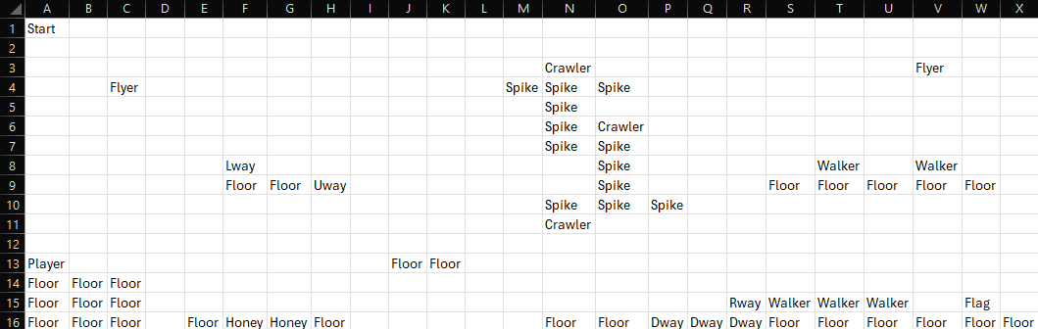
This is an example of a level in the .csv format I will be using (loaded in Microsoft Excel). It should be noted that the cell A1 contains “Start”. This is due to a quirk of compression csv uses. If “Start” was not present, then rows 1 and 2 would be wholly empty, which the csv format views as unneeded, and thus it deletes them. This only happens up to the first row containing a value, so the “Start” stops the first rows from being deleted.
To allow for every tile to be used, the “Start” only needs to be present if A1 would otherwise be empty, as .csv only checks IF something is present, not WHAT is present.

1.6 Gameplay Loops and Interactions
The main game will consist of a primary loop of platforming to the flag, then loading the next level, then repeat. There will be a secondary loop of attack enemies, then avoiding their attacks to break up the platforming gameplay. There will also be a secondary loop of exploring alternate paths to get movement updates. There will be a final gameplay loop to beat the level as fast as possible – enforced and measurable with the timer.
The following is a table of interactions for the game:
Type | Cause | Effect
Player to System | Click | The game updates the screen
Player to System | Arrow keys pressed | The player character moves left, right, and up respectively
System to System | Player stands off of a platform | Apply gravity to accelerate and fall downwards
System to System | Player touches a platform | The player stops falling and has a special effect applied based on the platform – Honey slows the player and prevents jumping, Spikes deal damage
Player to System | Player presses the attack key | The player performs an attack
System to System | An object touches an attack hitbox | The object takes damage if the attacker was on the opposite team
System to System | Player object touches the flag | The game closes the current level, and loads the next one

1.7 Finite State Machines and Flowcharts

1.7.1 Gameplay Finite State Machine
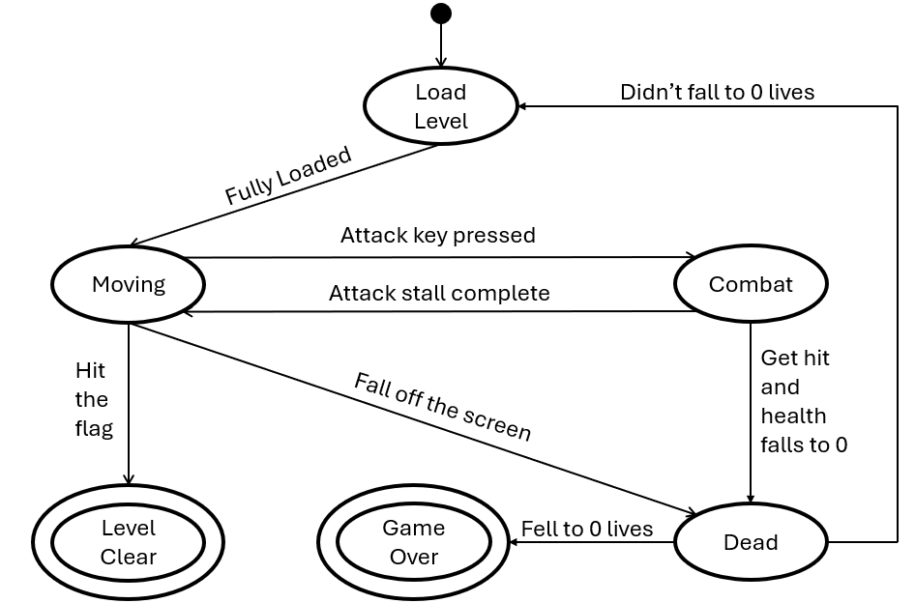
The game starts in the “Load Level” state. Here the program reads the relevant level file and instantiates objects for each tile and entity. The program will then automatically transition to the “Moving” state.
The user has input on the gameplay during the “Moving” and “Combat” states. All other states are entirely controlled by the program.
The “Moving” state refers to when the player is not in combat but has control over the character. The character might not necessarily be moving, but the character is not attacking nor being attacked. In this state, the program performs gravity and collision logic.
In the “Combat” state, the player is either performing an attack or being attacked by an enemy. In this state, the program performs logic to see if an attack connects with a target, and then any related logic such as dealing damage.
There are two death conditions: Fall off the screen or fall to/below 0 health. In both cases, the game enters the “Dead” state, where it stops taking user input and determines whether to restart the level, or perform a game over. During this state, the game will perform a short animation to indicate that the player is dead, then change states according to how many lives the player has remaining. If the player falls to zero lives the game enters the “Game Over” state, where the game terminates and returns to the file select screen. In this state, the program needs to save the game to reflect the game over.
If the player touches the flag, the game enters the “Level Clear” state. In this state, the game is terminated, with the next level subsequently being loaded, and the save file being updated.

1.7.2 Movement Flowchart
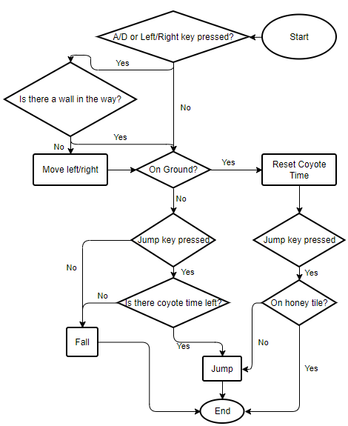
Movement is broken into two sections: horizontal, and vertical.
In the horizontal section, the program checks if the player is pressing one of the A, D, left arrow, or right arrow keys. If so, the program needs to move the player, if not then no horizontal movement is required this frame. Before moving horizontally, the program checks if the player is going to move into a wall – a movement we want to prevent. If so, the program cancels any horizontal movement, otherwise we perform logic to move left or right according to which keys were pressed.
In the vertical section, we first ask if the player is grounded. If so, then the player can jump freely, and they gain coyote time for when they are next airborne. If the player is grounded, and they press the jump button, we check if they are touching a honey tile. These tiles prevent vertical movement, so if we are touching a honey tile, we end the vertical movement (which reaches the end state), else we perform a jump , which then ends the vertical logic.
If the player was not grounded, they may still be able to perform a jump shortly after leaving the ground (coyote time). We first check if the player even wants to jump. If not, then they simply fall, and the vertical logic is done. If they do, however, then we check if the player still has coyote time – a timer which decrements whilst the player is falling. If they do not, then the player falls. If they do, then we instead perform a jump as though the player were grounded.

1.7.3 Damage Finite State Machine
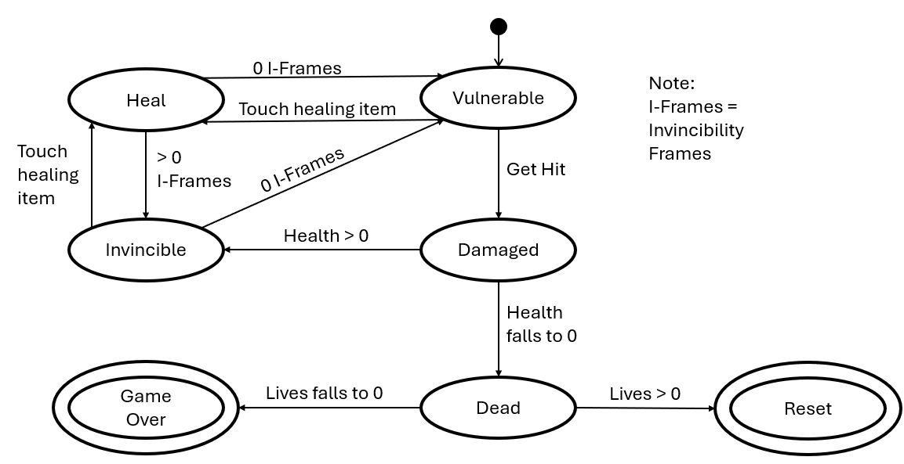
The player starts in the “Vulnerable” state. As the name implies, in this state the player is vulnerable to sources of damage, such as enemy attacks or spike tiles.
If the player takes damage, they transition to the “Damaged” state. This is a transition state, used by the program to determine whether the player is dead or not. If not, they transition to the “Invincible” state. In this state the player is immune to all sources of damage and will automatically transition after a timer (I-Frames, or invincibility frames) reaches 0.
The “Invincible” state can also be reached by touching a healing item. If this occurs, the player transitions to the “Heal” state, where the player is healed, and its I-Frames timer is increased. After touching a healing item, the player will almost always transition immediately to the “Invincible” state.
Once the player’s I-Frames timer reaches zero, they will transition to the “Vulnerable” state. These four states comprise the main loop which the player will stay in during the runtime of the game.
If the player enters the “Damaged” state and their health falls to zero, they will instead leave the main loop and transition to the “Dead” state. This is another transition state and is used to determine what to do if the player dies. If the player still has lives left, they transition to the “Reset” state, which terminates the game and reloads the level. If the player has no lives left, however, they will transition to the “Game Over” state. In this state, the game is fully terminated, and the file select screen is loaded.
Both the “Reset” state and the “Game Over” state will be used to save the game to reflect the change to the player’s life count.

1.7.4 Walker Control Finite State Machine
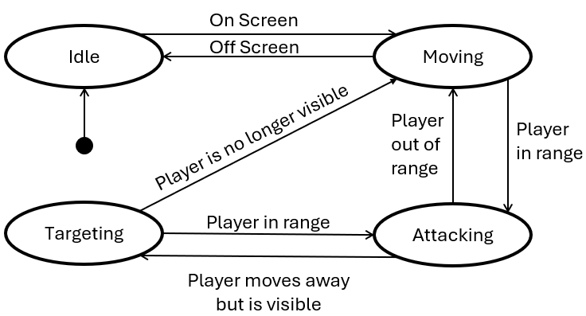
A walker enemy starts in the “Idle” state. In this state the walker is idle and will not move or attack. This is so the program does not waste time with logic for an entity which has no impact on what’s happening on screen.
Should the walker become visible, it enters the “Moving” state. In this state it performs the logic to walk back and forth on a platform.
If the player gets in range of a moving walker, the walker transitions to the “Attacking” state. In this state, the walker is stationary and tries to perform an attack each frame (attack logic handled by the main program).
Should the player get out of range of the walker, but the player is still visible to the walker, then the walker will transition to the “Targeting” state. In this state, the walker performs a modified version of the “Moving” state, but the walker will not turn around if it reaches an edge – it will just stay still. If the player is no longer visible, we return to the “Moving” state, which results in the program dropping the modified movement logic.

1.7.5 Flyer Control Finite State Machine
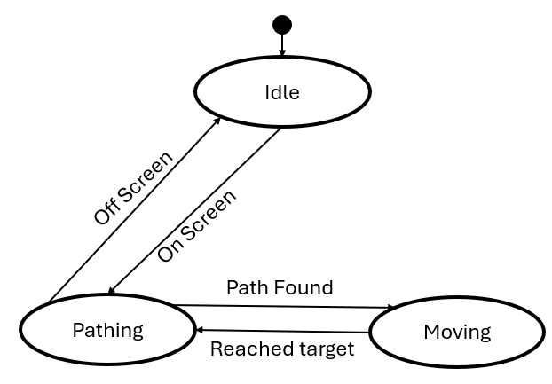
A flyer starts in the “Idle” state. Like walkers, in this state they do nothing, to save the program time.
When a flyer enters the screen, they enter the “Pathing” state. In this state, the flyer performs pathfinding logic to find the shortest path from itself to the player.
As pathfinding takes a decent amount of time – especially with multiple flyer enemies – once the flyer finds a path, it transitions to the “Moving” state. In this state, the flyer moves to the next tile along its path, before transitioning back to the “Pathing” state. This allows the flyer to appear to be constantly targeting the player but only performing the time expensive pathfinding algorithm every couple frames.

1.8 Prototype Design
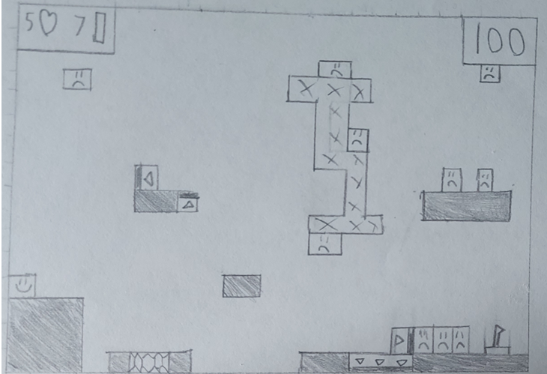
An example of what a level would look like.
Shaded tiles are floor tiles, hexagon filled tiles are honey, arrow tiles are one-way, X tiles are spikes, angry faces are enemies, smiley face represents the player’s spawn, and the flag represents the end.

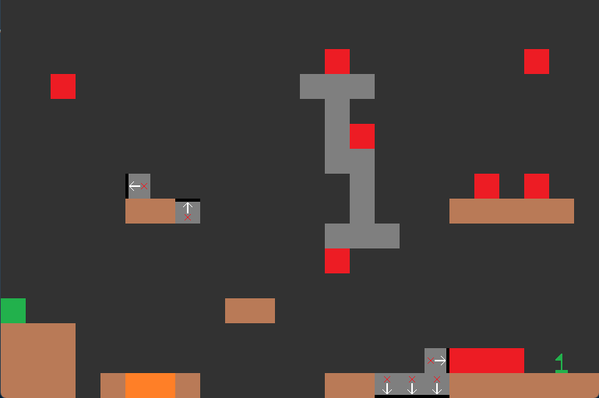
An implementation of the above level in a prototype engine

1.8.1 Client Feedback
I presented this design to John on April 12th, 2024. They had the following response:
“This is strong but has some major faults in my eyes. Firstly, I like the use of distinct colours, with the entities making themselves distinct from the duller floor and background colours. I dislike, however, that all the enemies are the same colour, as from a gameplay perspective it would be difficult from a glance to determine which enemy is which. Maybe use different shades of red for each type of enemy or update the sprite to indicate the unique types. A second flaw of the sprite’s is in the one-way platforms. While it makes sense to use the same sprite but rotated, the base sprite is confusing. Using the three downwards one-ways as an example: I would initially believe that these would allow the player to walk over them, preventing movement downwards. I recognise that the border line at the bottom indicates that there is a blocking edge, but the sprite as a whole leaves a lot to be desired – I would suggest a simpler design with two thick arrowheads, pointing in the allowed direction. A final flaw with this prototype is in the layout of the level itself. The platforms appear randomly added, making the linear path appear busy with unnecessary challenges. I would like level’s to effectively use the space available, with multiple paths to the end that make a run feel unique. Similarly, use the enemies to produce small moments in the level, rather than clumping them at the end flag.”

1.9 Languages I Will Use
I have decided to use Python to develop my game. Python is a multi-paradigm language (Imperative, Functional, and Object-Oriented). The object-oriented nature will make it easy to manage the multitude of objects in my game (such as the player, enemies, and tiles). By being a functional language, I can more easily organise my code into simpler functions, limiting the use of repeated code. Python also has a module system, allowing me to install and use the Pygame module to manage Input/Output elements of the game, such as monitoring keyboard strokes and displaying updated graphics. This module system also allows me to modularise my program, keeping the game logic separate from the menu logic, and the enemy logic separate from the tile logic. Through this, I can improve the readability of my code, allowing a more efficient development process.

2 Design

2.1 Design Overview
A top-down design approach will be used to modularise the program to create a successful result. By separating classes and segments of the main game loop into different Python scripts, I can more easily identify errors whilst programming and safely make changes without affecting the rest of the program. By separating into multiple scripts, I can more easily structure my code, as only the necessities for that specific script to run need to be present. Another benefit is through the ability to reuse code, saving space and allowing for cleaner code – instead of rewriting bubble sort each time I can just call example.bubble_sort() .
By using a main menu, I can further separate the level editor and main game to prevent unnecessary dependencies. I intend to use files to store levels – which will be loaded once when the level is played – as well as a file to store player data – just a list of values.
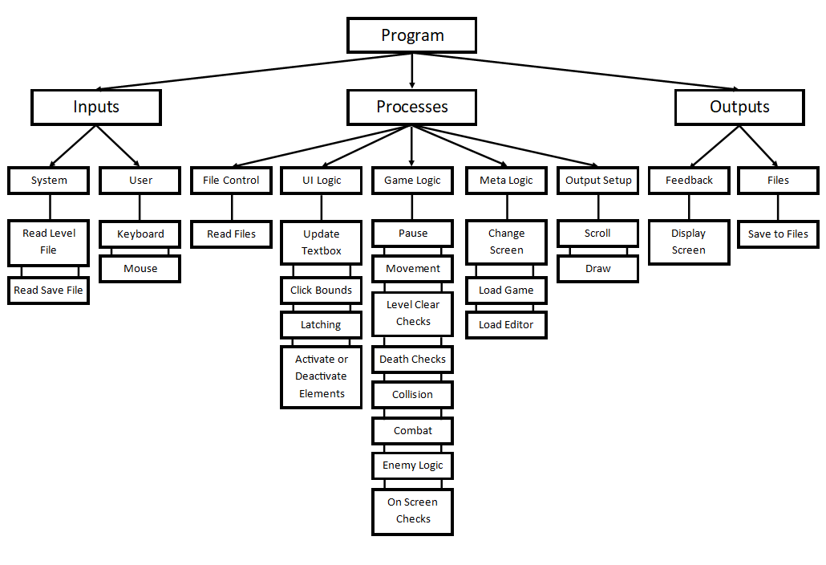

2.1.1 Inputs
Read Level File | File | When a level starts, the level data will be loaded from the relevant file
Read Save File | File | After loading the level, the relevant save data needs to be loaded
Keyboard | Key presses | Each frame, the program will check if the player is pressing any keys
Mouse | Left mouse clicks | Same as above, but for left mouse clicks

2.1.2 Processes
Read Files | Opens a file and reads the contents without editing them (side-effect free)
Update Textbox | The process of converting keyboard presses into a string for a Textbox element
Click Bounds | The process of checking if a click (mouse button down OR mouse button up) is fully in a button
Latching | A process to ensure the click starts and ends within the element (See 2.2.4)
Activate or Deactivate Elements | The process of including/excluding UI elements from being considered during a click event
Pause | The process of halting/continuing the game logic when the player pauses the game
Movement | Converting the user’s keyboard inputs into player movements. Also manages the gravity logic
Level Clear Checks | Check whether the player has reached the level flag
Death Checks | The logic to check if the player is dead (no health left) or off screen – and thus perform the death logic
Collision | The logic to prevent the player from falling through a platform (See 2.2.2)
Combat | The logic to collect and resolve the attacks of the player and enemies (See 2.2.8)
Enemy Logic | The logic to update and use the state of each enemy’s finite state machine for pathfinding and combat (See 2.2.7 and 2.2.9 to 2.2.14)
On Screen Checks | The process of minimizing the number of elements the program needs to draw to only those on screen (Mario Maker style) (See 2.2.5)
Change Screen | A process to change between game states, and display their respective UI elements
Load Game | The process of “activating” the game elements and logic processes
Load Editor | The process of “activating” the game elements and logic processes
Scroll | The process of moving the game instead of the player, to allow for more than one game screen
Draw | The process of drawing the relevant game elements to the screen object

2.1.3 Outputs
Display Screen | Display the image drawn by the game so the player can see what is happening
Save to Files | The program needs to save edited levels from the editor, as well as to update the save data file after the player beats a level or dies

2.2 Key Algorithms

2.2.1 glob.glob()
Glob is a premade library of functions for python. I will specifically be using glob.glob(), which takes a glob pattern and returns a list of all files which match that pattern.
This is effectively a regex for file exploration and will be used to find a list of custom levels, as the names are number of files present will vary through use of the level editor – and thus cannot be found statically.

2.2.2 Collision Detection
I intend to use pygame rects (rectangles) to represent the objects of the project. More specifically each object will have an associated rect for use in collision detection.
This system comes with the built in rect.colliderect() and rect.collidelist() functions which will check if a given rect intersects/collides with another rect.
Luckily, pygame is open source, with all the code available on GitHub, so the logic can be explored:
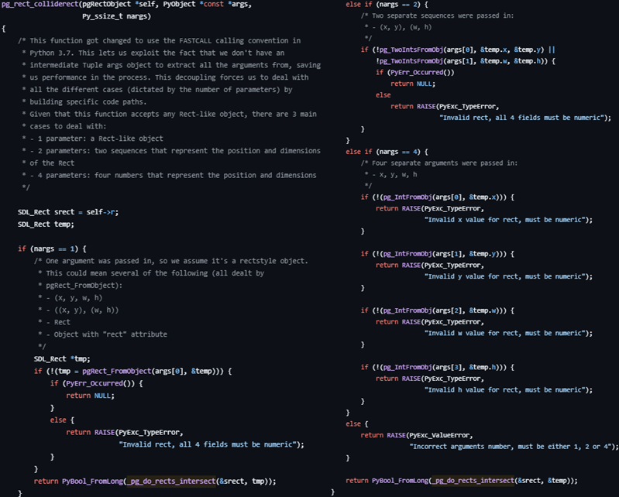
This is the code for the colliderect() function, which is just validating if the given rects are valid. If they are, _pg_do_rects_intersect() is called with the two rects.
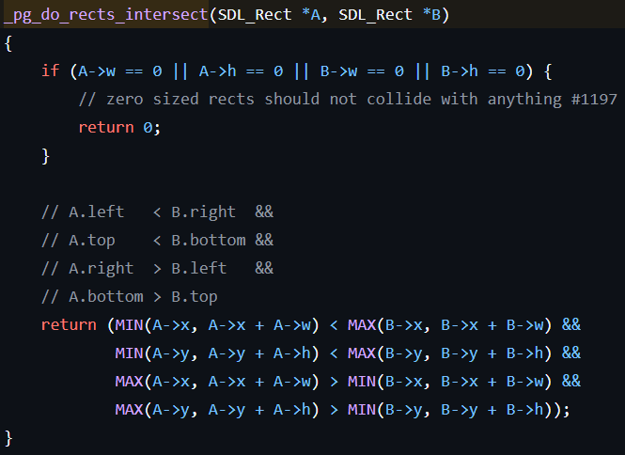
This is the actual collision detection algorithm and uses the following logic.
First a final validation is carried out to check if any of the dimensions are zero, and if they are then the function fails (return 0)
Looking at the return clause, four comparisons are made and logically AND ed together.
The 4 clauses can be read as follows (from the comment preceding the return clause):
The left of A < the right of B
The top of A < the bottom of B
The right of A > the left of B
The bottom of A > the top of B
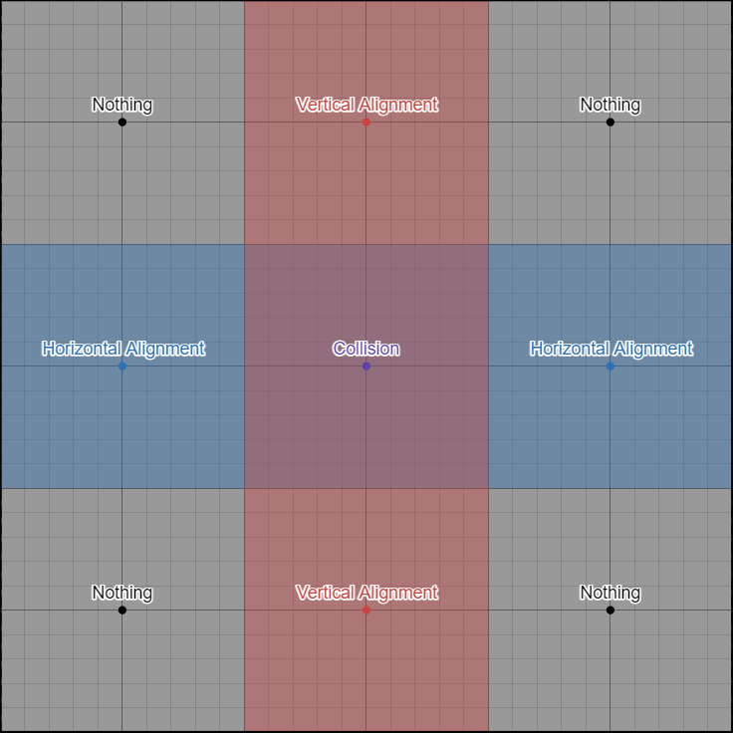
To confirm to us that this will work, the first and third conditions check if the two rects are vertically aligned, and the second and fourth conditions check if the two rects are horizontally aligned.
This is true as if the left of A is further right than the right of B, then A is strictly to the right of B (in this case condition 1 returns False), with the same statements holding for the left of B and the right of A, and the vertical conditions.
Looking at the diagram above, we see that a collision occurs if and only if the rects are both horizontally and vertically aligned, which is equivalent to the four conditions all being true, which is equivalent to the result of an AND between all four conditions. Thus, the professionally made algorithm does in fact work.
As a final note, the implementation of conditions 2 and 4 appear to read bottom of A < top of B, but pygame has the (0, 0) co-ordinate pair as the top left corner of the screen, so the smaller the y co-ordinate, the higher up the point is. As a result, Min(A -> y, A -> y + A -> h) returns the smaller y co-ordinate of A, and Max(B -> y, B -> y + B -> h) returns the larger y co-ordinate of B, so it tests the top of A < the bottom of B, which is what we want.
Code Sources:
https://github.com/pygame/pygame/blob/main/src_c/rect.c
At lines 664 and 356 for colliderect() and do_rects_intersect() respectively.

2.2.3 UI Click Detection
To integrate UI elements into the game, I will need a way to detect whether a click event occurs within a UI element.
To check if the click event is in bounds, I will use the same algorithm as above.
It is important to note that some UI elements exist as components of a container UI element – such as an entry to a list. As a result, these component elements will have positions which are relative to the container. This presents a problem: a click is relative to the screen, but a UI element is relative to a container. This requires a method to convert true co-ordinates to relative co-ordinates.
This is as simple as:
relative position = real position – container position

2.2.4 “Latching”
Even if a click happens in a UI element’s bounds, a click event should only be considered if the click starts and ends inside the element. This is the “latching” logic, which will also be used for pausing, as the game should only pause and unpause when the pause key is up.
“Latching” is done through two variables, the latch variable, and a trigger variable. Below is the pseudocode for a “latch” update.
Method update_latch(trigger: bool):
Global latch
If(not trigger):
Latch = True
Else If(latch):
Perform Action
Latch = False
Value of trigger variable | Click Event | Pause Event
True | Mouse Button Up | Pause Key Up
False | Mouse Button Down | Pause Key Down

2.2.5 On Screen Entities
To limit the number of entities we consider each frame, we can instead start the frame by determining which entities are even on screen – more specifically, on screen + 4 tiles in case the player scrolls onto them.
Method On_Screen(object_to_check, screen):
If object_to_check.left_side < screen.left_side
or object_to_check.right_side > screen.right_side:
Object_to_check.on_screen = False
Else:
Object_to_check.on_screen = True
Alongside making the game run faster through reducing the number of objects to draw, we no longer must perform pathfinding for enemies that are offscreen, which will stop enemies from reaching the player before the level would want them to be there, hopefully producing a better experience for the user.

2.2.6 Pythagorean Length
The project will use a co-ordinate system to determine where to draw each object. At points, we need to know the distance between two objects, such as for changing states of an entity’s finite state machine.
This will be done using the Pythagorean theorem:
$$A^{2}=B^{2}+C^{2}$$
In this case, B and C represent the absolute difference between the x and y co-ordinates respectively of the two objects.
In Pseudo code:
Method Pythagoras(objectA, objectB):
X_distance = absolute(objectA.x – objectB.x)
Y_distance = absolute(objectA.y – objectB.y)
B_squared = X_distance * X_distance
C_squared = Y_distance *Y_distance
Return root(B_squared + C_squared)

2.2.7 Enemy States
The project will contain three enemy types: Walkers, Flyers, and Crawlers.
Crawlers will trace the perimeter of a platform, and only have one state, so will not be considered further.
Walkers and Flyers operate as their names imply, and each have three states which affect their behaviour.
These can be modelled through a simple finite state machine – one for each type

Walker FSM
The Walker has three states: Idle, Moving, and Attacking
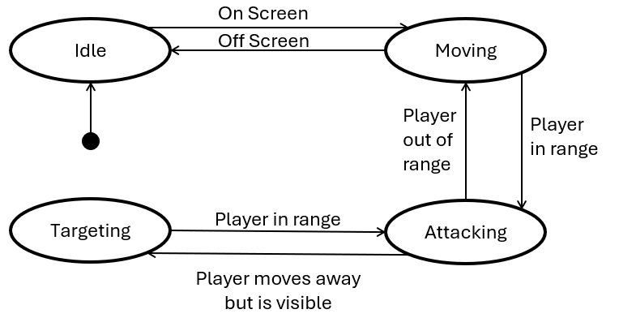
Method Update_state(State, On_Screen, Distance)
If (State == “idle” and On_Screen):
State = “moving”
Else If(State == “moving” and not On_Screen):
State = “idle”
Else If(State == “moving” and Distance <= Attack_Range):
State = “attacking”
Else If(State == “attacking” and Distance > Attack_Range):
State = “moving”
In this algorithm, Distance refers to the Pythagorean distance between the player and the walker.

Flyer FSM
The Flyer has three states: “idle”, “active”, “moving”
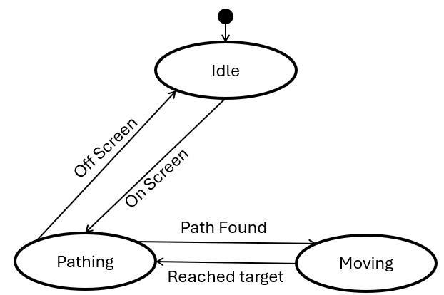Method Update_state(State, On_Screen, Move_Timer)
If (State == “idle” and On_Screen):
State = “active”
Else If(State == “active” and not On_Screen):
State = “idle”
Else If(State == “active” and Move_Timer > 0):
State = “moving”
Else If(State == “moving” and Move_Timer == 0):
State = “active”
In this algorithm, Move_Timer is a variable which counts down the number of frames the flyer has been moving for. This allows a reduced use of an expensive pathfinding algorithm which (while fast) would inevitably slow the performance of the game if called too much.

2.2.8 Attack Logic
Attacks are broken into two stages: Collection and Resolution. In the main game loop, the game allows all entities to attack (if they choose to).
Method Attack(attacker, possible_targets, attack_hitbox):
Connections = []
For target in possible_targets:
If target == attacker:
Next
If Collision_Detection(attack_hitbox, target):
Connections.append([attacker, target])
Return Connections
This method will take in the attacking object, all damageable entities that are on-screen, and the hitbox for the attack. It will then return all the targets which the attack collided with (whilst ignoring the attacker themselves). The returned list will then be added to a larger Collected_Attacks list, which is then used in the resolution phase. While Attack could be called by each entity each frame, Resolve will only be called once at the end of each frame before entities need to be drawn.
Method Resolve(Collected_Attacks, Damageable_Entities):
For connection in Collected_Attacks:
Attacker = connection[0]
Target = connection[1]
If Target.Protected:
Next
Target.Health -= Attacker.Attack_Damage
Target.Protected = True
For Entity in Damageable_Entities:
Entity.Protected = False
If Entity.Health <= 0:
Delete Entity

2.2.9 Pathfinding
For ground-based enemies, they will just consider if the player is on their left or right and move accordingly. Other enemies will fly in the air, using top-down movement controls. For this, we can create a graph of the level (marking the enemy node and the player node) and use the A* algorithm to determine where to move.
A* is a shortest pathfinding algorithm for non-negatively weighted graphs. A graph for our level will just be all empty tiles (the nodes), which have edges to all adjacent (including diagonally) empty tile. The weight for each edge is 1 when orthogonally adjacent, or $\sqrt{2}$ when diagonally adjacent (I will use 10 and 14 as weights for orthogonal and diagonal edges respectively, as $\sqrt{2} ≈1.4$, so multiplying both by 10 gives integer values and prevents obscure bugs which can occur with decimals in python). Each node will be labelled with their tile indices (calculated using top_left // 32). The source node’s label will be the enemy position // 32, and the destination node’s label will be player position // 32. This graph is constructed as the level is loaded.
Method A* _Pathfinding(source, destination, graph):
Closed_list = 2D array of Booleans
Nodes = 2D array of Node objects

Set source node data to 0, and parent = source

Open_List = MinHeap(Source Node)
While Open_List is not empty:
Closest_Node = Open_List.pop()
Flag Closest_Node as visited in Closed_list

If Closest_Node is destination:
Return path
For each neighbouring tile:
Check if it exists and can be reached
Check if it has already been visited (True in the closed_list)
Calculate new g and h values
F = g + h
If Nodes[neighbour].f > F:
Update neighbour’s f, g, and h
Set neighbour’s parent to closest_node
If Open_List is empty:
Return “FAIL”
This uses 3 data structures and 2 auxiliary method. This needs the Pythagoras function as described in (2.2.6), as well as a trace_path function, which will be discussed in 2.2.10. The first data structure is the node. A node is a class which bundles the information of a tile together, including the previous (parent) node and the current f, g, and h values. The second data structure is a tree, which is a special graph where there are no cycles – discussed in the data structures section. The final data structure is a Min-Heap, which (in brief) keeps track of the smallest element – this will also be discussed in the data structures section.
We store the tree within the nodes to allow us to quickly trace the final path. We store the open_list as a min_heap so we can always access the “closest” node quickly.

2.2.10 Trace Path Tree
A tree is a graph in which there are no cycles (you can’t get from node A through any of its child nodes). This is used in 2.2.9 to store the shortest path. As a tree is an abstract data structure, we don’t need a dedicated section of memory to store the graph, and instead we can just store references to the parent node within the node itself.
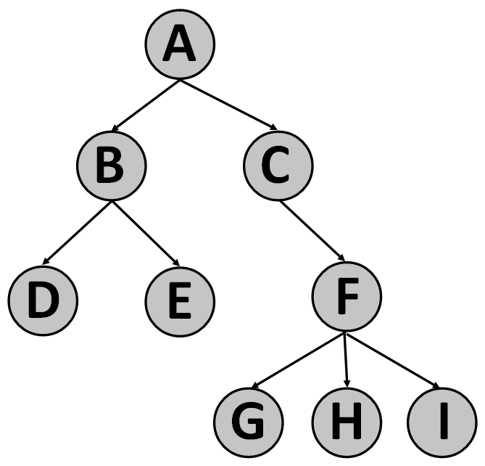
This is an example of a tree, where A is the root node. The trace_path algorithm starts from a leaf node (say E) and follows parent pointers up to A, in this case E -> B -> A. By storing the graph using parent pointers, we can just start from the leaf node (the destination of the search) and use a while loop to reach the root (source) node.
Method Trace_path(destination):
Node = Graph[destination]
Path = []
While Node.parent is not Node:
Path.append(Node)
Node = Node.parent
Return Path

2.2.11 Min-Heap Invariant Management
A Min-Heap is an array in which A[k] <= A[2k + 1] and A[k] <= A[2k + 2] for all k. This is useful as the smallest element is always at the first entry, so it is suitable for use as the open list in the for the a-star algorithm in 2.2.9. This relationship happens to describe a balanced binary tree, where A[0] is the root, and for A[k], A[2k + 1] and A[2k + 2] are its children. This gives us some terminology to help describe any algorithms.
The challenge comes in to preserve the minimum invariant. We need two key algorithms, one to insert a value into the heap, and one to pop the smallest value – both of which must preserve the minimum invariant.
For the insertion method, we append the value to the end of the heap. We can find that node’s parent using parent_pos = (my_pos – 1) // 2. We can then compare this node with the parent node and swap them if the new node is smaller. We repeat, using parent_pos as my_pos until the parent is smaller than the child, or the new node is now the root.
Method Bubble_down(position):
Parent = (position – 1) // 2
While Heap[Parent] > Heap[position] AND Parent > 0:
Swap Heap[Parent] and Heap[position]
Parent = (Parent – 1) // 2
Insertion is just appending followed by bubble_down(length(heap) – 1).
Popping is slightly harder. We always return the first entry (hence popping over deletion), and then delete that first entry. But now the root has been removed and we have two trees. So how do we recombine these trees whilst keeping the heap balanced? Instead of deleting the first entry immediately, we can instead overwrite it with the last entry, then bubble that entry down.
Method Bubble_up(position):
Child = 2 * position + 1
While Child < len(Heap):
RightChild = Child + 1
If(RightChild < len(Heap) NAND Heap[Child] < Heap[RightChild]):
Child = RightChild
Heap[position] = Heap[Child]
Position = Child
Child = 2 * position + 1
This method starts at the root, then loops through its children, swapping with the smaller of the two. To pop, we store the first entry, replace the first entry with the last entry, then perform Bubble_up. We can then safely delete the last entry and return the stored first entry.
Python has a built-in heapq module, which I will be using to implement the heap. Like 2.2.2, the code is open source, and viewable on GitHub.
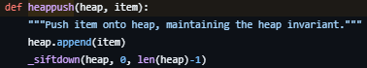
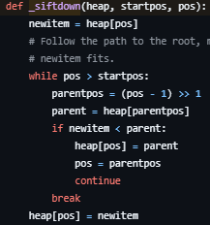
This is their implementation of Insert, with _siftdown() being the implementation of Bubble_down().
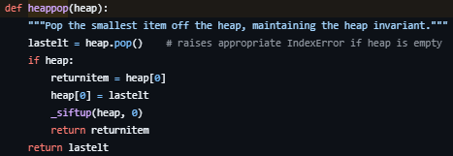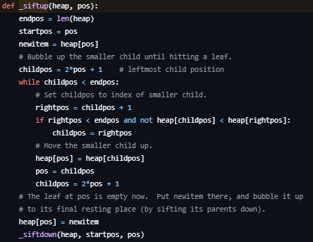
This is their implementation of pop, with _siftup() being the implementation of Bubble_up(). The only difference is that they bubble an empty entry and fill it in with the “last” entry at the end, whereas the pseudocode swaps the first and last entries before the bubbling.
Code Sources:
https://github.com/python/cpython/blob/main/Lib/heapq.py
Heappush(), _siftdown(), heappop(), and _siftup() can be found at lines 132, 207, 137, and 260 respectively.

2.2.12 Shudder (Crawler Movement)
A crawler is an enemy which moves anticlockwise around the perimeter of a platform, no matter how weird the shape is.
This is done by moving in a straight line until you hit a wall (rotate clockwise) or reach a corner (rotate anticlockwise). The important part of the algorithm is how we check for these conditions, this being the Shudder algorithm.
Method Shudder(direction):
Move 1 unit in direction
Check for Collision
Move back 1 unit
Return if a collision occurred
We need to also introduce the concept of the sticking point, which is the direction in which the crawler sticks to the platform. This is always 90 degrees anticlockwise from the direction of movement.
To perform a movement, we can now just do the following:
Method Movement():
Vector = Convert_to_vector(direction)
Move by vector
Wall_Check = Shudder(direction)
Stick_Check = Shudder(Sticking_Point)
If(Wall_Check):
Rotate clockwise
Else If(Stick_Check):
Rotate anticlockwise
Convert_to_vector is a method with no logic, just takes in a direction and returns a vector as a list.

2.2.13 Jiggle (Walker Movement)
All the tiles will be stored as a grid. Each tile will have coordinates which are multiples of 32 (as each tile is a square of lengths 32 by 32). The problem arises when an object does not walk a “clean” number of pixels in a frame.
Suppose the player moves 1 to 8 pixels each frame (1 on frame 1, 2 on frame 2, etc). In this case, after frame 7 we’ll have moved 28 pixels, but on frame 8 we’ll have moved 36 pixels. If there is a wall 32 pixels away from where we start then we’d have a problem, as frame 7 we’d be 4 pixels away, but frame 8 we’ll be 4 pixels in the wall, which can’t happen. One solution is to run a collision check, then move back 4 tiles (in this case) to get out of the wall. But what happens if we moved 32 pixels in a frame? In this case, we would have passed through the wall, which is behaviour we don’t want.
Another solution (which I will use) is to incrementally move (jiggle) the object until it either completes its move or collides, in which case we end the movement early.
This is as simple as a loop, shown in the pseudo code below:
Method Jiggle(To_Move):
Moved = 0
While Moved < To_Move
Move 1 pixel
If collided:
Move back 1 pixel
Return
Moved += 1

2.2.14 Walker Vision
As with the crawler’s shudder, a walker enemy doesn’t want to fall off the edge of a platform, and definitely doesn’t want to permanently walk into a wall. As a result, we need an algorithm to determine whether the walker should turn around – almost like vision.
This algorithm will use a 2-dimensional list of values, with each entry representing which tile is in the respective position – effectively the output of the level’s csv file.
For both conditions, we need to know where the walker currently is. This can be done by just taking the objects pygame position and dividing by 32 (the number of pixels per tile).
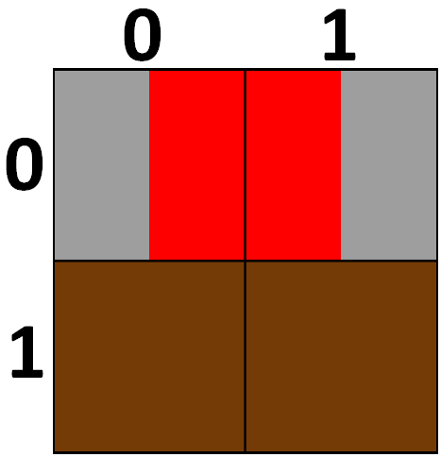
But what about here? Should the walker be in (0,0) or (1,0)?
This matters as if we choose the wrong index, then the walker will turn around a whole tile in advance. Luckily, this can be solved by first checking which direction the walker is moving, and then take the opposite corner. So, if we’re moving left, we take the right corner, and if we’re moving right, we take the left corner. As the pygame position is the top left corner, we can just add 1 to the x co-ordinate when moving left to get the right corner

Method Get_Indices(position):
X = position[0] // 32
Y = position[1] // 32
If (Moving_Left):
X += 1
Return X, Y
We can now test the two conditions.
For the first condition, look at what tile is below the tile we want to move to, and if it is unwalkable, then we turn around.
Method Check_Floor(X, Y):
If(Moving_Left):
Tile = Grid[Y + 1][X - 1]
Else:
Tile = Grid[Y + 1][X + 1]
Return Tile is walkable
For the second condition, look at the tile we want to move to, and if it is solid, then we turn around.
Method Check_Wall(X, Y):
If(Moving_Left):
Tile = Grid[Y][X - 1]
Else:
Tile = Grid[Y][X + 1]
Return Tile is not solid
We also need to check if the player is visible, as if they are then we don’t want to turn around.
This can be done by first checking if the player is even on the same level as the walker (the y indices match), and then looping through the row of tiles to see if the player is present.
Method Player_Check(X, Y, Player):
Player_X, Player_Y = Get_Indices(Player.Position)
If (Player_Y != Y):
Return False
If (Player_X == X):
Return True
Tile = grid[y][x]
While Tile is not solid AND X > 0 AND X < Edge of screen:
X += 1
Tile = grid[y][x]
If (Player_X == X):
Return True
Return False
(In the case of moving left, we decrement X instead)
The final algorithm is then just a combination of these rules:
Method Vision():
X, Y = Get_Indices(Position)
Floor_Validation = Check_Floor(X, Y)
Wall_Validation = Check_Wall(X, Y)
Player_Visible = Player_Check(X, Y, Player)

If (Floor_Validation NAND Wall_Validation):
If (Player_Visible):
Do Nothing
Else:
Turn around
Else:
Move

2.2.15 Kinematics (Walker Acceleration)
To make the movement of the player feel smoother, we need to add acceleration. This requires a part of mechanics called kinematics, which boils down to the relationship between time, velocity, and acceleration.
Acceleration will be used when the player falls – accelerating downwards – or when the player runs – accelerating in that direction.
These systems will use the same equation:
$$V=U+A*T$$
Where V is the final velocity, U is the initial velocity, A is the acceleration, and T is the time spent accelerating.
We can simplify this equation, as T will always be 1 (as we move every frame), so:
$$V=U+A$$

2.2.16 Mutation
To make each enemy feel different, I will use a simple algorithm to randomise an enemy’s health, damage, attack speed, and move speed upon instantiation.
This algorithm is as simple as generating a random number from a to b for each stat which will be that enemy’s value for that stat. More specifically, the random number will be a weight from 0 to m, which will then be used to determine which mutation occurs (higher roll = stronger enemy).
Method Mutation():
Attack_roll = random number from 0 to 7
If Attack_roll = 0 or 1:
Damage = normal, attack_speed = slow
If Attack_roll = 2 or 3:
Damage = normal, attack_speed = normal
If Attack_roll = 4:
Damage = good, attack_speed = normal
If Attack_roll = 5:
Damage = normal, attack_speed = fast
Else:
Damage = good, attack_speed = fast
This is how the attack stats will be randomised for a walker, and the same logic is used for all other stats. The specific values and weights of each stat are different for each enemy type, to account for their differing movement and attack styles (for example, the crawler attacks every frame, so it can’t attack faster).

2.2.17 Enumeration
This is a built-in function in python, which simply takes in an iterable (such as a list), and returns each element with a position – enumerating the values.
This is not a complicated algorithm, but necessary for the implementation of many algorithms, as well as to find the index of a value in a list which isn’t apparent. For example, if you had a list of objects, you wouldn’t inherently know the index of a pencil just from the fact it is a pencil. This idea extends to a list of game objects, which can’t easily be kept track of.

2.2.18 Garbage Collection
Python automatically allocates and deallocates memory. The bulk of the system is simple, you create an object, python runs an allocation request, so you don’t have to in your code, and when you delete an object, python releases that memory, allowing other software to use it. This system is simply to make Python more accessible, stopping learners from unintentionally using too much RAM and creating massive memory leaks through forgetting to release the memory.
What matters here is a part of the deallocation process called “garbage collection”.
In short, python’s garbage collector is an algorithm which checks whether an object is being referenced – potentially through other objects – and if it isn’t, the object can be removed. After all, a programmer wouldn’t have access to the object without a reference. On the most part, this is a useful addition but has some side-effects which affects how this project will need to manage objects.
To explain the problem, consider an enemy object. A reference to this object will be stored in a list so the project can have a dynamic set of enemies. If the enemy is defeated, then we just delete the object, and all is good. But because of garbage collection, the reference to the object in the enemy list is preventing the object from being deallocated, and so the enemy still exists within the code, and will continue to exist in the game – an incorrect behaviour.
So, in some cases, just deleting the object is not enough, and instead I will need to run my own garbage collection to gather which objects need destroying, and then remove their references one by one.

2.3 Game States
Screen | Description
MAIN | This is the screen that first loads when the program is run, and provides the option to either play levels, or use the editor (via two buttons, one for each option)
FILES | This screen loads when the player chooses to play a level, and allows the user to select which file they want to play on, as well as an option to return to MAIN
DELETE | This screen loads when the player chooses to delete a save file and allows the user to select which file they want to delete, as well as an option to return to FILES. To prevent files from accidentally being deleted, a captcha will be required to actually delete the file.
GAME | This screen loads when the player selects a file, and is where the game itself is played
PAUSED | This screen loads when the player presses the pause key whilst GAME is loaded. This will halt the logic occurring in the game, and will allow the player to either continue (unloading PAUSED and continuing the game logic) or to exit (which will save the game’s information and load MAIN)
LEVEL SELECT | This screen loads when the player chooses to use the editor on MAIN, and is used to list all the levels that the player can edit, an option to create a new level, and an option to return to MAIN
EDITOR | This screen loads when the player chooses a level to edit, and consists of a grid to place tiles on, and a tile palette to select how the player interacts with the grid
TOOL_TIPS | This is actually 3 screens with the same purpose: display the controls of a certain game state. The tool tips in question are: Controls, Editor_Buttons, and Editor_Keybinds, which display the game controls, the editor buttons and the editor key binds respectively. The Controls screen has a button to return to FILES, and the other two have a button to return to LEVEL SELECT
Only one screen will be loaded at a time, with the exception of PAUSED, which may be loaded over GAME.
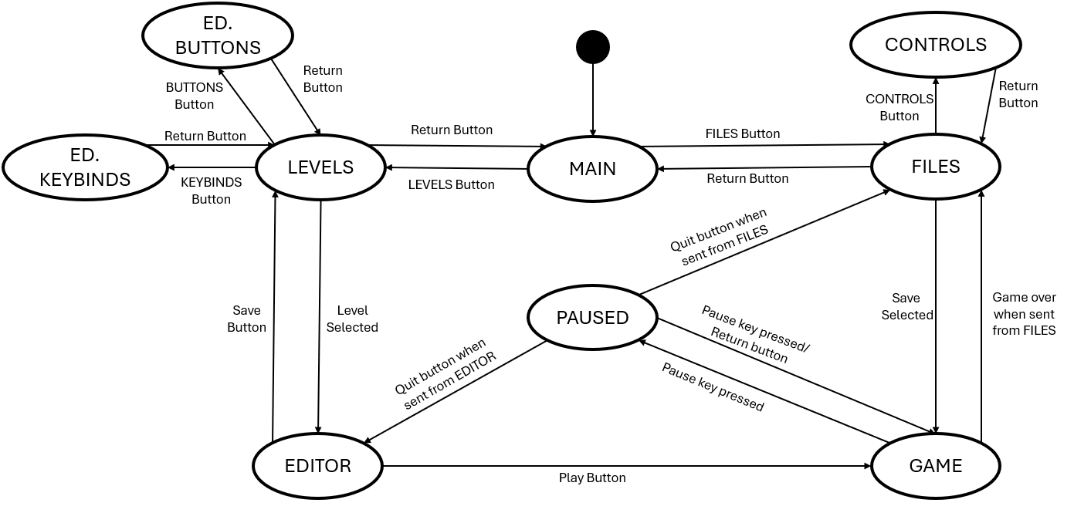
This is a state transition diagram showing how a user can traverse game states.

2.4 Data Structures

Iterables
2.4.1 to 2.4.3 are iterable variables. These are variables which can be iterated through, through an identifying key or index.

2.4.1 List
This is just (as the name would imply) a list of variables which share the same name but are differentiated by indices. This structure is automatically provided by Python and is defined as my_list = [5,12,4,7]. The first value is selected using my_list[0] as Python uses 0-based indexing (ordering things by 1, 2, 3, etc is 1-based). A list can be used to keep variables “in one place”.
Index | 0 | 1 | 2 | 3 | 4 | 5 | 6 | 7
Value | 14 | 7 | “u” | 89 | “e” | - | 0.167 | “five”
An example of a list, using 0-based indexing - starting at 0. The value at index 5 is blank, as it is yet to be assigned.
This will be used in pretty much every aspect of the program, but one example is the enemy list, as each level can have variable numbers of enemies so defining individual variables is neither plausible nor practical.

List Comprehension
List comprehension is a concept in functional programming in which you can define a (potentially complicated) list through a set of rules, rather than defining each element individually.
One application is to convert a predefined list of integers into their string counterparts, reducing the complexity of the code. Another is to initialise a list of variable length (such as the level grid).

List Concatenation
In python, two lists can be combined into one through the + operator. This allows us to (for example) define multiple “component” lists separately with individually clear names, which can then be combined into one list with a generic name.

2.4.2 Tuple
A tuple is identical to a list, but its values cannot be modified once assigned – this property is also called “immutability”. Tuples are useful for when a function is to return multiple values that just need to be read.
List comprehension nor list concatenation are functions of tuples, and so some cases where a tuple should be used, we use a list instead. If neither function is needed, we can use the following rule: use a list when elements are being removed or replaced, else use a tuple to prevent accidentally modifying the data.

2.4.3 Dictionary
A dictionary (or associative array) is in effect a more general list, where instead of an integer index pointing to a value (index-value pair), a dictionary uses an integer or a string as a key which would then similarly point to a value (key-value pair). Like lists, keys are atomic, so one key will always point to exactly one value, and this structure is similarly provided by Python, and can be defined using my_dict = {key: value, key: value, key: value}, or my_dict = dict([key: value, key: value, key: value]). Dictionaries are useful when collating multiple values which can only be distinguished through non-integer values.
Key | “half” | “one” | “e” | “zero” | “pi”
Value | 0.5 | 1 | 2.1828 | 0 | 3.1415
An example of a dictionary, being used to store mathematical constants.
Keys need to be “simple” variables: strings, integers or tuples, but can’t be abstract data types (discussed below).

2.4.4 Graph
A graph is a data structure based on the mathematical object of the same name. A graph consists of nodes – which are objects which store the data – which we “connect” using an edge – a pointer. An edge in a graph represents some kind of relationship between two nodes, which is constant across the whole graph. Edges can be directed, meaning that node A connects to node B, but node B does not connect to node A. Edges can also have weights, which indicate the extent of the connection. For a computer to store a graph, the nodes are stored as any object would be. Edges are much harder to store but can be stored in 2 ways: adjacency lists and adjacency matrices. In an adjacency list, each node stores their outgoing edges as elements of a linked list, and then all the linked lists are stored in one larger list – the adjacency list. Alternatively, you can use an adjacency matrix, which is a 2-dimensional array (or in python a list of lists) which uses the start and end node as the x and y co-ordinate respectively and stores the weight of the edge connecting them (0 if no edge is present, 1 if an edge is present and the graph is unweighted). Lists are used when the graph is sparse (nodes don’t have many edges).
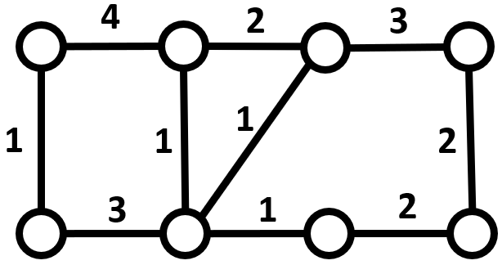
An example of a weighted graph
X | A | B | C | D | E | F | G | H
A |  | 4 | - | - | 1 | - | - | -
B | 4 |  | 2 | - | - | 1 | - | -
C | - | 2 |  | 3 | - | 1 | - | -
D | - | - | 3 |  | - | - | - | 2
E | 1 | - | - | - |  | 3 | - | -
F | - | 1 | 1 | - | 3 |  | 1 | -
G | - | - | - | - | - | 1 |  | 2
H | - | - | - | 2 | - | - | 2
An example adjacency matrix for the above graph – stored using a 2D list
Node | A | B | C | D | E | F | G | H
Edges | {B:4, E:1} | {A:4, C:2, F:1} | {B:2, D:3, F:1} | {C:3, H:2} | {A:1, F:3} | {B:1, C:1, E:3, G:1} | {F:1, H:2} | {D:2, G:2}
An example adjacency list for the above graph – stored using a list of dictionaries
In this example, the number of edges (20 as each edge is counted twice due to be undirected) is much less than the maximum number of edges (56) and is this a sparse graph. As a result, it would be better to use an adjacency list to store the graph, rather than an adjacency matrix.
I will be using a graph to store the adjacencies between tiles in the tile_grid, which is necessary to perform the A* algorithm (as pathfinding entities need to know where things are). Each node will have up to 8 outgoing edges, which will result in the final graph being sparse. As such, an adjacency list* will be used to store edges.

The Node “data structure”
A node is a class which is exclusively used to store data. In this case, it is used to store the position of the tile it’s representing, and may also store other variables, such as a pointer to its parent, or data needed by a graph function, like the heuristic value of the node for the a-star algorithm.

2.4.5 Tree
A tree is a variant of a graph, in which each node has at most 1 incoming edge (called a parent), and a singular node having no parents (called a root). If a node is not a parent to another node (it has no children) it is called a leaf. Trees are stored identically to graphs. Trees are used to identify a relationship between each node and the root. One application in my program is storing the shortest paths from an enemy’s position (the root node) to the player’s position.
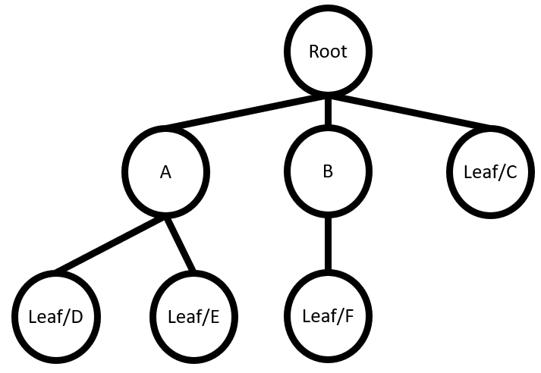
An example of a tree
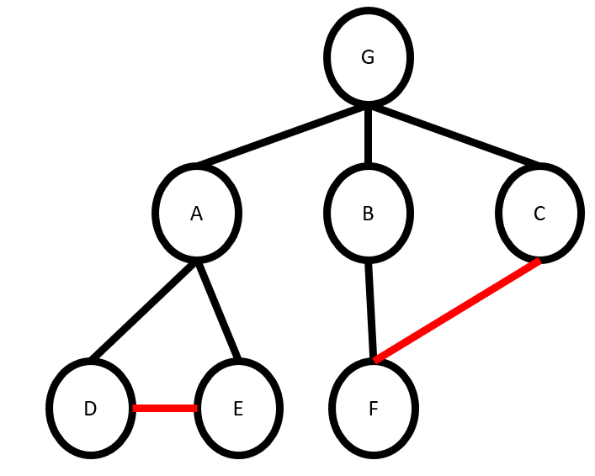
An example of a graph which is not a tree due to the cycles. By removing the red lines, a tree would be present
I will be using a tree to store the current path found during the A* algorithm – using the start node as the root. As each step of the path will lead to a brand-new node, no cycles can form. Also, by using a tree, the shortest path can be quickly reconstructed by going from the destination node (which will be a leaf) and jumping up parents until the root node is reached.
This can be stored through pointers in the node class.

2.4.6 Binary Heap (Complete Binary Tree)
Whilst trees use parent-child relationships to establish a connection, in a heap there is no importance to which elements are parents and which are children. Instead, a binary heap uses parent-child relationships to maintain a balanced characteristic. As such, the heap can be implemented as an array with the 0th element as the root, and the following rules for the ith node: the parent of the ith node is at position (i-1)//2, and its two children are at (2*i)+1 and (2*i)+2 respectively. When elements are added to a heap, it is identical to appending to the array. Now, when an element is removed from the heap, we take one of its children (typically the right first) to become the new parent, and we repeat until we reach a node with no children. This is called balancing and is used to ensure consistent lookup times when searching from a parent/child node.
A binary heap comes with two main variants: max and min-heap. These are near identical to binary heaps but impose certain restrictions on each node – called the heap invariant. In a min heap, the parent node MUST be less than or equal to both of its child nodes. If not, then we perform swaps to ensure the invariant holds. The inverse rule is applied for a max heap. Due to the balanced nature of the heap, when we add/remove an element, it only takes O(log₂(n)) time to return the invariant, as opposed to the O(n) time required to minify/maxify a list. Importantly, this structure will have the max/min as the first element.
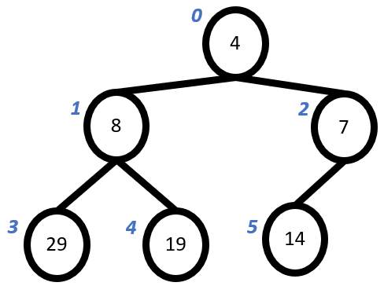
An example tree-based implementation of a min-heap for the input (19, 14, 8, 29, 7, 4)
Index | 0 | 1 | 2 | 3 | 4 | 5
Value | 4 | 8 | 7 | 29 | 19 | 14
An example list-based implementation of the min-heap above, where the index corresponds to the blue number next to a value
From these examples, you can check to find that the parent-child index relationship holds.
I will be using Min-Heaps to implement a priority queue, as mentioned later in 2.4.9 Priority Queue.
This data structure is built into python through the heapq module.

The binary characteristic
Simply, each node has exactly 0, 1 or 2 children.

The balanced/complete characteristic
The depth of a tree is the greatest number of children to reach a leaf from the root. In the example above, the tree has a depth of 2. To determine the depth of a tree, you can use the following recursive algorithm:

Method get_depth(node):
If node is a leaf:
Return 0
childDepth = 0
for each child of node:
childDepth = max of childDepth and get_depth(child)
return childDepth + 1
The balanced characteristic (for a binary tree) is when the depth of the left subtree is equal or one greater than the depth of the right subtree. This will make the tree complete, as all nodes that aren’t leaves/parents of leaves have exactly 2 children.
This is important, as the runtime of the insertion and removal functions of a min/max heap depend on the number of nodes we need to consider, which is equal to the depth of the heap. By balancing the heap, we can have a consistent runtime for these functions, as the depth is constant for each side of the tree (or constant + 1).
This (in conjunction with the binary characteristic) results in the O(log₂(n)) complexity we want.

2.4.7 Queue
A queue is another variant of an array known as a First-In-First-Out data structure. This structure only allows for the first element to be looked at (called peeking) or removed (called pop or dequeue). I will be using a circular queue, which stores a pointer called “head” and a pointer called “tail”. Elements are added by storing them in position last (then last increments by 1) and are popped by deleting the element at position first (then first increments by 1). This allows data to be quickly added and removed, at the cost of 2 variables, and making sure that first/last are always valid indices for the array.

Index | 0 | 1 | 2 | 3 | 4 | 5 | 6 | 7
Value | “e” | “O” | “l” | “d” | “Q” | “u” | “e” | “u”
Head: 4 |  |  |  | Tail: 0
An example of a circular queue.
Note how the tail pointer is less than the head pointer, meaning the queue is wrapping back around the static list. Also note how indices 1, 2, and 3 contain values, but are not in the range indicated by Head and Tail. This is another benefit of a circular queue, as we don’t need to care about deleting old values, but rather overwriting values when necessary.
I will not be using queues themselves, but rather priority queues, which are covered below (2.4.8 Priority Queue).

2.4.8 Priority Queue
A priority queue is a variant of the queue, but rather than dequeuing according to the FIFO rule, it first dequeues according to a priority. Priority is just an additional value assigned to each entry. Any priority ties are broken according to FIFO. One implementation is to just use a queue to maintain FIFO, then whenever a dequeue occurs, you search for the first occurrence of the highest priority in the queue. This is O(n) time and is why I will instead implement a priority queue using a min heap. This will organise the queue according to priority but damages the FIFO rule. I am currently using priority queues for the A* algorithm, which don’t care for FIFO, only which element has the highest priority, so losing this property is not an issue. Also, for the A* algorithm, I will be using the lowest priority in the queue, as the algorithm wants the “closest” node to be selected next, hence the min heap over the max heap.
Index | 0 | 1 | 2 | 3 | 4 | 5 | 6 | 7
Priority | 2 | 3 | 4 | 1 | 5 | 4 | 1 | -
Value | “e” | “d” | “b” | “f” | “a” | “c” | “g” | -
A FIFO priority queue – implemented as a linear queue.
“a” | “b” | “c” | “d” | “e” | “f” | “g”
The above queue’s outputs.
To get the next value from this queue, you would loop through all values, storing the first element of the highest priority. That element is then removed, and the rest shuffled along to remove gaps. This allows each priority tier to be FIFO, but the overall queue is not FIFO.
Index | 0 | 1 | 2 | 3 | 4 | 5 | 6
Priority | 5 | 4 | 3 | 1 | 2 | 3 | 1
Value | “a” | “b” | “d” | “f” | “e” | “c” | “g”
The same priority queue - implemented as a max-heap.
“a” | “b” | “c” | “d” | “e” | “g” | “f”
The above queue’s outputs.
As shown by the examples, the binary heap implementation won’t necessarily retain the FIFO quality that a priority queue should have, but as the priority queue is being used for the A* algorithm, the order in which elements are added is irrelevant, only the priority.

Big O Notation
Above O(n) and O(log₂(n)) are used in reference to time. This is Big O Notation and refers to how time taken (or space used) changes as number of elements (n) changes. In O(n), it means that as you double the items, the time taken doubles – linear time – and O(log₂(n)) means that as you double the items, the time taken increases by log₂(2n) = log₂(n) + log₂(2) = log₂(n) + 1 – logarithmic time, as doubling items increases time taken by a constant amount.
There are multiple time complexity notations. Big O specifically denotes the worst-case runtime, so while an algorithm may run on Ɵ(1) (Big Theta of 1 – average case is constant time), it may come with an O(n³) runtime, which is undesirable. We use Big O, as while on average an algorithm might be very fast, we don’t want to risk the worst case of it being VERY slow.

2.5 Data Requirements
As a database is not required, there are few data requirements for this project. As discussed in 2.7, specific formats will be used, but the program will ensure that user inputs comply with these formats by either limiting what keys the game “listens” to (used when a name is required), or only allowing the user to input with preformatted elements (in the case of the level editor).

2.6 File Organisation and Processing
File Name | Access | Description | Master/Transaction
Save.txt | Random | Stores all save data | Master file
Levels | Random | Folder storing all level data files | Master folder
*.csv | Random | A file storing the tile-map for a level (stored in the levels folder) | Master file
As this is an offline game, all files will be master files that have their contents updated when a save button is pressed. In the save file, there will be 3 lines which will be independently updated based on which player is saving. Whenever a new level is made, it is created and saved in the Levels folder as a list of comma separated values (csv).

2.7 Table/Record Structures

2.7.1 Save.txt
The variables in the table below will be stored on one line to represent a save file (of which there will be 3 lines for 3 files)
Data Item | Data Type | Length | Format | Validation | Source | Notes
Username | String | 16 | AAAAAAAA | 1≤Length≤16 | FILES | ---
Lives | Integer | 2 | 12 | >0 | GAME | Initially set to 5
Health | Integer | 2 | 12 | >0 | GAME | Initially set to 10
Level | Integer | 3 | 123 | >0, ≤100 | GAME | Initially set to 1*
When a new file is created, the player will be prompted to enter a name, between 1 and 8 characters. This name will be in all caps.
All values must be present.
*-1 will be used to indicate an empty save as to remove an unnecessary restriction on the username.

2.7.2 Level.csv
This file will simply be a csv file, with a value representing a tile id for a cell, and a line of values representing a row of cells.

(This is being displayed in Microsoft Excel, hence the numbered rows and alphabetized columns. These are not present in the file inherently).

2.8 Class Structure

Main Structure
This project will have its sections split into different modules. A consequence of this is a lack of true global variables. As such, most of the code will be stored in classes to mimic the behaviour of global variables, by referencing a property of the respective element.
As a consequence of this, the driver code for the project – such as the game loop – will have a “controller” class which stores the driver code as a function. So, there will be a controller class for the menus, one for the game, and one for the editor, as each one has distinct logic.
Pygame has two important classes which I will be using. The first is the surface, which is simply just an image of predefined size which you can paint onto – called blitting from bit block transfer. The screen that is displayed is one such surface, which we blit all our objects onto. The other is the rect, which just stores the position, width, and height of a rectangle. This is used to produce any hitboxes/colliders we need for the project.
All other classes will be used for actual objects. Each class will be put into its own module, unless they are very closely related – such as the different platform types.
The class structure for these classes can be displayed as a tree, with the “root” being the Sprite class. Most other classes are subclasses of the Sprite class, as most elements are visible, and thus need a sprite.
Note: All classes have a constructor method (__init__) which initialises all the properties of an object. This function is not listed in the class diagrams, as every class has one.
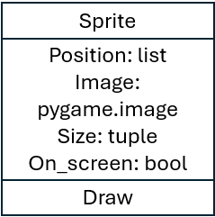
The rest of the class structure diagram will be split into two parts, one for the game classes, and one for the UI classes. The two diagrams can be combined through the common Sprite class.
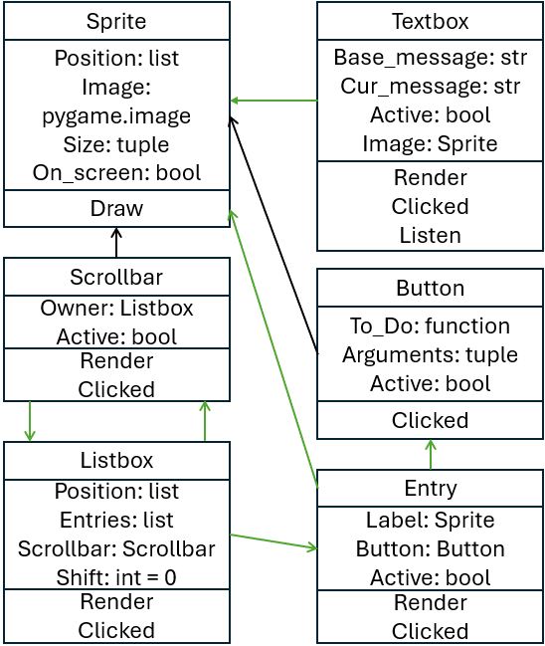
Black arrows point to a superclass.
Green arrows indicate a reference to another class.
The UI class diagram has less inheritance and is more about references. This is because an entry is just a label and a button, and a listbox is just a list of entries.
The scrollbar and listbox reference one another, as not all listboxes need a scrollbar, and the scrollbar is used to scroll/shift its associated listbox.
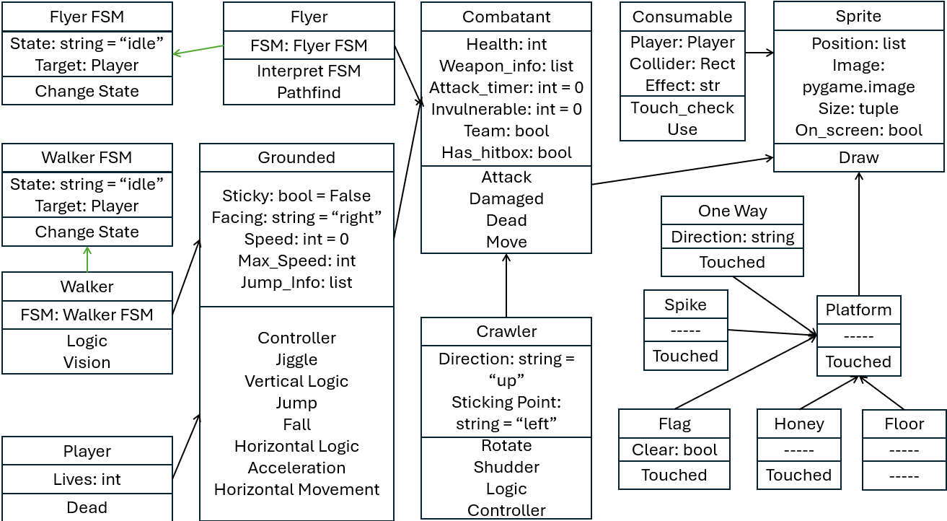
Black arrows point to a superclass.
Green arrows indicate a reference to another class.
The game class diagram is just as shown, with the only note being that the different platform types are not strictly subclasses of some Platform superclass but are simply illustrated this way to show how they are all closely related, differing through polymorphic touched methods.

2.8.1 Sprite
This is the main class for most objects in the game, as we need a way to see them.
Property | Position | The absolute position of the sprite’s top left corner in the level
Property | Image | The image of the sprite
Property | Size | The width and height of the image
Property | On-Screen | Is the sprite on the screen
Method | Draw | Draws the sprite onto its relative position on screen
Note: Pygame comes with an image class preinstalled, which will handle drawing the png file to the screen.

2.8.2 Platform
This class inherits from the sprite class and will thus inherit all the properties and methods of the sprite class – which will not be relisted.
There will not be a platform class, but rather a class for each type of platform (Standard, Honey, Spike, Flag, One Way). These classes will only have one method*, used to determine what should happen if something stands on it.
Standard | Nothing
Honey | Increase drag, prevent jumping
Spike | Deal damage
Flag | Tell the game controller to progress to the next level
One Way | Nothing
*One Way platforms will come with a property indicating their active side.

2.8.3 Combatant
This class inherits the sprite class and will similarly inherit all properties and methods. This class will act as the main parent for enemies and the player and contains the properties/methods to handle the combat side of the game.
Property | Health | How close is the entity to death
Property | Weapon_Info | How much damage does the attack do, how far can the entity attack, how long is the attack in frames.
Property | Invulnerable | How many frames is the entity immune to damage
Property | Attack_timer | Is the entity attacking – Used as a timer for how long an attack has taken
Property | Team | Is the entity on the player’s team?
Method | Attack | Determine what entities are in range of the attack
Method | Damaged | Used to decrease a combatant’s health
Method | Dead | Used to flag the combatant for deletion
Method | Move | Move the absolute position of the entity

2.8.4 Grounded Combatant
This class inherits from the combatant class and acts as a template for a grounded entity (player and enemy will have some difference, so will have to inherit from this class).
Property | Sticky | Used to activate honey’s effects
Property | Facing | Used to determine which way the entity was moving, and which direction to draw an attack’s hitbox
Property | Speed | The entity’s current speed
Property | Max_Speed | The maximum speed the entity can reach
Property | Jump_Info | How long the entity has fallen for, can they coyote jump.
Method | Controller | Converts arrow key inputs (in player case) into instructions on how to move the entity (called by the Move Method)
Method | Jiggle | See 2.2.13
Method | Vertical Logic | Used to determine if the entity should jump or fall
Method | Jump | Moves the entity “up” until a full jump is done, or a collision occurs
Method | Fall | Moves the entity “down” until a full fall is done, or a collision occurs
Method | Horizontal Logic | Used to determine which way the entity should move (if any)
Method | Acceleration | Used to accelerate/decelerate the entity
Method | Horizontal Movement | Used to move the entity horizontally

2.8.5 Finite State Machines
These classes are base classes, and act as a finite state machine for their respective enemy class. While the two machines are different, that is only in the states which can be held, and their state transition tables. The properties and methods are identical.
Property | State | What state is the enemy in right now
Property | Target | What is the enemy targeting
Method | Change State | Changes the enemy’s state (Covered in 2.2.7)

2.8.6 Walking Enemy (Walker)
This class inherits from the grounded combatant class and will contain an instance of the FSM class.
Property | FSM | Stores a reference to the associated finite state machine
Method | Logic | Uses the FSM state to choose what to do (2.2.7)
Method | Vision | Determine if the player is visible
Note: Idle state – do nothing, moving state –move, attacking state – attempt to attack the player, targeting state – don’t turn around if an edge is reached (just stop).

2.8.7 Flying Enemy (Flyer)
This class inherits directly from the combatant class and will contain an instance of the FSM class.
Property | FSM | Same as in 2.6.6
Method | Interpret FSM | Determine if pathfinding is necessary, or the next move is known (2.2.7)
Method | Pathfind | Use the A* algorithm (2.2.9) to find the shortest path from flyer to target
Note: Idle state – do nothing, active state – pathfind then move, moving state – just move.

2.8.8 Crawling Enemy (Crawler)
This class inherits directly from the combatant class and has much simpler logic than the other enemy types.
Property | Direction | Which direction is the crawler moving
Property | Sticking point | Which direction is the wall the crawler is sticking to in relation to the crawler (90 degrees clockwise from the direction property)
Method | Rotate | Change the direction and sticking point
Method | Shudder | See 2.2.12
Method | Logic | Move around the platform (top-down controls) as indicated by the result of Logic
Method | Controller | Determine how to actually move

2.8.9 Player
This class inherits from the combatant class and will be the entity which the player can play as.
Property | Lives | How many times can the player die before game over
Method | Dead | Decrement the lives counter and reset the level
The Dead method is a polymorphism of the combatant’s Dead method, as when the player dies, you want to reset the level, not delete it from memory.

2.8.10 Consumable
This class inherits from the sprite class and will be the entity which stores information for a modification to the player.
Property | Player | A reference to the player object, to prevent enemies from claiming consumables
Property | Collider | The pygame rectangle representing the consumables collider
Property | Effect | The effect which the consumable will have
Method | Touch_check | A method to validate if the player is touching the consumable, and if so, use it
Method | Use | A method to use and delete the consumable when touched (depends on the effect property).
There will be 2 main types of consumables: heals and upgrades. Heals simply increase the player’s health, whilst upgrades provide a new movement option to the player.
Consumable Type | Effect
Heal | +1 health
Heal | +2 health
Heal | +5 health
Upgrade | Double jump
Upgrade | Wall jump
Upgrade | Double attack (attack on both sides at once)
Upgrade | Run
Upgrade | Dash

2.8.11 Label
Pygame offers a font render function to convert a string, font, and colour into an image. This image can then be used as the image in a sprite. As a result, all labels will just be sprites with a little extra setup.

2.8.12 Button
This class will inherit from the sprite class.
Property | To_Do | The function to be carried out if the button is clicked
Property | Arguments | The arguments to be passed in To_Do
Property | Active | Used as the latch in 2.2.4
Method | Clicked | Monitors whether the left mouse button is pressed whilst hovering over the button

2.8.13 Entry
This class will not inherit from anything, but will have reference to a Sprite and a Button
Property | Label | The text of the entry – Stored as a Label object
Property | Button | The button used when this entry is selected – Stored as a Button Object
Property | Active | Is this entry visible on the associated Listbox?
Method | Render | Combine the Label and Button into one image
Method | Clicked | Perform the referenced Button’s Clicked method with a position relative to the entry

2.8.14 Listbox
This class will not inherit from anything but will have reference to many entries.
Property | Position | Where the visible Listbox should be drawn
Property | Entries | The actual elements of the list
Property | Scrollbar | The associated scrollbar
Property | Shift | How far has already been scrolled
Method | Render | Draw only the relevant entries
Method | Clicked | Perform the Clicked method of all the active entries with a position relative to the Listbox.

2.8.15 Scrollbar
This class is a subclass of Sprite and will inherit all of its properties and methods. This is a class which can optionally be created along with a Listbox when the Listbox has more than 3 elements (when scrolling becomes a necessity).
Property | Owner | References the associated Listbox
Property | Active | Used as the latch in 2.2.4
Method | Render | Used to reposition the scrollbar next to the Listbox
Method | Clicked | If the up or down buttons are pressed, then increment/decrement the associated Listbox’s Shift property (must be in bounds).  If the scrollbar portion is clicked, then alter shift according to what percentage of the way down the Scrollbar the click was.

2.8.16 Textbox
This class will not inherit from anything, but will contain a reference to the sprite class.
Property | Base Message | Stores what the textbox should display when the user has not inputted anything (or deleted their message)
Property | Current Message | Stores what the textbox is currently displaying
Property | Active | Used as the latch in 2.2.4
Property | Image | A sprite to display the current message
Method | Render | A method to convert the current message into a sprite
Method | Clicked | A method to detect whether the player is currently using the textbox or not
Method | Listen | A method to detect a user’s keyboard inputs to modify the current message

Meta Structure
As stated previously, there are some classes which act as controllers for the different game states. There are three such classes: MAIN, GAME, and EDITOR.

2.9.17 MAIN
This is the class which is generated when the game is first loaded. It stores the main game loop, and all the UI functions to navigate between game states.
Property | Screen | A pygame screen object, which will be used to display my game to the real life monitor
Property | Clock | A pygame clock object, which ensures that the game updates every 60th of a second
Property | Game | A reference to the GAME object – needed to run the platformer
Property | Editor | A reference to the EDITOR object – needed to run the editor
Property | Game UI | A reference to the Game UI container object (see below) – needed to select and display the correct UI whilst the platformer is active
Property | Editor UI | A reference to the Editor UI container object (see below) – needed to display the UI elements of the editor, such as the tile palette
Property | Active UI | A list of UI elements which may be required on a given screen
Property | Running | A Boolean value to identify if the game is running (needed to safely quit the application)
Method | In Control | This method stores the main loop, and is called to start the game
Method | Change Screen | This method loads the UI of the requested screen, and (if necessary) runs the platformer/editor.
Method | Click Event | This method is ran whenever a click occurs, and loops through all UI elements to run their clicked() methods
Method | Listener | This method listens for keyboard input, and passes it to a Textbox (only ran if a Textbox is on screen)
Method | Run Game | This method tells the GAME object to load a file
Method | Delete Save | This method checks for a captcha, then deletes a save file

2.9.18 GAME
This class encapsulates all the properties and methods relating to the platformer itself, such as the player object, and the level information.
Property | Main Menu | A reference to the MAIN object – needed to load the correct UI during a pause, and change screens as necessary
Property | File | The index of the current save file in the main save .txt file
Property | Running | A Boolean storing whether the platformer is active or not
Property | Paused | A Boolean storing whether the platformer is paused or not
Property | Pause Latch | Used as the latch in 2.2.4
Property | Sent From | Stores which state the platformer was loaded from (Menu or Editor), needed to return to the correct part of the program
Property | Max Level | The number of levels in the main game – prevent loading a non-existent level
Property | Grid | A 2D array of all the tiles in the .csv file
Property | Graph Info | The dimensions of the grid (and thus the level)
Property | Tiles | A list of all the tile objects
Property | Flag | A reference to the flag object
Property | Tile Colliders | A list of all the tile colliders – otherwise each frame each entity would create the list again, so this saves time
Property | Player | A reference to the player object
Property | Crawlers | A list of all the crawler objects
Property | Flyers | A list of all the flyer objects
Property | Walkers | A list of all the walker objects
Property | Hitboxes | A list of all attack hitboxes objects (Sprite objects which disappear after 6 frames)
Property | Timer | The number of frames remaining until the level ends (countdown from 100)
Method | Load File | A method to load a level’s .csv and instantiate all the required objects
Method | Clear Game | A method to delete all the old objects between levels to prevent old objects referencing deleted objects
Method | New File | A method to create a new save file from an inputted name
Method | Run Frame | A method to perform call all the logic methods – effectively the game loop
Method | Draw Game | A method to draw all visible objects onto the screen
Method | Forced Draw | A method to fully clear the screen and just display the game mid-frame (only called on level clear or player death)
Method | Movement | A method to call all the entity move methods
Method | Gather Attacks | A method to gather the attacks (See 2.2.8)
Method | Resolve Attacks | A method to resolve the attacks (See 2.2.8)
Method | On Screen | A method to only draw objects which are on-screen (See 2.2.5)
Method | Save to File | A method to modify the save file
Method | Reset | A method to play an animation then reset the level if the player dies.

2.9.19 EDITOR
This class encapsulates all the properties and methods relating to the level editor, such as the current grid.
Property | Main Menu | A reference to the MAIN object – needed to load the correct UI during a pause, and change screens as necessary
Property | Focuses | A set of two “focus” Sprites, which hover over the selected tile and mode so the user knows what a click will do
Property | Positions | A dictionary of positions for each image, and thus where to move the focus to when selected
Property | Images | A dictionary of all the images
Property | Active | A Boolean storing whether the editor is active or not
Property | File | The name of the current level file
Property | Mode | The current mode (Draw or Erase)
Property | Tile | The current tile
Property | Scroll | How much has the level been scrolled
Property | Player Position | What is the current position of the player (A player must exist to run the level, and there can only be one player)
Property | Flag Position | What is the current position of the flag (A flag must exist to run the level, and there can only be one flag)
Property | Previous Position | What was the previous position that a click occurred (used as a guard clause to save time when someone holds the mouse down over the same tile)
Property | Grid | A 2D array of strings storing the tile in each position – this is saved to the .csv
Property | Objects | A 2D array of Objects – this is to show the level so far
Property | Hidden | A Boolean storing whether the UI should be hidden or not
Property | Latches | A set of 9 Booleans, each used as the latch in (2.2.4) for the different key binds the player can use
Property | Palette | A string storing which palette is active
Property | Palette Pointer | An index for the active palette, so the player can “scroll” through the palettes
Method | New File | A method to create an empty .csv file for a new level
Method | Load | A method to load a csv file, and re-initialise the properties
Method | Unload | A method to save the csv file, then send to either the level select screen, or to game (if a flag and player also exist)
Method | Shift Focus | A method to move a focus over the selected tile/mode
Method | Change Mode | A method to update the mode (and then call Shift Focus)
Method | Change Scroll | A method to scroll the visible part of the level
Method | Button Clicked | A method to determine what each button should do
Method | Manage Flag And Player | A method to make sure only one flag/player exists, and that a reference only exists to a real object
Method | Modify Grid | A method to update the grid and object list according to the tile, mode, and mouse position
Method | Run Frame | A method to check for key bind presses, and mouse clicks – effectively the editor loop
Method | Shortcuts | A method to perform the latching logic (2.2.4) for each of the 9 key binds
Method | Hide Buttons | A method to load/unload the UI elements
Method | Change Palette | A method to change between the palettes

UI Container Structure
To separate logic from UI, each screen has its own module to generate the UI elements for that screen. As most screens are static, they just use a polymorphic function called generate_UI(). For these static screens, not classes are required, but it is still important to note how the UI is actually being generated.
What matters more here are the dynamic UI screens, such as the game overlay, the pause menu, and the editor. To accommodate these, I will use a game_ui class and an editor_ui class which will manage what to display.

2.8.20 Game UI
This screen requires a class to dynamically create the game overlay whilst unpaused (such as keeping the timer up to date) and to statically generate the pause menu when paused. This in itself does not warrant a class, but my implementation of the Button requires a function to be passed into it. So the buttons on the pause menu need a function to determine what to do. Whilst this could go into a meta class (like GAME), it would be easier to encapsulate it with the generate_UI functions for the game overlay and the pause menu.
Property | GAME | A reference to the GAME object
Property | MAIN_MENU | A reference to the MAIN object
Property | Common_images | A place to store the heart and health bar images which are needed in both the game overlay and the pause menu
Property | Main UI | A list of UI elements for the game overlay
Property | Pause UI | A list of UI elements for the pause menu
Method | Generate main UI | Generates the game overlay
Method | Generate pause UI | Generates the pause screen UI
Method | Resolve Pause | A function to determine what to do when the return button is pressed, or what to do if the quit button is pressed depending on which state loaded the level
The MAIN object will choose between Main UI and Pause UI when it needs to draw the UI.

2.8.21 Editor UI
A class is strictly required to store all the UI and only display it when the editor is not in the “Hidden” state. This class contains a method to generate the buttons which are on every palette, an abstract method to generate a palette from a list of button names, and a method for each palette which calls the generic method, passing that palette’s elements.
These methods are just to make the code easier to read, and is functionally equivalent to the generate_UI method of all the other UI containers – just spread into small chunks.
The importance of a class is to store all these UI elements, and select which to show based on the active palette and editor state.
Property | Tiles | A list of UI elements on the “Tiles” palette
Property | Entities | A list of UI elements on the “Entities” palette
Property | Mods | A list of UI elements on the “Mods” palette
Property | Static | A list of UI elements that are present on all palettes
Method | Generate UI | A set of methods to generate the above properties
Method | Assemble | A method to determine which palette’s UI should be displayed, and then whether any UI should be displayed (dependant on EDITOR.hidden)

2.9 UI Design
I will use a GUI for my program, due to the nature of a game already including graphical assets.

2.9.1HOME
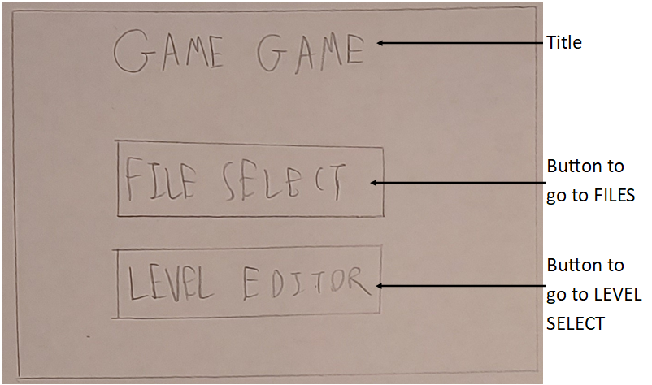
Object | Event | Description
btnFILES | Click | Close HOME and load FILES
btnLEVELS | Click | Close HOME and load LEVEL SELECT

2.9.2 FILES
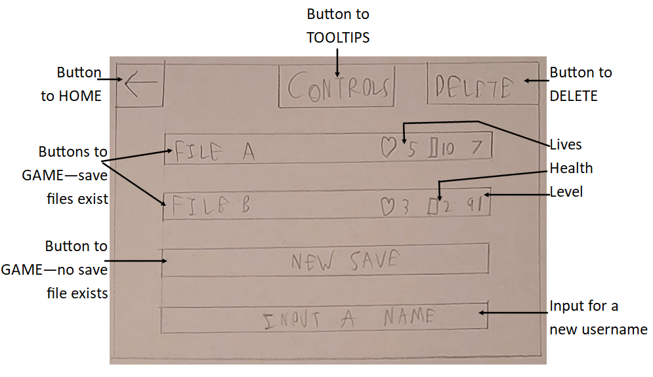
Object | Event | Description
FILES | Load | On load, the form reads the save data file to show the correct information on the file buttons
btnHOME | Click | Close FILES and load HOME
btnTOOLTIPS | Click | Close FILES and load TOOLTIPS
btnDELETE | Click | Close FILES and load DELETE
btnFileA | Click | Close FILES and load GAME, using the first save file’s data
btnFileB | Click | Close FILES and load GAME, using the second save file’s data
btnFileC | Click | Close FILES and load GAME, starting a new save file*
txtName | Typing | Add/Remove characters from the textbox based on what the user types
FILES | Unload | If a new save file needs to be created, use the contents of txtName as the save file’s name
*The three buttons will work differently based on which saves have an active save file. In this case, saves A and B both have saves, whilst C does not.

2.9.3 DELETE
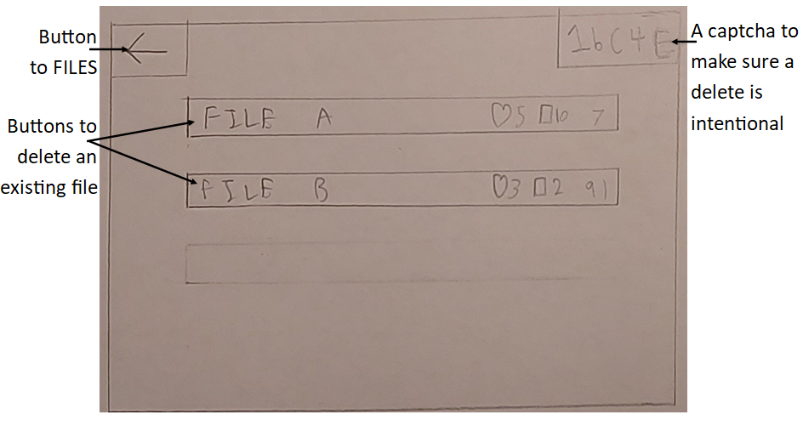
Object | Event | Description
DELETE | Load | On load, reread the save data file to show the correct information for each file. Also, generate a new random captcha from numbers, lowercase, and uppercase letters.
btnFILES | Click | Close DELETE and load FILES
btnFileA | Click | Close DELETE and load FILES, and delete the information for the first save file if the captcha was successful
btnFileB | Click | Close DELETE and load FILES, and delete the information for the second save file if the captcha was successful
txtCaptcha | Typing | Add/Remove characters from the textbox based on what the user types
Because no save data exists for file C in this example, a button to delete file C is not generated. If save data were to exist for file C, then a button would appear in the faint area.

2.9.4 TOOLTIPS
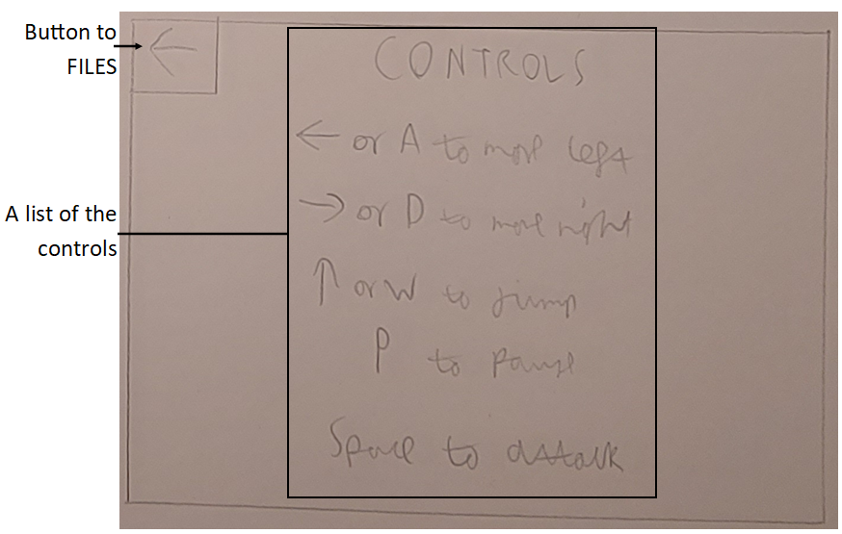
Object | Event | Description
btnFILES | Click | Close TOOLTIPS and load FILES
This form is used just to show the controls for the game/editor. The screen will display different things according to if the form was loaded by FILES – showing the controls for the game – or if the form was loaded by LEVEL SELECT – showing the controls for the editor.

2.9.5 GAME
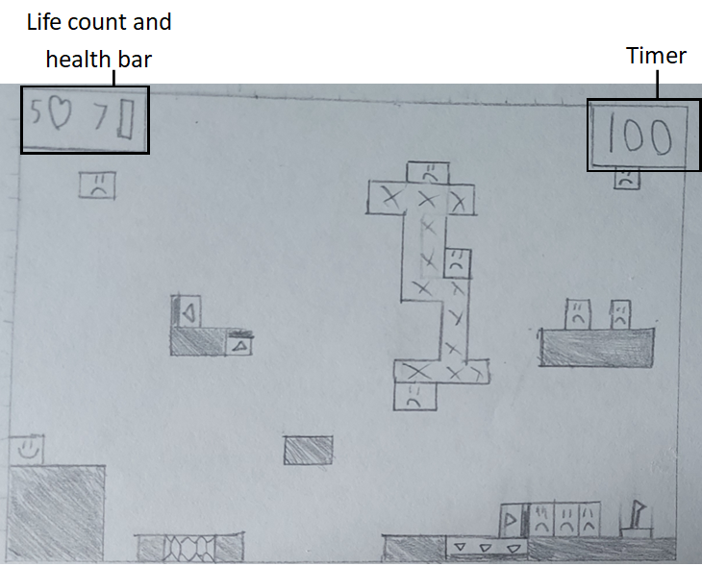
Object | Event | Description
GAME | Load | Based on the passed save file (if from FILES) or the passed level name (if from LEVEL SELECT), load the relevant level.csv file and instantiate all the objects, and initialise the timer to 100 and the health display to show the save file’s information (a custom level will have 1 life and 10 health)
Health Display | Player is damaged | Decrement the value displayed based on how much damage was taken (Healing just increments the counter instead)
Timer | 1 second passes | Decrement the timer display by 1
GAME | The p key was pressed | Load PAUSED – the game logic has stopped, but GAME is still active
GAME | The player dies | If playing a custom level: reload GAME  Otherwise, if on 0 lives: close GAME and load FILES  Otherwise: reload GAME
GAME | The player beats the level | Reload GAME, with either the next level, or the same level if a custom level is being played

2.9.6 PAUSED
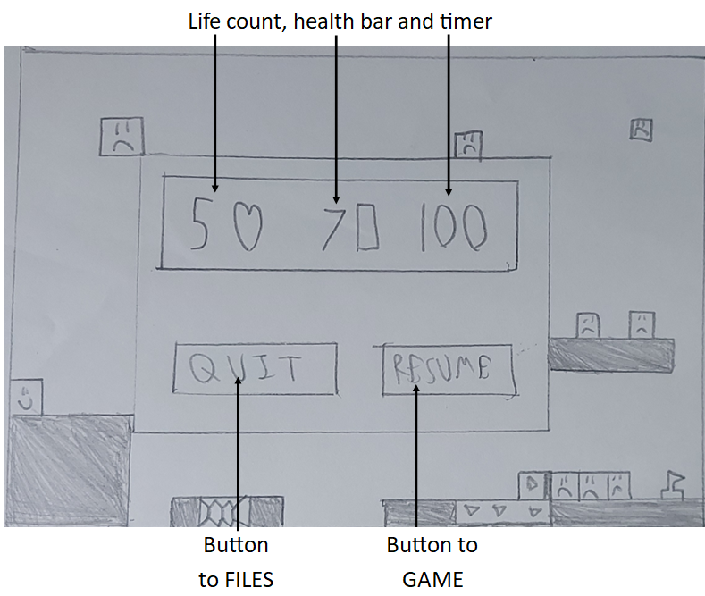
Object | Event | Description
PAUSED | Load | Move the health and timer displays to the centre of the screen
btnFILES | Click | Close PAUSED and GAME and load FILES
btnGAME | Click | Close PAUSED and continue the game logic

2.9.7 LEVEL SELECT
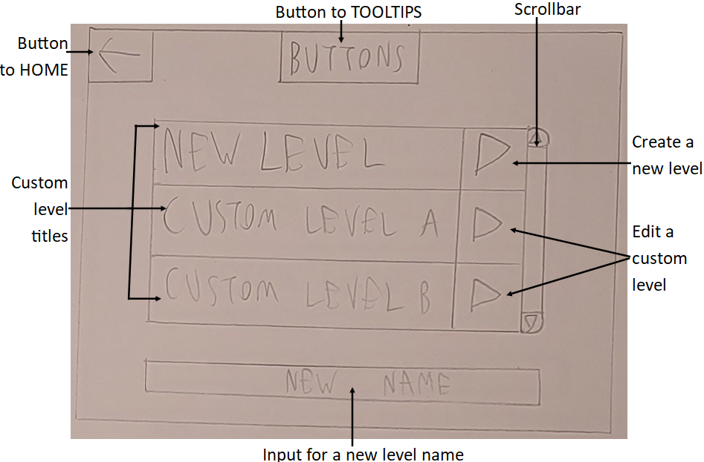
Object | Event | Description
LEVEL SELECT | Load | Open the custom levels folder and create a list of custom levels. If 0, 1, or 2 custom levels exist, don’t create a scrollbar – as there is no need to scroll
btnHome | Click | Close LEVEL SELECT and load HOME
btnTOOLTIPS | Click | Close LEVEL SELECT and load TOOLTIPS
btnNEW | Click | Close LEVEL SELECT and load EDITOR, creating an empty level
btnCustom | Click | Close LEVEL SELECT and load EDITOR, loading that custom level’s csv file*
Scrollbar – Arrow | Click | Scroll up/down by 1 entry
Scrollbar - Body | Click | Jump as far down the list as the click specifies – clicking the middle jumps to the middle
txtName | Typing | Add/Remove characters from the textbox based on what the user types
LEVEL SELECT | Unload | If a new level needs to be created, use the value in txtName as that level’s name
*One button will exist for each custom level file, but they all have the same behaviour: load the respective file in the EDITOR.

2.9.8 EDITOR
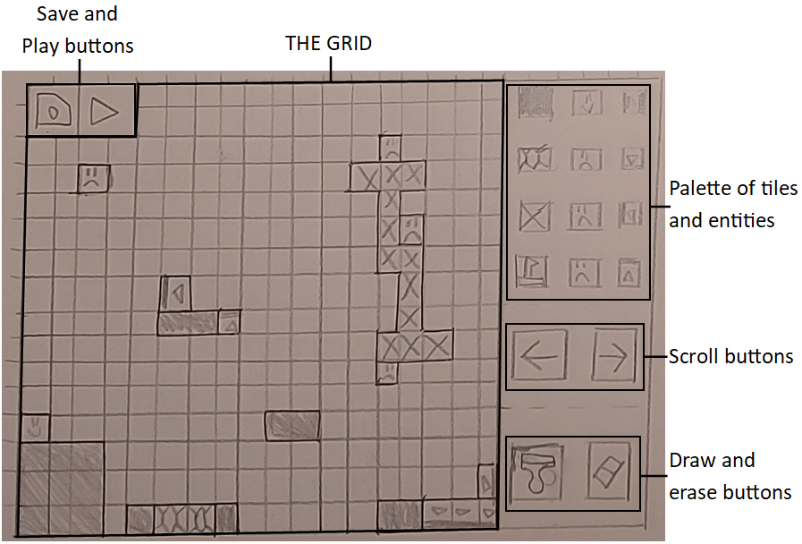
Object | Event | Description
EDITOR | Load | Load the respective level file, drawing each tile to the grid
btnSave | Click | Close EDITOR and load LEVEL SELECT, saving the level in the process
btnPlay | Click | Close EDITOR and load GAME, saving the level and passing the file to GAME
Grid | Click | Effectively one big button which changes to show the level as it is being edited
btnPalette | Click | Change the “tile to draw” variable to the button that was clicked*
btnScroll | Click | Scroll the grid left/right according to which button was pressed*
btnDraw | Click | Change the mode variable to “draw”
btnErase | Click | Change the mode variable to “erase”
*One button will exist for each tile option and each direction of scroll. Their function is the same as the function specified above but they have not been shown to save space.

2.9.9 Implementations

HOME
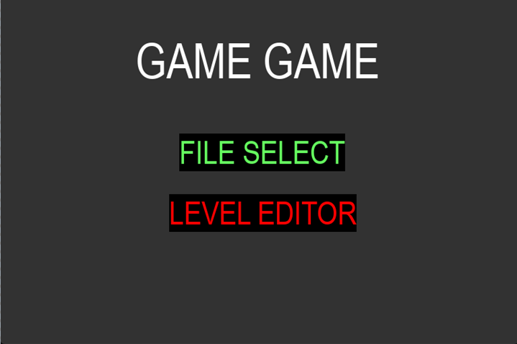
One of the simplest forms in the program. I have chosen a dark background to stay on theme with the game taking place in an evil magic tower. I have chosen bright colours for my text to stand out, with different colours differentiating the sections beyond the text itself. The buttons have a solid black background to clearly indicate the active region of each button.

GAME
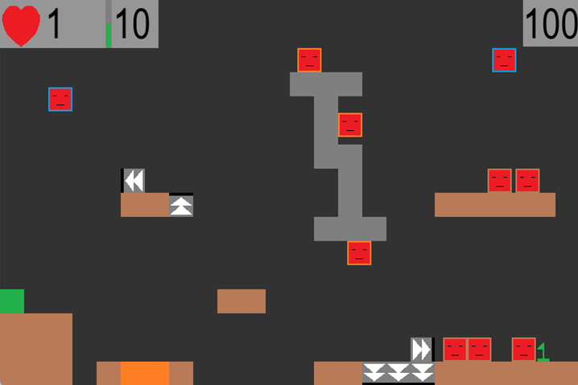
This is an updated implementation of the level shown in 1.5. The enemies have different positions from the example as they have had time to move whilst I was taking a screenshot. The one-way graphic has also been updated as John suggested – they now clearly indicate that motion is allowed in the shown direction, with a solid line indicating that the given side is solid. A lighter grey has been used for the UI elements to separate them from the background, whilst not drawing attention away from the game itself.

EDITOR
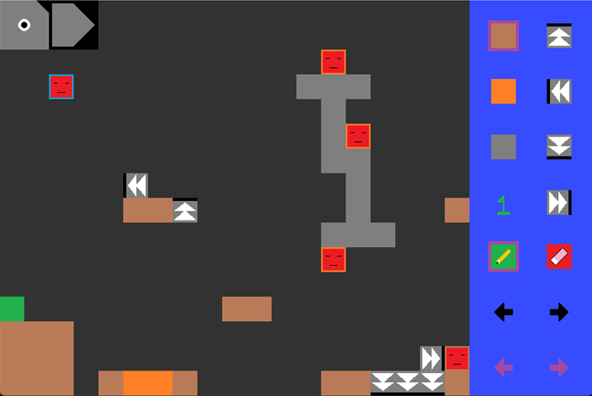
This is just a copy of the above design, but with each enemy having a border colour to indicate their type. The palette in the design was very busy, so I have separated it into three palettes, grouped by type. This is the “tile” palette, with one for “entities” and one for “consumables”. To accommodate the change, I have added purple arrows at the bottom to change palette. The palette section has been made smaller to show more of the grid as a result of less tiles being present on the palette. Another change is the purple borders around the floor tile and the draw mode. These indicate what is the current tile and mode, and will move to provide a reminder of what a click would do.
I have used purple as it stands out on all the background colours, and made the scroll arrows black to differentiate them from the palette change buttons.
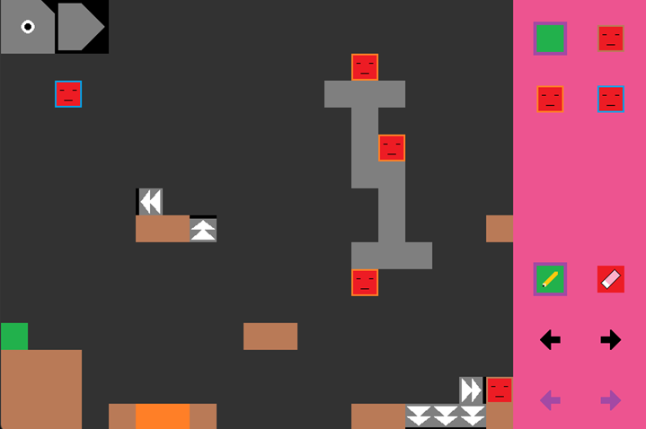
This is the same form, but with the “entities” palette loaded. Pink was used to make it distinct from the “tile” palette’s blue, and the “consumables” palette’s green.

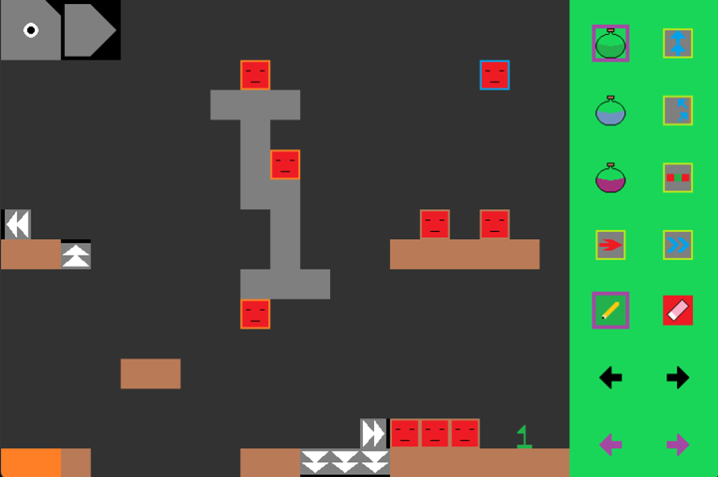
This is the “consumables” palette. By separating into multiple palettes, I can provide more options. The consumables are as follows:
Small Heal (1 health) | Double Jump
Medium Heal (2 health) | Wall Jump
Large Heal (5 health | Double Strike (allows the player to attack on both sides)
Run (doubles max speed) | Dash (allows the player to dash 3 tiles)
The screen has also been scrolled to show the rest of the level.

3 Program

3.1 File Structure
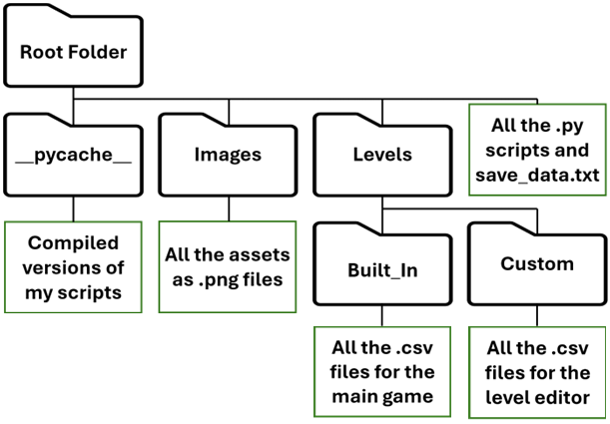

3.2 Drivers

3.2.1 MAIN.py
###IMPORTS###
import pygame
import sys
import glob
###UI Modules###
import Home_Screen_UI
import Files_Screen_UI
import Levels_Screen_UI
import Delete_Screen_UI
import Control_Screen_UI
import Editor_Tip_Screen_UI as ETSUI
import Editor_Screen_UI
from Game_Screen_UI import Game_UI
###Logic Modules###
import GAME
import EDITOR

#A class to display the relevant objects (the driver object)
class Menu_Controller:
def __init__(self):
pygame.init() #Create a window
pygame.display.set_caption("GAME GAME")
self.screen = pygame.display.set_mode((768, 512))
self.clock = pygame.time.Clock()

self.change_screen("#HOME") #Load the home screen
self.game = GAME.Game_Controller(self) #Instantiate the logic modules
self.game_ui = Game_UI(self.game)
self.editor = EDITOR.Editor_Controller(self)
self.editor_ui = Editor_Screen_UI.Editor_UI(self.editor)

#A function to delete a save file
def delete_save(self, args):
for part in self.active_UI: #Find the textbox object
try:
answer = part.get_message()
captcha = part.base_message
except: pass

if(captcha == answer): #Determine if the captcha was correct
file = args[0]

saves = open("save_data.txt", "r").read().split("\n") #If so load the save data
this_save = "new, 5, 10, -1" #Delete the relevant save
saves[file] = this_save

f = open("save_data.txt", "w") #Then store to the file
f.write("\n".join(saves))
f.close()

self.change_screen("#FILES")

#A function to load the platformer
def run_game(self, context, caller):
self.game.load_file(context, caller) #Just load the platformer
self.active_UI = []

#Sets the UI elements and passes "control"
def change_screen(self, target, caller = "Menu"):
if(type(target) is tuple or type(target) is list): #Split the arguments if necessary
args = target[1:]
target = target[0]

match target: #Load the relevant screen
case "#HOME":
self.active_UI = Home_Screen_UI.generate_UI(self.change_screen)
case "#FILES":
self.active_UI = Files_Screen_UI.generate_UI(self.change_screen)
case "#LEVELS":
self.active_UI = Levels_Screen_UI.generate_UI(self.change_screen)
case "#GAME":
self.run_game(args[0], caller)
case "#DELETE":
self.active_UI = Delete_Screen_UI.generate_UI(self.change_screen, self.delete_save)
case "#CONTROLS":
self.active_UI = Control_Screen_UI.generate_UI(self.change_screen)
case "#TIPS":
if(args[0] == "Buttons"): #The editor has two tip screens
self.active_UI = ETSUI.generate_buttons_UI(self.change_screen)
else:
self.active_UI = ETSUI.generate_keybinds_UI(self.change_screen)
case "#NEW GAME":
name = ""
marked_part = None
for part in self.active_UI: #Find the Textbox
try:
name = part.get_message().strip() #And check if a username was passed
marked_part = part
except: pass
if(name == ""): #If not
marked_part.update("Input a name first") #Update the textbox
marked_part.change_focus(True)
return
self.game.new_file(name, args[0]) #Else create a new file
self.run_game(args[0], caller) #And run the game
case "#NEW LEVEL":
name = ""
marked_part = None
for part in self.active_UI: #Same thing as #NEW GAME
try: #Make sure a level name was given
name = part.get_message().strip()
marked_part = part
except: pass
if(name == ""):
marked_part.update("Input a name first")
marked_part.change_focus(True)
return
existing_files = [lvl[14:len(lvl)-4] for lvl in glob.glob('Levels/Custom/*.csv')] #Ensure a level name is unique
if(name in existing_files):
marked_part.update("Input a name first")
marked_part.change_focus(True)
return

self.editor.load(name, new_level = True) #And only load if so
case _: #The default case is to load a
self.editor.load(target) #custom level of the passed name

#A function to monitor for clicks
def click_event(self, mouse_engaged: bool):
mouse_position = list(pygame.mouse.get_pos()) #Determine where the click is
for part in self.active_UI: #And for each object
try: part.clicked(mouse_engaged, mouse_position) #Try to perform clicked function
except: pass #But ignore non buttons

#A function to pass a Textbox keyboard inputs
def listener(self, part, keys):
part.del_timer = max(0, part.del_timer - 1) #Decrement the backpace timer
for key in keys: #Then for each key press
part.listen(key) #Pass the key to the Textbox

#The main driver loop
def in_control(self):
'''
On loop:
Display the active elements
Manage UI
'''
self.running = True
pause_started = False
mouse_down = False
while self.running: #MAINLOOP
key_buffer = []
for event in pygame.event.get(): #For each pygame event
if(event.type == pygame.MOUSEBUTTONDOWN): #If the left mouse is down
if(event.button == 1):
mouse_down = True #Flag mouse as down
self.click_event(mouse_down) #Run click event
if(event.type == pygame.MOUSEBUTTONUP): #If the left mouse is up
if(event.button == 1):
mouse_down = False #Flag mouse as up
self.click_event(mouse_down) #Run click event
if(event.type == pygame.KEYDOWN): #If a key was pressed
key_buffer.append(pygame.key.name(event.key)) #Add to the buffer
if(event.type == pygame.QUIT): #If the game was exited
pygame.display.quit() #Close the game
sys.exit()

self.screen.fill((50,50,50)) #Clear the screen

if(self.game.running): #If the game is running
if(not self.game.paused): #And unpaused
self.game_ui.generate_main_ui() #Load the unpaused UI
self.active_UI = self.game_ui.main_UI
pause_started = False
elif(not pause_started): #Else if paused and it is the first pause frame
self.game_ui.generate_pause_ui() #Load the paused UI
self.active_UI = self.game_ui.pause_UI
pause_started = True
self.game.run_frame() #Then run the game

if(self.editor.active): #If the editor is active
self.editor.run_frame(mouse_down) #Monitor for mouse presses
self.active_UI = self.editor_ui.assemble() #And load the relevant UI

for part in self.active_UI: #For each UI element
part.draw(self.screen) #Overlay it
try:
part.listen("") #Then "listen" if it is a Textbox
self.listener(part, key_buffer)
except: pass

pygame.display.flip() #Draw to the screen

self.clock.tick(60) #Then tick 1 60th of a second

if __name__ == "__main__": #Only run if this file was the initial file
controller = Menu_Controller() #Instantiate the controller
controller.in_control() #And begin the driver code

3.2.2 GAME.py
###IMPORTS###
###Assets###
from Sprite import Sprite
import Crawler
import Flyer
import Walker
import Platforms as P
import Player
import Consumables as C
###Premade functions
import csv
import pygame
import time
import glob

#A class to store the methods and variables needed to run the platformer
class Game_Controller:
def __init__(self, menu_control):
self.main_menu = menu_control
self.file = None
self.running = False
self.paused = False
self.pause_latch = False
self.sent_from = "Menu"
self.max_level = len(glob.glob('Levels/Built_In/*.csv')) #Determines the number of levels that exist

#A function to create a new save
def new_file(self, name, file: int):
saves = open("save_data.txt", "r").read().split("\n") #Load the save files
this_save = f"{name}, 5, 10, 1" #Update the relevant row
saves[file] = this_save

f = open("save_data.txt", "w") #Then rewrite to the file
f.write("\n".join(saves))
f.close()

#Auxiliary function to free up memory
def clear_game(self):
self.grid = None
self.graph_info = None
self.tiles = None
self.flag = None
self.tile_colliders = None
self.player = None
self.crawlers = None
self.flyers = None
self.walkers = None
self.hitboxes = []

#A function to load a level
def load_file(self, file, sent_from: str):
self.sent_from = sent_from
self.clear_game()
self.scroll = 0

#Loading screen
self.main_menu.screen.fill((0,0,0)) #Fill the screen with black
pygame.display.flip()
time.sleep(1) #And stall for 1 second

self.file = file
self.running = True
self.paused = False

#Load File
if(self.sent_from == "Menu"): #Loads a built_in level
this_save = open("save_data.txt", "r").read().split("\n")[file]
player_info = [int(x) for x in this_save.split(", ")[1:3]]
this_level = this_save.split(", ")[3]
if(int(this_level) > 100):
this_level = 100
print("Congratulations, you have beaten Game Game :D”)
level_file = f"Levels/Built_In/{this_level}.csv"
else: #Loads a custom level
player_info = [1, 10]
level_file = f"Levels/Custom/{file}.csv"

#Read Level File
with open(level_file, "r") as lvlfile: #Actually read the level file
csv_reader = csv.reader(lvlfile)
row_data = [row for row in csv_reader]

#Gridify
to_generate = {"Player":[], "Flag":[], #Create a dictionary for each object
"Crawler":[], "Walker":[], "Flyer":[],
"Floor":[], "Honey":[], "Spike":[],
"Uway":[], "Dway":[], "Lway":[], "Rway":[],
"SHeal":[], "MHeal":[], "LHeal":[],
"DJump":[], "WJump":[], "DStrike":[],
"Run":[], "Dash":[]}
self.grid = [[""]*len(row_data[0]) for i in range(len(row_data))] #And a blank array for the grid
for y,row in enumerate(row_data): #For each tile
for x,tile in enumerate(row):
if(tile == "Start"): continue #Ignore non_solid objects
if(tile != ""): to_generate[tile].append((x,y))
if(tile in ["Player","Flag","Crawler","Walker","Flyer"]): #Treat the entities as non_solid objects
tile = ""
self.grid[y][x] = tile #Store the platform type to the grid
level_bound = len(self.grid[0]) * 32
self.camera_edge = level_bound - 768

ROWS = len(self.grid) #Set and group these constants for later use
COLS = len(self.grid[0])
self.graph_info = (ROWS, COLS)

#GENERATE OBJECTS - Tiles, Entities
img_dict = {}
for filename in [image[7:] for image in glob.glob('Images/*')]: #For each image file
this_img = pygame.image.load(f"Images/{filename}").convert_alpha() #Load the image
img_dict[filename[:-4]] = this_img #And store to the dictionary

##TILES
self.tiles = []
for position in to_generate["Floor"]: #For each floor:
true_position = [position[0] * 32, position[1] * 32] #Find the in game position
new_floor = P.Std_Platform(true_position, img_dict["Floor"]) #Instantiate an object
self.tiles.append(new_floor) #Store to the list

for position in to_generate["Honey"]: #Repeat for each honey tile
true_position = [position[0] * 32, position[1] * 32]
new_honey = P.Honey_Platform(true_position, img_dict["Honey"])
self.tiles.append(new_honey)

for position in to_generate["Spike"]: #And for each spike
true_position = [position[0] * 32, position[1] * 32]
new_spike = P.Spike_Platform(true_position, img_dict["Spike"])
self.tiles.append(new_spike)

for position in to_generate["Uway"]: #And for each upwards one_way
true_position = [position[0] * 32, position[1] * 32]
new_uway = P.One_Way_Platform(true_position, img_dict["Oway"], "down")
self.tiles.append(new_uway)

for position in to_generate["Dway"]: #And do mostly the same for downwards one_ways
true_position = [position[0] * 32, position[1] * 32]
img = pygame.transform.rotate(img_dict["Oway"], 180) #Just rotating the one_way image accordingly
new_dway = P.One_Way_Platform(true_position, img, "up")
self.tiles.append(new_dway)

for position in to_generate["Lway"]: #Repeat the new method for left one_ways
true_position = [position[0] * 32, position[1] * 32]
img = pygame.transform.rotate(img_dict["Oway"], 90)
new_lway = P.One_Way_Platform(true_position, img, "right")
self.tiles.append(new_lway)

for position in to_generate["Rway"]: #And then for right one_ways
true_position = [position[0] * 32, position[1] * 32]
img = pygame.transform.rotate(img_dict["Oway"], 270)
new_rway = P.One_Way_Platform(true_position, img, "left")
self.tiles.append(new_rway)

flag_position = (to_generate['Flag'][0][0] * 32, to_generate['Flag'][0][1] * 32) #Determine where the flag is
self.flag = P.Flag(flag_position, img_dict["Flag"]) #And instantiate the flag object
self.tiles.append(self.flag) #Then add to the list

self.tile_colliders = [pygame.Rect(tile.position, tile.size) for tile in self.tiles] #Then create a collider for all the tiles

##ENTITIES
player_pos = [to_generate["Player"][0][0] * 32, to_generate["Player"][0][1] * 32] #Determine where the player is
lives = player_info[0] #And the lives/health
health = player_info[1]
self.player = Player.Player(player_pos, img_dict["Player"], lives, health, level_bound) #Instantiate the Player object

self.crawlers = []
for position in to_generate["Crawler"]: #For each Crawler:
true_position = [position[0] * 32, position[1] * 32] #Find the in_game position
new_crawler = Crawler.Crawler(true_position, img_dict["Crawler"], self.grid) #Then instantiate the Crawler
try:
if(new_crawler.destroy_flag): continue #This is a check to remove trapped/floating crawlers
except:
pass
self.crawlers.append(new_crawler) #Then add to the crawler list

self.flyers = []
for position in to_generate["Flyer"]: #Repeat for all flyers
true_position = [position[0] * 32, position[1] * 32]
new_flyer = Flyer.Flyer(true_position, img_dict["Flyer"], self.player)
self.flyers.append(new_flyer)

self.walkers = []
for position in to_generate["Walker"]: #And then for all walkers
true_position = [position[0] * 32, position[1] * 32]
new_walker = Walker.Walker(true_position, img_dict["Walker"], self.player, level_bound)
self.walkers.append(new_walker)

##CONSUMABLES/MODS
self.consumables = []
heal_amounts = [1,2,5]
for x, heal in enumerate(["SHeal", "MHeal", "LHeal"]): #For each heal type
for position in to_generate[heal]: #For each instance of that type
true_position = [position[0] * 32, position[1] * 32] #Find the in game position
new_heal = C.Heal(true_position, img_dict[heal], self.player, heal_amounts[x]) #Instantiate a Heal object
self.consumables.append(new_heal) #And add to the list

for upgrade in ["DJump", "WJump", "DStrike", "Run", "Dash"]: #Then repeat for each upgrade type
for position in to_generate[upgrade]:
true_position = [position[0] * 32, position[1] * 32]
new_upgrade = C.Upgrade(true_position, img_dict[upgrade], self.player, upgrade)
self.consumables.append(new_upgrade)

self.timer = 6060 #100 second level with 1 grace second

#The driver code for the game controller
def run_frame(self):
keys = pygame.key.get_pressed() #Determine what keys were pressed

##Pause logic
if(keys[pygame.K_p]): self.pause_latch = True #Perform the pause latch
else:
if(self.pause_latch):
self.paused = not self.paused #Changing state if necessary
self.pause_latch = False

self.draw_game() #Always draw the game
if(self.paused): return #And end the frame early if paused

##Move
movementKeys = (keys[pygame.K_UP] or keys[pygame.K_w], #Check the movement keys
keys[pygame.K_LEFT] or keys[pygame.K_a],
keys[pygame.K_RIGHT] or keys[pygame.K_d],
keys[pygame.K_LSHIFT] or keys[pygame.K_RSHIFT])
self.movement(movementKeys) #Then perform movement for all entities

##Level clear check
if(self.flag.complete): #Check if the level flag was hit
self.draw_game() #Make sure the player can see they hit the flag
if(self.sent_from == "Menu"): #If actually playing the game
self.save_to_file(self.player.lives, self.player.health, level_shift = 1) #Progress to the next level
self.forced_draw()
time.sleep(1)
self.load_file(self.file, self.sent_from) #Then load the file again
return #Ending the frame early

##Timer check
self.timer -= 1 #Decrement the timer
if(self.timer <= 0): #If timer falls to 0
self.player.lives -= 1 #Lose a life
self.reset(False) #And reset
return #Ending the frame early

##Consumable logic
self.resolve_consumables() #Perform the function

##Attack logic
attacks = self.gather_attacks(keys[pygame.K_SPACE]) #Gather all the attacks
self.resolve_attacks(attacks) #And then resolve them

##Hitbox logic
to_destroy = []
for x, hitbox in enumerate(self.hitboxes): #For each hitbox to draw
hitbox.timer -= 1 #Reduce its timer
if(hitbox.timer < 0): #Flagging hitboxes with a timer < 0
to_destroy.insert(0, x)
else:
hitbox.draw(self.main_menu.screen) #And drawing the others
for index in to_destroy: #Then for each flagged hitbox
this_hitbox = self.hitboxes.pop(index) #Remove the reference
del this_hitbox #Then delete the object

##Update FSMs
fsms = [f.fsm for f in self.flyers] + [w.fsm for w in self.walkers] #Group the objects with FSM's
for fsm in fsms: fsm.change_state() #And update their state

##On_screen checks
self.on_screen() #Finally, check which objects are on screen

#A function to draw the game
def draw_game(self):
visible_tiles = [tile for tile in self.tiles if tile.on_screen] #Determine which tiles are visisble
entities = self.consumables + self.crawlers + self.flyers
entities = entities + self.walkers + [self.player] + [self.flag]
visible_entities = [entity for entity in entities if entity.on_screen] #And which entities are visible

for visible in visible_tiles: #Draw the visible tiles
visible.draw(self.main_menu.screen, self.scroll)

for visible in visible_entities: #Then for each visible entitiy
try:
if((visible.invulnerable // 5) % 2 == 1): continue #Flash if invulnerable
except: pass
visible.draw(self.main_menu.screen, self.scroll) #Else draw

#A function to force the screen to update mid frame
def forced_draw(self):
self.main_menu.screen.fill((50,50,50)) #Clear the screen
self.draw_game() #Draw the game
pygame.display.flip() #Then show it

#A function to run the movement function of each entity
def movement(self, player_keys: list):
self.player.controller(player_keys, self.tiles, self.tile_colliders)
for crawler in self.crawlers: crawler.logic(self.tile_colliders)
for walker in self.walkers: walker.logic(self.grid, self.tiles, self.tile_colliders)
for flyer in self.flyers: flyer.interpret_fsm(self.grid, self.graph_info)

#A function to determine what consumables have been touched by the player
def resolve_consumables(self):
touched = []
for x, consumable in enumerate(self.consumables): #For each consumable
if(consumable.touch_check()): #Flag the ones which were touched
touched.insert(0, x)

for deletion in touched: #Then for each flagged object
target = self.consumables.pop(deletion) #Remove any reference to the object
del target #And delete the object

#A function to gather the attacks of all combatant objects
def gather_attacks(self, player_key: bool) -> list:
attacks = []
if(player_key): attacks = self.player.attack(attacks, facing = self.player.facing) #If the player attacks, run the player attack
for crawler in self.crawlers: #For each crawler
attacks = crawler.attack(attacks) #Try to attack
for flyer in self.flyers: #For each flyer
attacks = flyer.attack(attacks) #Try to attack
for walker in [w for w in self.walkers if w.fsm.current_state == "attacking"]: #For each attacking walker
attacks = walker.attack(attacks, facing = walker.facing) #Try to attack
return attacks

#A function to actually deal damage and remove dead objects
def resolve_attacks(self, attack_list: list):
enemies = self.walkers + self.flyers + self.crawlers #Group the enemy type objects
dead_list = []
for packet in attack_list: #Packet format: Hitbox, Attacker
hitbox = packet[0]
attacker = packet[1]
damage = attacker.weapon_damage
player_team = attacker.is_player_team
draw_hitbox = attacker.draw_hitbox

if(draw_hitbox): #If the hitbox is to be drawn
position = (hitbox.left - self.scroll, hitbox.top) #Determine its position
image = pygame.Surface((hitbox.width, hitbox.height)) #Create a red square
image.fill((255,0,0))
new_hitbox = Sprite(position, image) #Instantiate a Sprite object
new_hitbox.timer = 6 #Start a 6 frame counter
self.hitboxes.append(new_hitbox) #And save to the hitbox list

if(player_team): attackable = enemies #Prevent enemies hurting enemies
else: attackable = [self.player]

for opponent in attackable: #For each opponent
collider = pygame.Rect(opponent.position, opponent.size) #Create their collider
if(not pygame.Rect.colliderect(collider, hitbox)): continue #Test for a collision

is_dead = opponent.damaged(damage) #Deal damage
if(is_dead): dead_list.append(opponent) #And if dead, flag

for combatant in enemies + [self.player]: #For each combatant
combatant.invulnerable = max(combatant.invulnerable - 1, 0) #Decrement their invulnerable timer
combatant.locked = max(combatant.locked - 1, 0) #And decrement their attack lock timer

if(self.player.position[1] > 512): self.reset(True) #If the player is off_screen, reset
if(self.player.health <= 0): self.reset(False) #If the player is dead, reset

for dead in dead_list: #For each dead object, remove all references
for x, flyer in enumerate(self.flyers):
if(flyer != dead): continue
del self.flyers[x]
for x, walker in enumerate(self.walkers):
if(walker != dead): continue
del self.walkers[x]
for x, crawler in enumerate(self.crawlers):
if(crawler != dead): continue
del self.crawlers[x]
if(self.player == dead):
self.reset(False) #Don't delete the player, just reset
break
del dead #Then delete the object

#A function to update a save file
def save_to_file(self, lives: int, health: int, level_shift = 0):
saves = open("save_data.txt", "r").read().split("\n") #Read the relevant file
this_save = saves[self.file].split(", ")

level = int(this_save[3]) + level_shift
if(level > self.max_level): #Stop the game from loading a
print("Congratulations, you have beaten GAME GAME :D") #non_existant level (the game has been beaten)
level = int(this_save[3])

alternate_save = [this_save[0], str(lives), str(health), str(level)] #Group the updated save info
saves[self.file] = ", ".join(alternate_save)

f = open("save_data.txt", "w") #Then save to the file
f.write("\n".join(saves))
f.close()

#A function to reset the level
def reset(self, screen_death: bool):
self.forced_draw() #Force the game to draw
def silly(shift: int): #Auxiliary function to just play an animation
self.player.move(0,shift)
self.forced_draw()
time.sleep(0.01)

self.running = False #Stop running the game
if(screen_death): #Determine which type of death happened
self.player.lives -= 1 #In off screen, the player loses a life
self.player.position[1] = 480 #Reposition the player
self.forced_draw() #Prevent smearing of the player
toRise = 0
toFall = 32
else:
toRise = 16
toFall = (544 - self.player.position[1]) // 4

time.sleep(1) #Pause to let player reflect
for a in range(toRise): #Then play the animation
silly(-2)
for b in range(toFall):
silly(4)
time.sleep(1)

if(self.sent_from == "Editor"): #Reload the level if sent from the editor
self.load_file(self.file, self.sent_from)
return

if(self.player.lives <= 0): #Else check for a game over
self.save_to_file(5, 10) #Reseting the lives and health if so
self.main_menu.change_screen("#HOME") #And sending back to the home screen
return

self.save_to_file(self.player.lives, 10) #Otherwise save and reset
self.load_file(self.file, self.sent_from)

#A function to determine which objects are on screen
def on_screen(self):
margin = [self.scroll + 128, self.scroll + 640] #Determine the margins of the screen
left_conditions = self.player.facing == "left" and self.scroll > 0 #Determine if a left scroll is possible
if(self.player.position[0] < margin[0] and left_conditions): #If moving into the left margin
self.scroll = max(0,self.player.position[0] - 128) #Scroll as far left as possible

right_conditions = self.player.facing == "right" and self.scroll < self.camera_edge #Determine if a right scroll is possible
if(self.player.position[0] > margin[1] and right_conditions): #If moving into the right margin
self.scroll = min(self.camera_edge, self.player.position[0] - 640) #Scroll as far right as possible

screen_bounds = [self.scroll - 128, self.scroll + 896] #Determine the bounds of the screen
objects = self.tiles + [self.flag] + [self.player] #Group all the objects
objects = objects + self.crawlers + self.flyers + self.walkers
for obj in objects: #For each object
if(obj.position[0] < screen_bounds[0] or obj.position[0] > screen_bounds[1]): #Check if on screen
obj.on_screen = False
else: obj.on_screen = True

3.2.3 EDITOR.py
###IMPORTS###
from Sprite import Sprite
import pygame
from Common_Functions import click_in_bounds
###Premade functions###
import glob
import csv

#A class to control what the editor is doing
class Editor_Controller:
def __init__(self, menu_control):
self.main_menu = menu_control

border_img = pygame.image.load('Images/Border.png').convert_alpha() #Load the border image
focusA = Sprite((632,26), border_img) #Instantiate sprites for the focuses
focusB = Sprite((632,312), border_img) #-These identify what tile and mode is selected
self.focuses = [focusA, focusB]

self.positions = {}
self.img_dict = {}
for filename in [image[7:] for image in glob.glob('Images/*')]: #For each image file
this_img = pygame.image.load(f"Images/{filename}").convert_alpha() #Load the image
self.img_dict[filename[:-4]] = this_img #And store to the dictionary
variants = ["R","U","L","D"]
for i, var in enumerate(variants): #Rotate the Oway image to produce the individual one-way platforms
degrees = -90 + 90 * i #Determine the rotation amount
rotated = pygame.transform.rotate(self.img_dict["Oway"], degrees)
self.img_dict[f"{var}way"] = rotated

self.active = False #Not active on initial load

#A function to prepare a new csv file
def new_file(self, name: str):
temp_grid = [[""] * 240 for x in range(16)] #Create a max_size blank grid
with open(f"Levels/Custom/{name}.csv", "w", newline='') as newfile: #Then write to the csv file
writer = csv.writer(newfile)
writer.writerows(temp_grid)

#A function to initialise the variables
def load(self, file, new_level = False):
if(new_level): #Create a file for a new level
self.new_file(file)
self.file = file

self.shift_focus((632,26), 0) #Reset the tile and move
self.shift_focus((632,312), 1)
self.mode = "Draw"
self.tile = "Floor"

self.scroll = 0
self.active = True
self.player_pos = None #Must have 1 player
self.flag_pos = None #and 1 flag
self.previous_position = [-1,-1]
self.grid = [[""] * 240 for x in range(16)] #Create a grid for 10 screens of level <- for fast lookup
with open(f"Levels/Custom/{self.file}.csv", "r") as lvlfile: #Load the relevant file
csv_reader = csv.reader(lvlfile)
row_data = [row for row in csv_reader]
for y, row in enumerate(row_data): #Then add to the grid
for x, tile in enumerate(row):
self.grid[y][x] = tile
if(tile == "Player"): #Flagging the player and flag if they exist
self.player_pos = (x, y)
elif(tile == "Flag"):
self.flag_pos = (x, y)

self.objects = [[None] * 240 for x in range(16)] #Create an array to store the objects <- for drawing
for y, row in enumerate(self.grid): #Instantiate a Sprite for each tile
for x, tile in enumerate(row):
if(tile == "Start"): continue #Ignore the air tiles
if(tile == ""): continue
new_pos = (x * 32, y * 32) #Determine the actual position
new_img = self.img_dict[tile] #And the relevant image
new_obj = Sprite(new_pos, new_img) #Then instantiate
if(new_pos[0] > 576): new_obj.on_screen = False #Flag as off_screen if off screen
self.objects[y][x] = new_obj #Store to the array

self.hide_latch = False #A set of latches used for the keybinds
self.hidden = False

self.mode_latch = False
self.erase_latch = False
self.draw_latch = False

self.tiles_latch = False
self.entity_latch = False
self.mods_latch = False

self.left_latch = False
self.right_latch = False

self.palette = "Tiles" #Initialise the palette to Tiles
self.p_pointer = 0

#A function to save the file and change screen
def unload(self, mode: list):
self.active = False #Deactivate
if(self.grid[0][0] == ""): #Ensure the first tile has a value (quirk of .csv format)
self.grid[0][0] = "Start"

#Trim empty columns (save space)
empty_cols = [True] * 240
for row in self.grid: #Loop through each tile to see which columns are empty
for x, tile in enumerate(row):
if(tile != ""):
empty_cols[x] = False
continue

max_x = 24 #Ensure at least 1 screen exists
for pos in range(239, 23, -1): #Loop through each column (from the right)
if(empty_cols[pos]): continue #And find the first non_empty column
max_x = pos + 1 #Flag the first non_empty column
break

to_save = []
for row in self.grid:
to_save.append(row[:max_x]) #Slice each row to the size determined

with open(f"Levels/Custom/{self.file}.csv", "w", newline='') as newfile: #Then actually save
writer = csv.writer(newfile)
writer.writerows(to_save)

if(mode[0] == "Save"): #If just saving:
self.main_menu.change_screen("#LEVELS") #Change the screen to the Level Select screen
elif(self.player_pos is None or self.flag_pos is None): #Prevent testing a level without a player/flag
print("You need a flag and a player") #Feedback to the player the error
self.active = True #Reactivate
else:
self.main_menu.change_screen(("#GAME",self.file), "Editor") #Play the level, telling the GAME object to return to the editor

#A function to change the position of a focus
def shift_focus(self, position, focus):
self.focuses[focus].position = position #Just move the relevant focus
self.previous_position = [-1,-1] #And declare the last click as offscreen (used later)

#A function to change the mode of the editor
def change_mode(self, new_mode: str):
self.mode = new_mode #Set the mode
if(new_mode == "Erase"): #Then shift the focus accordingly
self.shift_focus((704,312), 1)
else:
self.shift_focus((632,312), 1)
self.previous_position = [-1,-1] #And declare the last click as offscreen

#A function to scroll the editor
def change_scroll(self, amount: int):
self.scroll += amount #Move
self.scroll = max(0, self.scroll) #Make sure we're not negative
if(self.hidden): #If the palette is hidden:
self.scroll = min(216, self.scroll) #Can't scroll past 9 screens
shift = 23 #There are 24 tiles on screen
else:
self.scroll = min(221, self.scroll) #Can't scroll past 9 screens and 5 tiles
shift = 18 #There are19 tiles on screen

bounds = (self.scroll, self.scroll + shift) #Determine what x positions are on screen
for y in range(16): #Loop through each coordinate
for x in range(240):
obj = self.objects[y][x]
if(obj is None): continue #Ignoring empty tiles

if(x < bounds[0] or x > bounds[1]): #Flag off screen objects as off_screen
obj.on_screen = False
else:
obj.on_screen = True #And on screen objects as on_screen

#An interface function between the palette and the editor
def btn_clicked(self, button):
action = button[0]
match action: #Determine the button clicked and perform its action
case "Draw": self.change_mode("Draw")
case "Erase": self.change_mode("Erase")
case "Left": self.change_scroll(-1)
case "Right": self.change_scroll(1)
case "LPalette": self.change_palette(-1)
case "RPalette": self.change_palette(1)
case _: #In this case we are drawing a tile
self.tile = action #So update the tile selected
self.shift_focus(self.positions[action], 0) #And shift focus accordingly

#A function to check the existance of the player/flag when the grid changes
def revoke_core_objects(self, hovered_tile):
if(hovered_tile == "Player"): #The tile updated contained the player
self.player_pos = None
elif(hovered_tile == "Flag"): #The tile updated contained the flag
self.flag_pos = None

#The function to keep the grid up to date
def modify_grid(self):
mouse_position = list(pygame.mouse.get_pos()) #Deterime where the mouse is

right_side = 607 #Determine where the right side of the screen is
if(self.hidden): #More screen available when the palette is hidden
right_side = 767

if(not click_in_bounds(mouse_position, [0, right_side, 0, 511])): return #Check if the mouse is on_screen (ignores palette)
if(click_in_bounds(mouse_position, [0, 127, 0, 63]) and not self.hidden): #Ignore if the player is trying to save/play
return

current_position = [mouse_position[x] // 32 for x in range(2)] #Convert mouse_position to grid indices
current_position[0] += self.scroll #And adjust to scroll
if(current_position == self.previous_position): return #Only consider new clicks
self.previous_position = current_position

hovered_tile = self.grid[current_position[1]][current_position[0]] #Then update the relevant tile
self.revoke_core_objects(hovered_tile) #Check if the flag/player was overwritten
if(self.mode == "Erase"): #Erase if in erase mode
self.grid[current_position[1]][current_position[0]] = ""
self.objects[current_position[1]][current_position[0]] = None #Garbage collection will delete an overwritten object
else: #Draw if in draw mode
self.grid[current_position[1]][current_position[0]] = self.tile #Set the grid to store the tile
new_pos = (current_position[0] * 32, current_position[1] * 32) #Determine the true position
new_img = self.img_dict[self.tile] #And image
new_obj = Sprite(new_pos, new_img) #To Instantiate a Sprite of the tile
self.objects[current_position[1]][current_position[0]] = new_obj #Then store to the object array
if(self.tile == "Player"): #Then flag the player
if(self.player_pos is not None): #Only allow one player at a time
self.grid[self.player_pos[1]][self.player_pos[0]] = "" #So erase a duplicate
self.objects[self.player_pos[1]][self.player_pos[0]] = None
self.player_pos = current_position #Perform the flagging
elif(self.tile == "Flag"): #Repeat for the flag
if(self.flag_pos is not None):
self.grid[self.flag_pos[1]][self.flag_pos[0]] = ""
self.objects[self.flag_pos[1]][self.flag_pos[0]] = None
self.flag_pos = current_position

#A function to actually run the editor each frame
def run_frame(self, mouse_down):
self.shortcuts() #Check if any shortcuts/keybinds were used
if(mouse_down): self.modify_grid() #Then update the grid if the mouse is down

visible = []
for row in self.objects: #Flag all the on_screen objects
for obj in row:
if(obj is None): continue
if(not obj.on_screen): continue
visible.append(obj)
for vis in visible: #Then draw the on_screen objects
vis.draw(self.main_menu.screen, self.scroll * 32)

#A function to check if the player is using any shortcuts
def shortcuts(self): #No logic, just latching
keys = pygame.key.get_pressed() #Get a list of all keys pressed this frame

if(keys[pygame.K_h]): self.hide_latch = True #Hide/show the save and play buttons as well as the palette
else:
if(self.hide_latch): self.hide_buttons(not self.hidden)
self.hide_latch = False

if(keys[pygame.K_m]): self.mode_latch = True #Alternate the mode
else:
if(self.mode_latch):
if(self.mode == "Draw"): self.change_mode("Erase")
else: self.change_mode("Draw")
self.mode_latch = False

if(keys[pygame.K_e]): self.erase_latch = True #Set mode to Erase
else:
if(self.erase_latch): self.change_mode("Erase")
self.erase_latch = False

if(keys[pygame.K_d]): self.draw_latch = True #Set mode to Draw
else:
if(self.draw_latch): self.change_mode("Draw")
self.draw_latch = False

if(keys[pygame.K_1]): self.tiles_latch = True #Change palette to the Tiles palette
else:
if(self.tiles_latch): self.change_palette("Tiles")
self.tiles_latch = False

if(keys[pygame.K_2]): self.entity_latch = True #Change palette to the Entitites palette
else:
if(self.entity_latch): self.change_palette("Entities")
self.entity_latch = False

if(keys[pygame.K_3]): self.mods_latch = True #Change palette to the Mods palette
else:
if(self.mods_latch): self.change_palette("Mods")
self.mods_latch = False

if(keys[pygame.K_LEFT]): self.left_latch = True #Scroll left
else:
if(self.left_latch): self.change_scroll(-1)
self.left_latch = False

if(keys[pygame.K_RIGHT]): self.right_latch = True #Scroll right
else:
if(self.right_latch): self.change_scroll(1)
self.right_latch = False

#A function to adjust the screen when hidden
def hide_buttons(self, new_state):
self.hidden = new_state #Update the hide flag
if(self.scroll == 221 and self.hidden): #If hiding and at the end of the file
self.change_scroll(-5) #Move forward 5 tiles
elif(self.scroll == 216 and not self.hidden): #If unhiding and at the end of the file
self.change_scroll(5) #Move back 5 tiles
else:
self.change_scroll(0) #Make sure that tiles behind the palette are revealed

#A function to change the palette
def change_palette(self, target):
self.hide_buttons(False) #Unhide the buttons
palettes = ["Tiles", "Entities", "Mods"] #A list of palette options
palette_primaries = ["Floor", "Player", "SHeal"] #A list of the first tile in each palette
if(type(target) is str): #If directly updating (the target is known)
self.palette = target #Update the palette
self.p_pointer = palettes.index(target) #And move the pointer
else: #Else you're "scrolling" the palettes
self.p_pointer += target #Determine the next palette
self.p_pointer = self.p_pointer % 3
self.palette = palettes[self.p_pointer] #And update accordingly
self.tile = palette_primaries[self.p_pointer] #Update the selected tile to reflect the palette
self.shift_focus(self.positions[self.tile], 0) #Then shift focus accordingly

3.3 Assets

3.3.1 Sprite.py
#The base class of all visual elements
#stores the information needed to draw the object to the correct part of the screen
class Sprite:
def __init__(self, position: tuple, image):
self.position = list(position) #Position refers to the top-left corner
self.image = image
self.size = (self.image.get_width(), self.image.get_height()) #Size should reflect the image size in pixels
self.on_screen = True

#Function to draw the Sprite onto a surface (typically the screen)
def draw(self, surface, shift = 0):
relative_position = [self.position[0] - shift, self.position[1]] #Adjust the image position if necessary
surface.blit(self.image, relative_position) #Then draw

3.3.2 Platforms.py
###IMPORTS###
from Sprite import Sprite
import pygame

#touched() in all cases returns whether a collision should block movement
#Other platform effects are covered in the main document

#The standard platform that just blocks movement
class Std_Platform(Sprite): #All platforms are subclasses of the Sprite class
def __init__(self, position: tuple, image):
super().__init__(position, image) #Instantiate the superclass (see Sprite for details)

def touched(self, *_) -> bool: #*_ allows for a polymorphic touched function, ignoring all parameters
return True #Always block

#The honey platform blocks VERTICAL movement
class Honey_Platform(Sprite):
def __init__(self, position: tuple, image):
super().__init__(position, image) #Instanatiate the superclass

def touched(self, collider, direction_of_motion: str) -> bool:
try: collider.is_sticky = True #Mark the object as sticky (if possible)
except: pass
return direction_of_motion in ["up","down"] #Only block vertical motion

#The spike platform blocks all movement and deals damage
class Spike_Platform(Sprite):
def __init__(self, position: tuple, image):
super().__init__(position, image) #Instantiate the superclass

def touched(self, collider, _) -> bool: #Ignore the direction of motion
collider.damaged(1) #Deal 1 damage
return True

#The oway blocks entry from one direction
class One_Way_Platform(Sprite):
def __init__(self, position: tuple, image, direction: str):
super().__init__(position, image) #Instantiate the superclass
self.direction = direction #Note: an up one_way has a down blocking direction
match direction: #Determine where the blocking edge is
case "down":
alt_position = position
alt_size = (32, 1)
case "up":
alt_position = (position[0], position[1] + 31)
alt_size = (32, 1)
case "left":
alt_position = (position[0] + 31, position[1])
alt_size = (1, 32)
case "right":
alt_position = position
alt_size = (1, 32)
self.edge = pygame.Rect(alt_position, alt_size) #Generate a collider for that edge

def touched(self, collider, direction_of_motion: str) -> bool:
if(self.direction != direction_of_motion): return False #If not moving in the blocked direction, then allow motion

position = collider.position
match self.direction: #Generate a collider for the relevant edge on the colliding object
case "up":
alt_position = position
alt_size = (32, 1)
case "down":
alt_position = (position[0], position[1] + 31)
alt_size = (32, 1)
case "right":
alt_position = (position[0] + 31, position[1])
alt_size = (1, 32)
case "left":
alt_position = position
alt_size = (1, 32)
col_edge = pygame.Rect(alt_position, alt_size) #Generate the collider

return self.edge.colliderect(col_edge) #Only block if the colliding object is ENTERING the platform

#A special platform, which doesn't block motion, but flags if the level is completed
class Flag(Sprite):
def __init__(self, position: tuple, image):
super().__init__(position, image) #Instantiate the superclass
self.complete = False

def touched(self, collider, _) -> bool:
if(collider.is_player_team): self.complete = True #Only mark as complete if collided with the player
return False #DON'T BLOCK MOTION

3.3.3 Combatant.py
###IMPORTS###
from Sprite import Sprite
import pygame

#A class used to represent any damageable object (player and enemies)
class Combatant(Sprite): #Combatant is a subclass of the Sprite class
def __init__(self, position: tuple, image, start_health: int,
weapon_info: tuple, team: bool, draw_hitbox: bool):
super().__init__(position, image) #Instantiate the superclass (see Sprite for details)
self.health = start_health

self.weapon_damage = weapon_info[0]
self.weapon_range = weapon_info[1]
self.weapon_duration = weapon_info[2]
self.locked = 0
self.invulnerable = 0

self.is_player_team = team
self.draw_hitbox = draw_hitbox
self.upgrade = None #Only used for the player

#A function to determine if the object is attacking
def attack(self, packet_list, facing = False, first_call = True) -> list:
'''
Check if the attack is possible
Create the hitbox
Create a packet
Start the lock timer
'''
if(self.locked > 0 or not self.on_screen): return packet_list #Can't attack if invisible, or attacked recently

if(not facing): #Flyers and Crawlers are their own hitbox
hitbox = pygame.Rect(self.position, self.size) #Generate a collider for the object
else: #Player and Walkers use a "weapon"
if(facing == "left"): #Determine what direction the object is attacking
left = self.position[0] - self.weapon_range
else:
left = self.position[0] + self.size[0]
hitbox_position = (left, self.position[1]) #Generate a collider for the weapon
hitbox_size = (self.weapon_range, self.size[1])
hitbox = pygame.Rect(hitbox_position, hitbox_size)

packet = (hitbox, self)
packet_list.append(packet) #Add to the current list of attacks

if(self.upgrade == "DStrike" and first_call): #If the player has double strike, and this is the first strike
if(facing == "left"): #strike again in the opposite direction
packet_list = self.attack(packet_list, "right", first_call = False)
else: packet_list = self.attack(packet_list, "left", first_call = False)

self.locked = self.weapon_duration #Prevent spam attacking

return packet_list #Return the list of attacks

#A function to determine whether the attack killed the combatant
def damaged(self, damage_amount: int, piercing = False) -> bool:
if(self.invulnerable > 0 and not piercing): return False #If in an invulnerable state

self.health -= damage_amount

if(self.health <= 0): #If health <= 0, you die
return self.dead() #A function is used specifically for the player

self.invulnerable = 60 #Mark the object as invulnerable for 60 frames
return False #Mark the object as alive

def dead(self) -> bool:
return True

#LOGIC-FREE MOVEMENT - JUST REPOSITION
def move(self, x_shift: int, y_shift: int):
self.position[0] += x_shift
self.position[1] += y_shift

3.3.4 Grounded.py
###IMPORTS###
from Combatant import Combatant
import pygame

#A class which walks left to right
class Grounded(Combatant): #Grounded is a subclass of Combatant
def __init__(self, position: tuple, image, start_health: int, weapon_info: tuple,
team: bool, has_hitbox: bool, max_speed: int, edge: int):
super().__init__(position, image, start_health, weapon_info, team, has_hitbox) #Instantiate the superclass (see Combatant for details)

self.is_sticky = False
self.facing = "right"
self.speed = 0
self.max_speed = max_speed

self.jump_count = 0 #0 = grounded, 16 = jump maxxed
self.fall_count = 0
self.coyote_frames = 8 #8 = grounded
self.double_jump = False
self.jump_release = False

self.dash_timer = 0

self.screen_edge = edge - 32
self.upgrade = None

#A function which takes boolean inputs and causes the object to move accordingly
def controller(self, inputs: tuple, platform_list: tuple, collider_list: tuple):
self.vertical_logic(inputs[0], platform_list, collider_list)
self.position[1] = max(self.position[1], 0) #The object can't go off screen

if(inputs[1] and not inputs[2]): #Move horizontally if the left and right
self.horizontal_logic("left", platform_list, collider_list) #inputs satisfy an XOR gate
elif(inputs[2] and not inputs[1]):
self.horizontal_logic("right", platform_list, collider_list)
else: self.horizontal_acceleration("none")

if(self.upgrade == "Dash"): #If the player has the dash upgrade
if(inputs[3] and self.dash_timer <= 0): #If a dash is desired and possible
self.speed = self.max_speed #Max out speed
self.dash_timer = 15 #Prevent dashing again for 15 frames
for x in range(24): #Try to move 3 tiles in the current direction
self.horizontal_movement(self.facing, platform_list, collider_list)
else: self.dash_timer -= 1 #Decrement the timer

#A function to incrementally move the objects forward
def jiggle(self, direction: str, x_shift: int, y_shift: int, distance_to_move: int,
platform_list: tuple, collider_list: tuple) -> bool:
'''
Move a little bit
Check for collisions
If collided, perform that platform's touched function
Repeat until fully moved or collided
'''

displacement = 0
collided = False
while displacement < distance_to_move: #While I still want to move
displacement += 1
self.move(x_shift,y_shift) #Move

my_collider = pygame.Rect(self.position, self.size) #Generate my collider
collision_index = my_collider.collidelist(collider_list) #Check if I collide with any platforms
if(collision_index >= 0):
if(platform_list[collision_index].touched(self, direction)): #Check if the movement is blocked
collided = True #If so, undo move and stop moving further
self.move(-x_shift,-y_shift)
break
self.position[0] = min(self.position[0], self.screen_edge) #Keep myself on screen
self.position[0] = max(self.position[0], 0)

return collided #Return whether a collision occured

#Polymorphically used in the player class - Here it is just a fall
def vertical_logic(self, _, platform_list: tuple, collider_list: tuple):
try:
if(self.grounded): return #Do nothing if on a platform
except: pass

self.fall_count += 1 #Else accelerate downwards
speed = self.fall_count // 2
self.grounded = self.jiggle("down", 0, 1, speed, platform_list, collider_list) #Set the grounded flag when you land

#A function to accelerate and move horizontally
def horizontal_logic(self, direction: str, platform_list: tuple, collider_list: tuple):
self.horizontal_acceleration(direction)
self.horizontal_movement(self.facing, platform_list, collider_list)

#A function to accelerate/decellerate horizontally
def horizontal_acceleration(self, direction: str):
if(self.facing == direction): #If moving in the previous direction
self.speed = min(self.speed + 1, self.max_speed) #Get faster (up to a terminal velocity
else:
self.speed -= 1 #Else get slower

if(self.speed < 0): #If speed is negative, turn around
if(direction != "none"): self.facing = direction
self.speed = 0

#A function to move the object horizontally
def horizontal_movement(self, direction: str, platform_list: tuple, collider_list: tuple):
match direction: #Determine the direction of movement
case "right": shift = 1
case "left": shift = -1

self.jiggle(direction, shift, 0, self.speed, platform_list, collider_list) #Then call jiggle to move as far as possible

3.3.5 Player.py
###IMPORTS###
import Grounded
import pygame

#This is the class to represent the player's character
class Player(Grounded.Grounded): #This is a subclass of Grounded
def __init__(self, position: tuple, image, start_lives: int, start_health: int, edge: int):
super().__init__(position, image, start_health, (1,32,60), True, True, 4, edge) #Instantiate the superclass (See Grounded for details)

self.lives = start_lives

#A function to determine how to move vertically each frame (overrides the superclass)
def vertical_logic(self, jump_pressed: bool, platform_list: tuple, collider_list: tuple):
'''
Being sticky prevents vertical movement
Jumping takes precendence over falling
'''

if(self.is_sticky): #Check if you are on/under a honey tile
self.coyote_frames = 0 #Prevent coyote jumping out of honey
honey_list = [pygame.Rect(plat.position, plat.size) #Create a simplified list of just honey tiles
for plat in platform_list
if str(type(plat))[18:23] == "Honey"]
modded_position = (self.position[0], self.position[1] - 1) #Make the player temporarily 2 pixels taller
modded_size = (self.size[0], self.size[1] + 2)
big_collider = pygame.Rect(modded_position, modded_size) #Create a collider for the modified player
collision_index = big_collider.collidelist(honey_list) #Test if the player collides with a honey tile
if(collision_index < 0): self.is_sticky = False #If not, then unflag sticky
return #Always end vertical movement if you were sticky
if(self.jump_conditions(jump_pressed, collider_list)): #Check if you can/want to jump
self.jump(platform_list, collider_list) #-Jump if so
else: self.fall(jump_pressed, platform_list, collider_list) #Else fall

#A function to check if the player can jump and wants to jump
def jump_conditions(self, jump_pressed: bool, collider_list: tuple) -> bool:
'''
Double Jump Conditions:
1 - Double jump available
2 - First jump complete
'''
d_jump_condition = self.upgrade == "DJump" and not self.double_jump #Check if a double jump is an option
first_jump_complete = self.jump_release and self.jump_count == 16 #Check that the first jump is done
if(d_jump_condition and first_jump_complete): #If both are the case
if(jump_pressed): #AND you want to jump
self.jump_count = 0 #Perform a double jump by resetting the jump_count
self.double_jump = True #Then flag the double jump
return True
return False

'''
Wall Jump Conditions:
1 - Touching a wall
2 - First jump complete
'''
if(self.upgrade == "WJump" and first_jump_complete): #Check if wall jumping is an option
left_position = [self.position[0] - 1, self.position[1]] #Determine the pixels directly to the left
right_position = [self.position[0] + 32, self.position[1]] #And right of the player
modded_size = [1, self.size[1]]
left_collider = pygame.Rect(left_position, modded_size) #Create a collider for each
right_collider = pygame.Rect(right_position, modded_size)
left_collision = left_collider.collidelist(collider_list) >= 0 #Test for a collision on each (i.e. there is a wall)
right_collision = right_collider.collidelist(collider_list) >= 0

condition = left_collision or right_collision
if(condition and jump_pressed): #If there is a wall and you want to jump
self.jump_count = 4 #A wall jump is slightly weaker
self.fall_count = 0

#XOR the collision conditions to:
if(left_collision and not right_collision): #Bounce right off of a left wall
self.facing = "right"
self.speed = 4
elif(right_collision and not left_collision): #Bounce left off of a right wall
self.facing = "left"
self.speed = 4
#If XOR fails then we are between two walls
return True

#A jump must last at least 8 frames
try_jumping = jump_pressed or (self.jump_count > 0 and self.jump_count < 8) #Check if the player pressed jump or a jump is in progress
#Then jump if you want to AND coyote frames remain
return try_jumping and self.coyote_frames > 0 and self.jump_count < 16 #AND you've not reached the top of a jump

#A function to actually perform a jump
def jump(self, platform_list: tuple, collider_list: tuple):
self.jump_release = False #A flag to say that the jump key was/wasn't released

self.coyote_frames = 1 #Prevent double_jumping by quickly tapping
collided = self.jiggle("up", 0, -1, 8, platform_list, collider_list) #Then jiggle upwards into place

if(collided): self.jump_count = 16 #Colliding is the same as reaching the top of a jump
else: self.jump_count += 1 #Else just increment the timer

#A function to accelerate the player downwards
def fall(self, jump_pressed: bool, platform_list: tuple, collider_list):
self.fall_count += 1 #Just a timer
speed = self.fall_count // 2 #V = U + AT => U = 0, A = 1/2 => V = T/2 (Kinematics)
grounded = self.jiggle("down", 0, 1, speed, platform_list, collider_list) #Jiggle downwards into place

if(not jump_pressed): #Check if the jump key was released
self.jump_release = True
if(grounded):
if(self.jump_release): #Only allow jump when the jump key is released
self.jump_count = 0
self.jump_release = False
self.fall_count = 0 #Reset the other variables
self.coyote_frames = 8
self.double_jump = False
else:
self.coyote_frames -= 1 #Reduce coyote_frames
if(self.coyote_frames <= 0): self.jump_count = 16 #If coyote jump is no longer an option then max out jump

#A function to decrement the life counter rather than delete the player (override the superclass)
def dead(self):
if(self.health >= 0): self.lives -= 1
return True

3.3.6 Walker.py
###IMPORTS###
import Grounded
from Finite_State_Machine import Walker_FSM
import random

#This class is for an enemy which walks left to right on a platform
class Walker(Grounded.Grounded): #Walker is a subclass of Grounded
def __init__(self, position: tuple, image, player_object, edge: int):
health, damage, attack_time, speed = self.mutations() #Randomise the stats

weapon = (damage, 32, attack_time) #Grouping weapon info just to make the next line shorter
super().__init__(position, image, health, weapon, False, True, speed, edge) #Instantiate the superclass (see Grounded for details)

self.fsm = Walker_FSM(self, player_object) #Instantiate an FSM

#A function to randomise the stats of the class
def mutations(self):
health = random.randint(2,4) #Pick a random number from 2 -> 4

weapon_roll = random.randint(0,7) #Pick a random number from 0 -> 7
damage, attack_time = 1, 15 #The basic stats
if(weapon_roll < 2): #On a low roll (0, 1), attack slower
attack_time = 30
elif(weapon_roll >= 4 and weapon_roll < 6): #On a good roll (4, 5), do more damage or attack faster
if(weapon_roll % 2 == 0): damage = 2
else: attack_time = 10
elif(weapon_roll >= 6): #On an exceptional roll (6, 7), do more damage and attack faster
damage = 2
attack_time = 10

speed_roll = random.randint(0,3) #Pick a random number from 0 -> 3
if(speed_roll == 0): speed = 1 #On a bad roll (0), move slowly
elif(speed_roll == 3): speed = 4 #On a good roll (3), move quickly
else: speed = 2 #Else move normal speed

return health, damage, attack_time, speed

#A function to determine how the Walker should move
def logic(self, grid, platform_list, collider_list):
move_inputs = self.interpret_fsm(grid) #Reads the state of the FSM to determine how to move
self.controller(move_inputs, platform_list, collider_list) #Then perform the move (method of the superclass)

#A function to read/interpret the FSM
def interpret_fsm(self, grid) -> tuple:
state = self.fsm.current_state

player_visible = self.is_player_visible(grid) #Determine if the player is visible
if(state == "attacking" and player_visible): return (False,False,False,False) #Don't move if in combat with the player
return [False] + self.determine_move(player_visible, grid) + [False] #Else determine how to move

#Check if the player is in-line with the walker and not behind a wall
def is_player_visible(self, grid) -> bool:
x_index = self.position[0] // 32 #Determine the grid position
y_index = self.position[1] // 32

player_position = self.fsm.target.position #Detemrine the player's position
player_indices = (player_position[0] // 32, player_position[1] // 32) #And where that is on the grid
if(player_indices[1] != y_index): return False #Check if the two objects are in-line

if(self.facing == "left"): #Determine:
if(player_indices[0] > x_index): return False #If the player is even in this direction
shift = -1 #How to traverse the grid
bound = -1 #When to stop
block_list = ["Spike","Floor","Rway"] #And what counts as a wall
else:
x_index -= 1 #Make sure we're considering the left side of the walker
if(player_indices[0] < x_index): return False
shift = 1
bound = len(grid[0])
block_list = ["Spike","Floor","Lway"]

for this_x in range(x_index, bound, shift): #Step across the grid in the determine direction
if(grid[y_index][this_x] in block_list): return False #If you reach a wall, then the player is hiden
return False #The search failed otherwise

#A function to determine how to move
def determine_move(self, player_visible: bool, grid) -> list:
y_index = self.position[1] // 32 #Find what row the walker is on

match self.facing:
case "left": #Determine:
vector = -1 #How to move
x_index = ((self.position[0] - 2) // 32) + 1 #Which side (left or right) to consider <- this case is left
block_list = ["Spike","Floor","Rway"] #What stops movement
new_face = "right" #And how to turn around
case "right":
vector = 1
x_index = (self.position[0] + 2) // 32
block_list = ["Spike","Floor","Lway"]
new_face = "left"

state = "normal"
next_x = x_index + vector #Determine the tiles in front
unwalkable = ["","Uway","Spike"]
if(next_x < 0 or next_x >= len(grid[0])): state = "turn" #Turn if you reach the screen edge
elif(grid[y_index][next_x] in block_list): state = "turn" #Turn if there is something in the way
elif(grid[y_index + 1][next_x] in unwalkable): state = "turn" #Turn if you reach a platform's edge

moves = [False, False]
if(state == "normal" or player_visible): #Only turn if the state is turn and the player isn't visible
moves[(vector + 1) // 2] = True #Covert the vector to an index
elif(state == "turn"):
self.facing = new_face

return moves #Tell the logic method how to move

3.3.7 Flyer.py
###imports###
from Combatant import Combatant
from Finite_State_Machine import Flyer_FSM
import AStar
import random

#An enemy which flies around the screen, targeting the player
class Flyer(Combatant): #The flyer is a subclass of the Combatant class
def __init__(self, position: tuple, image, player_object):
health, damage = self.mutations() #Randomise the flyer's stats

super().__init__(position, image, health, (damage,4,1), False, False) #Instantiate the superclass (see Combatant for details)

self.fsm = Flyer_FSM(self, player_object) #Instantiate a finite state machine for the flyer
self.move_timer = 0
self.target_position = [0,0]

#A function to randomise the flyer's stats
def mutations(self):
health_roll = random.randint(0,3) #Randomly choose a number from 0 to 3
if(health_roll == 3): health = 2 #Good roll = double health
else: health = 1 #Else, normal health

damage_roll = random.randint(0,3) #Randomly choose a number from 0 to 3
if(damage_roll == 3): damage = 2 #Good roll = double damage
else: damage = 1 #Else, normal damage
return health, damage #Return the randomised stats

#A function to choose an action based on the finite state machine
def interpret_fsm(self, grid, graph):
state = self.fsm.current_state
if(state == "idle"): return #Don't do anything if idle
if(state != "moving"): #If there is not a path found
next_indices = self.pathfind(grid, graph) #Find the next indices on the path
self.target_position = [32 * index for index in next_indices] #Convert to a position
self.move_timer = 16 #Only pathfind after 16 frames
self.move_timer -= 1 #Reduce timer

horiz_direction = self.target_position[0] - self.position[0] #Determine where the target is horizontally
if(horiz_direction == 0): x_shift = 0 #Then move accordingly
elif(horiz_direction > 0): x_shift = 2
else: x_shift = -2

vert_direction = self.target_position[1] - self.position[1] #Determine where the target is vertically
if(vert_direction == 0): y_shift = 0 #Then move accordingly
elif(vert_direction > 0): y_shift = 2
else: y_shift = -2
self.move(x_shift, y_shift) #Then actually move

#A function to find the closest position on the path to the player
def pathfind(self, grid, graph) -> tuple:
my_indices = (self.position[0] // 32, self.position[1] // 32) #Determine the indices of the flyer and the player
player_indices = (self.fsm.target.position[0] // 32,
self.fsm.target.position[1] // 32)

result = AStar.a_star(grid, my_indices, player_indices, *graph) #Use the AStar algorithm to find the shortest path

if(type(result) is str): #If "Fail" was returned, don't move
result = my_indices

return result #Return the indices of the position to target

3.3.8 Crawler.py
###IMPORTS###
from Combatant import Combatant
import pygame
import random

#A class for an enemy which crawls around a platform
class Crawler(Combatant): #The crawler is a subclass of the Combatant
def __init__(self, position: tuple, image, grid):
#Auxiliary function to make sure the neighbouring tile is real
def validate(indices, shifts, grid, walls):
modded_indices = [indices[x] + shifts[x] for x in range(2)] #Determine the position of the neighbour

if(modded_indices[0] < 0): return False #Guard clauses to reject non existant tiles
if(modded_indices[1] < 0): return False
if(modded_indices[0] >= len(grid[0])): return False
if(modded_indices[1] > 15): return False

tile = grid[modded_indices[1]][modded_indices[0]] #If the tile is real
return tile in walls #Only valid if the tile is a platform

health, damage, attack_time = self.mutations() #Mutate the crawler to make it unique

super().__init__(position, image, 2, (1,4,15), False, False) #Instantiate the superclass (see Combatant for details)

my_indices = (position[0]//32, position[1]//32) #Convert position to indicies
walls = ["Floor", "Honey", "Spike", "Uway", "Dway", "Rway", "Lway"] #The solid objects
self.direction = "up"
options = 0
if(validate(my_indices, (-1,0), grid, walls)): #For each direction, mark if the crawler could spawn there
self.direction = "up" #i.e. has something to stick to
options += 1
if(validate(my_indices, (1,0), grid, walls)):
self.direction = "down"
options += 1
if(validate(my_indices, (0,-1), grid, walls)):
self.direction = "right"
options += 1
if(validate(my_indices, (0,1), grid, walls)):
self.direction = "left"
options += 1

if(options == 0 or options == 4): self.destroy_flag = True #Destroy if there's nothing to stick to, or fully trapped
self.set_sticking_point() #Determine the sticking direction

#A function to randomise the stats of the crawler
def mutations(self):
health = random.randint(2,4) #Health is 2 -> 4

attack_roll = random.randint(0,7) #Choose a random number from 0 to 7
damage, attack_time = 1, 15 #Basic stats
if(attack_roll < 2): #Low roll (<2)
attack_time = 30 #slow attacker
elif(attack_roll >= 4 and attack_roll < 6): #Above average roll (4, 5)
if(attack_roll % 2 == 0): damage = 2 #either give a damage boost
else: attack_time = 10 #or attack faster
elif(attack_roll >= 6): #Exceptional roll (6, 7)
damage = 2 #High damage and fast attacker
attack_time = 10

speed_roll = random.randint(0,3) #Choose another random number from 0 to 3
if(speed_roll == 0): self.speed = 1 #Bad roll = half speed
elif(speed_roll == 3): self.speed = 4 #Good roll = double speed
else: self.speed = 2 #Average roll = normal speed

return health, damage, attack_time #Return the randomised stats

#A function to determine the "sticking point" of the crawler
def set_sticking_point(self):
match self.direction: #The sticking point is 90 degrees clockwise from the direction of motion
case "up": self.sticking_point = "left"
case "left": self.sticking_point = "down"
case "down": self.sticking_point = "right"
case "right": self.sticking_point = "up"

#A function to rotate the crawler's direction by 90 degrees
def rotate(self, clockwise: str):
salted_direction = self.direction + clockwise #Clockwise and anticlockwise rotations are different
match salted_direction: #Just rotate 90 degrees in the indicated direction
case "upc": self.direction = "right"
case "upa": self.direction = "left"
case "leftc": self.direction = "up"
case "lefta": self.direction = "down"
case "downc": self.direction = "left"
case "downa": self.direction = "right"
case "rightc": self.direction = "down"
case "righta": self.direction = "up"

self.set_sticking_point() #Then update the sticking point

#A function to determine if there is a platform in the indicated direction
def shudder(self, shudder_direction: str, collider_list) -> bool:
modded_position = [self.position[0], self.position[1]] #Create a copy opf the current position to not have to undo a shift

match shudder_direction: #Shift the position in the indicated direction
case "up": modded_position[1] -= self.speed
case "down": modded_position[1] += self.speed
case "left": modded_position[0] -= self.speed
case "right": modded_position[0] += self.speed

my_collider = pygame.Rect(modded_position, self.size) #Generate a collider of where the crawler would be if it moved this way

return my_collider.collidelist(collider_list) != -1 #Return True if there is something in the way

#The main function to determine what the crawler should do
def logic(self, collider_list):
if(self.shudder(self.direction, collider_list)): #If the next tile is blocked
self.rotate("c") #rotate clockwise
return

self.controller() #Move

if(not self.shudder(self.sticking_point, collider_list)): #If the crawler is no longer connected to a platform
self.rotate("a") #rotate anticlockwise

#A function to logically move the crawler
def controller(self):
x_shift = y_shift = 0

match self.direction: #Determine what movement is necessary
case "up": y_shift = -self.speed
case "down": y_shift = self.speed
case "left": x_shift = -self.speed
case "right": x_shift = self.speed

self.move(x_shift, y_shift) #Then move

3.3.9 Finite_State_Machine.py
###IMPORTS###
from Common_Functions import pythagorus

#THESE CLASSES JUST TELL THE ENEMY WHAT THEY SHOULD BE DOING GENERALLY, NOT HOW TO DO IT

#A class storing the finite state machine for a walker enemy
class Walker_FSM:
def __init__(self, owner, target):
self.current_state = "idle"
self.owner = owner
self.target = target

#See Finite State Machine Transition Diagram
#Function to determine (and perform) if a state change is necessary
def change_state(self):
match self.current_state:
case "idle": #The do nothing state
if(self.owner.on_screen): #Move when visible
self.current_state = "moving"

case "moving": #The just move state
if(pythagorus(self.owner.position, self.target.position) <= self.owner.weapon_range): #Attack when you can hit
self.current_state = "attacking"

elif(not self.owner.on_screen): #Stay still when you're off screen
self.current_state = "idle"

case "attacking": #The attack the player state
if(pythagorus(self.owner.position, self.target.position) > self.owner.weapon_range): #Move when you can't hit
self.current_state = "moving"

#A class storing the finite state machine for a flyer enemy
class Flyer_FSM:
def __init__(self, owner, target):
self.current_state = "idle"
self.owner = owner
self.target = target

#See Finite State Machine Transition Diagram
def change_state(self):
match self.current_state:
case "idle": #The do nothing state
if(self.owner.on_screen): #If visible, "turn on"
self.current_state = "active"

case "active": #The pathfinding state
if(not self.owner.on_screen): #If off screen, deactivate
self.current_state = "idle"

elif(self.owner.move_timer > 0): #If path found, don't waste
self.current_state = "moving" #resources pathfinding

case "moving": #The path found, just move state
if(self.owner.move_timer == 0): #If destination has been reached
self.current_state = "active" #pathfind again

3.3.10 Consumables.py
###IMPORTS###
from Sprite import Sprite
import pygame

#A class used to store a consumable entity in the game
class Consumable(Sprite): #Consumable is a subclass of the Sprite class
def __init__(self, position: tuple, image, player):
super().__init__(position, image) #Instantiate the superclass (see Sprite for details)
self.player = player
self.collider = pygame.Rect(self.position, self.size) #Create a collider for the consumable

#Function to test if the player has touched the consumable
def touch_check(self) -> bool:
player_collider = pygame.Rect(self.player.position, self.player.size) #Create the player collider
if(not self.collider.colliderect(player_collider)): return False #Test for collision

self.use() #Perform use if collided
return True #Then flag for deletion

#A class used to store the method for an upgrade consumable
class Upgrade(Consumable): #Upgrade is a subclass of the Consumable class
def __init__(self, position: tuple, image, player, upgrade: str):
super().__init__(position, image, player) #Instantiate the superclass
self.upgrade = upgrade

#A function to "use" the consumable
def use(self):
if(self.player.upgrade == "Run"): #If the player has the run upgrade
self.player.max_speed //= 2 #half the player's speed
if(self.upgrade == "Run"): #If this is a run upgrade
self.player.max_speed *= 2 #Double the player's speed

self.player.upgrade = self.upgrade #Then just set the upgrade variable

#A class used to store the method for a healing consumable
class Heal(Consumable): #Heal is a subclass of the Consumable class
def __init__(self, position: tuple, image, player, amount: str):
super().__init__(position, image, player) #Instantiate the superclass
self.amount = -amount #Healing is just reverse damage

#A function to "use" the consumable
def use(self):
self.player.damaged(self.amount, piercing = True) #Healing can happen if the player is invulnerable

3.4 UI

3.4.1 Button.py
###IMPORTS###
from Sprite import Sprite
from Common_Functions import click_in_bounds

#An object which runs a function when clicked
class Button(Sprite): #Button is a subclass of Sprite
def __init__(self, position: tuple, image, action, *args): #*args collates all final arguments into a list
super().__init__(position, image) #Instantiate the superclass (see Sprite for details)
self.action = action #The function and parameters to be ran when clicked
self.args = args
self.active = False #A variable acting as the latch

#Validate if a click starts and ends within the button
def clicked(self, mouse_down: bool, mouse_position):
bounds = (self.position[0], self.position[0] + self.size[0], #The button's bounds
self.position[1], self.position[1] + self.size[1])
if(not click_in_bounds(mouse_position, bounds)): #If not clicking the button
self.active = False #Unlatch and end
return

if(self.active and not mouse_down): #If latched AND releasing the mouse
self.action(self.args) #Run the function
self.active = False #Unlatch
if(mouse_down): self.active = True #If pressing down, latch

3.4.2 Entry.py
###IMPORTS###
import pygame

#An object which stores a label and a button, used as an entry of a listbox
class Entry:
def __init__(self, position: list, label, button, is_active: bool):
self.position = position #Determine and set the dimensions of the object
image_width = label.size[0] + button.size[0]
image_height = max(label.size[1], button.size[1])
self.image = pygame.Surface((image_width, image_height)) #Generate a background for the label and button

label.position = [0,0] #Reposition the label and button to be
button.position = [label.size[0],0] #relative to the entry
label.draw(self.image) #Then draw onto the background
button.draw(self.image)

del label #Destroy the label to save memory
self.button = button #Keep track of the button
self.is_active = is_active #Stores whether the entry is currently ON the listbox

#A function to draw the entry to the screen
def draw(self, surface):
surface.blit(self.image, self.position)

#A function to check if the label's button was clicked
def clicked(self, mouse_down: bool, mouse_position):
relative_position = (mouse_position[0] - self.position[0], #Reposition the click position to be relative
mouse_position[1] - self.position[1]) #to the entry (like the button is)
self.button.clicked(mouse_down, relative_position) #Then let the button perform the click checks

3.4.3 Listbox.py
###IMPORTS###
import pygame

#An object which acts as a container of Entry objects
class Listbox:
def __init__(self, position: tuple, entry_list: tuple, scrollbar):
#Reposition all the entries
self.position = list(position) #The listbox can change position, so make sure it is mutable
self.entries = entry_list
total_height = 0
self.entry_height = entry_list[0].image.get_height() #Determine the height of an entry
for entry in entry_list: #Then for each entry
entry.position = [0, total_height] #Reposition to be relative to the listbox
total_height += self.entry_height #then update the current height of the listbox

#Draw onto one image
this_width = entry_list[0].image.get_width() #Determine the width of an entry
self.image = pygame.Surface((this_width, total_height)) #Generate a big background
for entry in entry_list: #Then draw all the entries onto it
entry.draw(self.image)

self.shift = 0
self.shift_bound = len(self.entries)-3 #Can scroll up to number of entries - 3 time
surface_height = self.entry_height * 3
self.to_draw = pygame.Surface((this_width, surface_height)) #Generate a new image which is actually to be drawn
self.to_draw.fill((50,50,50)) #Fill with a grey background
self.shift_and_render(0) #Perform the function to put it together

self.scrollbar = scrollbar
if(scrollbar is not None): self.scrollbar.make_relative(self) #If a scrollbar is present, move it next to the listbox

#A function which shifts the listbox up and down, and then renders the new image
def shift_and_render(self, shift_amount: int):
self.shift += shift_amount
self.shift = min(self.shift, self.shift_bound) #Keep in bounds
self.shift = max(self.shift, 0)

self.to_draw.blit(self.image, (0, -self.entry_height * self.shift)) #Draw the active section of the big image onto the little image

for x, entry in enumerate(self.entries): #Then active/deactivate the entries
if(x < self.shift): entry.is_active = False #to make sure only displayed entries are active
elif(x > self.shift + 2): entry.is_active = False
else: entry.is_active = True

#A function to draw the listbox onto a surface
def draw(self, surface):
surface.blit(self.to_draw, self.position) #Draw the active listbox (little image)
if(self.scrollbar is not None): self.scrollbar.draw(surface) #Draw the scrollbar if it exists

#A function to perform the clicked check for each of the contained objects
def clicked(self, mouse_down: bool, mouse_position):
'''
The "active" listbox moves, whereas the scrollbar remains the same
-Thus different mouse position lists are necessary
'''
effective_top = (self.position[1] - self.entry_height * self.shift) #Determine where the top of the active listbox is
mpA = [mouse_position[0] - self.position[0], #Make the mouse position relative to the active listbox
mouse_position[1] - effective_top] #-for entries
mpB = [mouse_position[0] - self.position[0], #Make the mouse position relative to the listbox
mouse_position[1] - self.position[1]] #-for the scrollbar

for entry in self.entries: #Then for each ACTIVE entry, perform the clicked check
if(entry.is_active): entry.clicked(mouse_down, mpA)
if(self.scrollbar is not None):
self.scrollbar.clicked(mouse_down, mpB) #Perform the scrollbar clicked check if it exists

3.4.4 Scrollbar.py
###IMPORTS###
from Sprite import Sprite
from Common_Functions import click_in_bounds

#An object which is used to scroll a listbox
class Scrollbar(Sprite): #Scrollbar is a subclass of Sprite
def __init__(self, position: tuple, image):
super().__init__(position, image) #Instantiate the superclass (see Sprite for details)
self.click_position = [0,0]
self.owner = None
self.active = False

#A function to reposition the scrollbar next to a listbox
def make_relative(self, new_owner):
relative_x = new_owner.position[0] + new_owner.to_draw.get_width() #Scrollbar goes on the right side of the listbox
self.position = [relative_x, new_owner.position[1]] #Set the position relative to the listbox
self.click_position = [new_owner.to_draw.get_width(), 0]

self.owner = new_owner

#Validate if a click starts and ends within the button
def clicked(self, mouse_down: bool, mouse_position):
bounds = (self.click_position[0], self.click_position[0] + self.size[0], #The bounds of the scrollbar
self.click_position[1], self.click_position[1] + self.size[1])
if(not click_in_bounds(mouse_position, bounds)): #If not in bounds, unlatch and end
self.active = False
return

if(self.active and not mouse_down): #If latched and releasing the mouse
if(mouse_position[1] < 14): self.owner.shift_and_render(-1) #Shift 1 up if the top was clicked
elif(mouse_position[1] > 178): self.owner.shift_and_render(1) #Shift 1 down if the bottom was clicked
else:
jump_to = ((mouse_position[1] - 14) * (self.owner.shift_bound + 1)) // 164 #Else determine what percentage of the
#scrollbar the click was
to_shift = jump_to - self.owner.shift #Then jump that percentage of the way into the listbox
self.owner.shift_and_render(to_shift)
if(mouse_down): self.active = True #Set the latch

3.4.5 Textbox.py
###IMPORTS###
from Sprite import Sprite
from Common_Functions import text_to_image, click_in_bounds
import pygame
###Premade lists of legal characters
from string import ascii_lowercase as LOW #A list of lowercase letters (a -> z)
from string import digits as DIG #A list of digits (0 -> 9)

#An object which allows the user to enter text based data into the program
class Textbox(Sprite): #Textbox is a subclass of Sprite
def __init__(self, position: list, size: tuple, fg: tuple, active_bg: tuple,
inactive_bg: tuple, base_message: str, max_length: int):
super().__init__(position, pygame.Surface(size)) #Instantiate the superclass (see Sprite for details)
self.base_message = base_message
self.max_length = max_length
self.current_message = ""
self.font = pygame.font.SysFont("Arial", 54) #Load the Arial 54 font
self.fg = fg
self.active_bg = active_bg
self.inactive_bg = inactive_bg

self.active = False
self.using = False

self.generate_image() #Generate the initial image

self.caps = False
self.del_timer = 0
self.valid_keys = tuple([char for char in LOW + DIG] + ["space"]) #The player can only enter letters, digits or spaces

#Auxiliary function for the main loop to read the textbox
def get_message(self) -> str:
return self.current_message

#Auxiliary function to override the message
def update(self, message: str) -> str:
self.current_message = ""
self.base_message = message

#Function which updates the image to reflect the current message and state of the textbox
def generate_image(self):
message = self.current_message
if(message == ""): message = self.base_message #If empty, use the base message

if(self.using): #Select a background cover depending on the current state
bg = self.active_bg
else:
bg = self.inactive_bg

text_image = text_to_image(self.font, message, True, self.fg, bg) #Generate an image from the text and background
left = (self.image.get_width() - text_image.get_width()) // 2 #Centralise the text to the box

self.image.fill(bg) #Clear the current image and fill with background colour
self.image.blit(text_image, (left, 0)) #Then draw the new text image

#Function to modify the current message
def make_change(self, to_add = "", adding = True):
if(not adding): #If backspace
curmsg = self.current_message
self.current_message = curmsg[:len(curmsg)-1] #trim one character
elif(to_add.lower() == "space"): #Else add space
self.current_message += " "
else: #Or the relevant character
self.current_message += to_add
self.generate_image() #Then update the image

#Function to activate/deactivate the textbox
def change_focus(self, new_state):
self.using = new_state #Change state
self.generate_image() #Then update the image

#Function to detect if a click started and ended in the textbox
def clicked(self, mouse_down: bool, mouse_position):
bounds = (self.position[0], self.position[0] + self.size[0], #The bounds of the textbox
self.position[1], self.position[1] + self.size[1])
if(not click_in_bounds(mouse_position, bounds)): #If not in bounds
self.active = False #Unlatch
self.change_focus(False) #Deactivate
return

if(self.active and not mouse_down): #If latched and releasing mouse
self.change_focus(True) #Activate
self.active = False #Unlatch
if(mouse_down): self.active = True #Else latch

#Function to read the keyboard inputs and add to the message
def listen(self, this_key: str):
if(this_key == "caps lock"): #If caps lock pressed
self.caps = not self.caps #just invert the state of the caps lock
return
#This is here to let you hold backspace down
keys = pygame.key.get_pressed() #Get all the keys which are currently down
deletable = self.current_message != "" and self.del_timer == 0 #Can only delete if there is message to delete
#and its been 5 frames
if(keys[pygame.K_BACKSPACE] and deletable): #If backspace down
self.del_timer = 5 #Start the timer
self.make_change(adding = False) #Then remove a character (using the function)
return

if(len(self.current_message) == self.max_length): return #Can't add to a full textbox
if(this_key not in self.valid_keys): return #Can't add an invalid character (see above)

shift = keys[pygame.K_RSHIFT] or keys[pygame.K_LSHIFT] #Check if a shift key is down

if(self.caps ^ shift): #Bitwise XOR of caps lock and shift
to_add = this_key.upper() #Upper case
else:
to_add = this_key #Lower case

self.make_change(to_add = to_add) #Then make the change

3.5 UI Screens

3.5.1 Home_Screen_UI.py
###IMPORTS###
from Sprite import Sprite
from Button import Button
from Common_Functions import text_to_image
import pygame

#Function to generate the UI for the home screen
def generate_UI(change_screen) -> list:
'''
Elements:
-Title
-File Select Button
-Level Select Button
'''
big_font = pygame.font.SysFont("Arial", 72) #Load the Arial 72 font for the title
lil_font = pygame.font.SysFont("Arial", 48) #Load the Arial 48 font for the buttons

title_img = big_font.render("GAME GAME", True, (255,255,255)) #Create an image for the title, and two buttons
files_img = text_to_image(lil_font, "FILE SELECT", True, (101,254,95))
levels_img = text_to_image(lil_font,"LEVEL EDITOR", True, (255,0,0))

lblTitle = Sprite((200,50), title_img) #Instantiate a Sprite for the title
btnFiles = Button((265,200), files_img, change_screen, "#FILES") #Instantiate the two buttons
btnLevels = Button((250,290), levels_img, change_screen, "#LEVELS")

return [lblTitle, btnFiles, btnLevels] #Return the elements

3.5.2 Files_Screen_UI.py
###IMPORTS###
from Button import Button
from Textbox import Textbox
from Common_Functions import text_to_image
import pygame

#Function to generate the UI for the file select screen
def generate_UI(change_screen) -> list:
'''
Elements:
-Return Button
-List of save file buttons
-Delete Button
'''
return_img = pygame.image.load('Images/return_button.png').convert() #Load the return, heart, and health bar images
heart_img = pygame.image.load('Images/heart.png').convert_alpha()
bar_img = pygame.image.load('Images/health.png').convert()

btnReturn = Button((0,0), return_img, change_screen, "#HOME") #Instantiate the return button

font = pygame.font.SysFont("Arial", 54) #Load the Arial 54 font
fg, bg = (0,0,0), (0,160,255) #Black Foreground, Blue Background
saves = open("save_data.txt", "r").read().split("\n") #Load the save data file
save_btn_list = [None] * 3
save_found = False
for x, save in enumerate(saves): #For each save file
position = (34, 152 + 80 * x) #Determine its position

parts = save.split(", ") #Separate the parts of the save file

save_img = pygame.Surface((700,64)) #Generate the background for the button
save_img.fill(bg)

if(parts[3] == "-1"): #If the save is empty
txt_img = text_to_image(font, "NEW SAVE", True, fg, bg) #Generate an image to show that
save_img.blit(txt_img, (234,0))
newBtn = Button(position, save_img, change_screen, "#NEW GAME",x) #Instantiate a button of for the new save
else:
save_found = True

name_img = text_to_image(font, parts[0], True, fg, bg) #Generate an image to show the save file's information
lives_img = text_to_image(font, parts[1], True, fg, bg)
health_img = text_to_image(font, parts[2], True, fg, bg)
level_img = text_to_image(font, parts[3], True, fg, bg)

save_img.blit(name_img, (16,0)) #Assemble it all into one image
save_img.blit(heart_img, (400,0))
save_img.blit(lives_img, (464,0))
save_img.blit(bar_img, (528,0))
save_img.blit(health_img, (536, 0))
save_img.blit(level_img, (632,0))
newBtn = Button(position, save_img, change_screen, "#GAME",x) #Instantiate a button for that save
save_btn_list[x] = newBtn #Add to save button list

controls_img = text_to_image(font, "Controls", True, fg, bg) #Generate an image for the control tooltip button
btnControls = Button((301,0), controls_img, change_screen, "#CONTROLS") #Instantiate the control tooltip button

if(save_found): #Only generate if a save exists to be deleted
delete_img = text_to_image(font, "DELETE", True, fg, (255, 0, 0)) #Generate an image to go to the delete form
btnDelete = [Button((594,0), delete_img, change_screen, "#DELETE")] #Instantiate the send to delete button
else:
btnDelete = []

nameEntry = Textbox((34,420),(700,64), fg, bg, (0,100,160), "New Name", 16) #Instantiate a textbox to enter a new username

return [nameEntry, btnReturn, btnControls] + btnDelete + [*save_btn_list] #Return the UI elements

3.5.3 Game_Screen_UI.py
###IMPORTS###
from Sprite import Sprite
from Button import Button
from Common_Functions import text_to_image
import pygame

#The game screen has an overlay for the health bar and timer
#Or can be paused to reveal a pause screen
class Game_UI:
def __init__(self, game_control):
self.game = game_control #The current object storing the game itself
self.main_menu = game_control.main_menu #The current object storing the menu
#-importantly, it stores the UI driver code
self.common_imgs = {"heart": pygame.image.load('Images/heart.png').convert_alpha(), #A dictionary of the heart and health images
"health": pygame.image.load('Images/health.png').convert()} #which are used in both the game and the
#pause screens
self.main_UI = [] #Lists to store the UI generated
self.pause_UI = []

#Function to generate the UI overlay whilst the game is running
def generate_main_ui(self):
'''
Elements:
-Life count
-Health bar
-Timer
'''
life_UI = pygame.Surface((140,64)) #Create a light grey background for
life_UI.fill((150,150,150)) #the life and health bar
health_UI = pygame.Surface((70,64))
health_UI.fill((150,150,150))

lives = self.game.player.lives #Read the player's current life and health
health = self.game.player.health
raw_time = self.game.timer #Read the current time
time_in_seconds = raw_time // 60 #Then convert to seconds

font = pygame.font.SysFont("Arial", 54) #Load the Arial 54 font
fg, bg = (0,0,0), (150,150,150) #Black foreground, Light Grey background
life_img = text_to_image(font, str(lives), True, fg, bg) #Create an image for the life, health and time
health_img = text_to_image(font, str(health), True, fg, bg)
timer_img = text_to_image(font, str(time_in_seconds), True, fg, bg)

life_UI.blit(self.common_imgs["heart"], (0,0)) #Draw the life symbol and life image
life_UI.blit(life_img, (60,0)) #Onto the life display image
health_UI.blit(self.common_imgs["health"], (0,0)) #Do the same for the health display image
health_UI.blit(health_img, (10,0))

life_display = Sprite((0,0), life_UI) #Instantiate a sprite for each image
health_display = Sprite((140,0), health_UI)
timer_x = 768 - timer_img.get_width() #(The timer is on the right side)
timer_display = Sprite((timer_x,0), timer_img)
self.main_UI = [life_display, health_display, timer_display] #Store to the main UI list

#Function to generate the UI for the pause screen
def generate_pause_ui(self):
'''
Elements:
-Repositioned Life, Health, and Timer displays
-Background
-Return Button
-Quit Button
'''
self.generate_main_ui() #All elements on the overlay above can be
for element in self.main_UI: #repositioned for the pause screen
element.position[0] += 200 #The repositioning method
element.position[1] += 120
self.main_UI[2].position[0] -= 400 #Pull the timer to the center of the screen

background_img = pygame.Surface((500,400)) #Generate a background for the screen
background_img.fill((30,30,30)) #Dark grey fill

font = pygame.font.SysFont("Arial", 66) #Load the Arial 66 font
fg = (0,0,0) #Black foreground
return_img = text_to_image(font, "RETURN", True, fg, (0,255,0)) #Create the return button image (green bg)
quit_img = text_to_image(font, "QUIT", True, fg, (255,0,0)) #Create the quit button image (red background)

background = Sprite((134,56), background_img) #Instantiate the background as a Sprite
returnBtn = Button((363,320), return_img, self.resolve_pause, True) #Instantiate the two buttons
quitBtn = Button((180,320), quit_img, self.resolve_pause, False)

self.pause_UI = [background, returnBtn, quitBtn] #Store the UI in one place
self.pause_UI += self.main_UI

#Function to control what the return and quit buttons do
def resolve_pause(self, return_to_game: bool):
if(return_to_game[0]): #If returning to game
self.game.paused = False #Just unpause
return
self.game.running = False #Else stop the game
if(self.game.sent_from == "Menu"): #Then if you are playing the actual game
self.game.save_to_file(self.game.player.lives, self.game.player.health) #Save
self.main_menu.change_screen("#FILES") #Return to the file select screen
else: #Otherwise you came from the level editor
self.main_menu.change_screen(self.game.file) #So go back to the level editor

3.5.4 Control_Screen_UI.py
###IMPORTS###
from Sprite import Sprite
from Button import Button
from Common_Functions import text_to_image
import pygame

#Function to create the UI for the Control Screen
def generate_UI(change_screen) -> list:
'''
Elements:
-Return Button
-List of controls as images
'''
return_img = pygame.image.load('Images/return_button.png').convert() #Load the return button image
btnReturn = Button((0,0), return_img, change_screen, "#FILES") #Instantiate the return button

font = pygame.font.SysFont("Arial", 54) #Load the Arial 54 font
fg, bg = (255,255,255), (50,50,50) #White foreground, Grey background
title_img = text_to_image(font, "CONTROLS", True, fg, bg) #Create images of the inputted text
left_img = text_to_image(font, "Left or A to move left", True, fg, bg)
right_img = text_to_image(font, "Right or D to move right", True, fg, bg)
jump_img = text_to_image(font, "Up or W to jump", True, fg, bg)
pause_img = text_to_image(font, "P to pause", True, fg, bg)
attack_img = text_to_image(font, "Space to attack", True, fg, bg)

title = Sprite((261,16), title_img) #Instantiate a Sprite of each text
left_tip = Sprite((181,96), left_img)
right_tip = Sprite((149,176), right_img)
jump_tip = Sprite((223,256), jump_img)
pause_tip = Sprite((278,336), pause_img)
attack_tip = Sprite((231,416), attack_img)

return [btnReturn, title, left_tip, right_tip, jump_tip, pause_tip, attack_tip] #Return the generated objects

3.5.5 Delete_Screen_UI.py
###IMPORTS###
from Button import Button
from Textbox import Textbox
from Common_Functions import text_to_image
import pygame
###Premade lists and functions I need for the captcha###
from string import ascii_lowercase as LOW #A list of lowercase characters (a -> z)
from string import ascii_uppercase as UP #A list of uppercase characters (A -> Z)
from string import digits as DIG #A list of digits (0 -> 9)
from random import choices #A function which generates a random string

#Function to generate the UI for the file delete screen
def generate_UI(change_screen, delete_save) -> list:
'''
Elements:
-Return Button
-List of save file buttons
'''
return_img = pygame.image.load('Images/return_button.png').convert() #Load the return, heart, and healthbar images
heart_img = pygame.image.load('Images/heart.png').convert_alpha()
bar_img = pygame.image.load('Images/health.png').convert()

btnReturn = Button((0,0), return_img, change_screen, "#FILES") #Instantiate the return button

font = pygame.font.SysFont("Arial", 54) #Load the Arial 54 font
fg, bg = (255,255,255), (0,0,0) #White foreground, Black background
saves = open("save_data.txt", "r").read().split("\n") #Load and read the save data file
save_btn_list = [None] * 3 #Create an empty list for the save file buttons
for x, save in enumerate(saves): #For each save file:
position = (34, 152 + 120 * x) #Produce its position

parts = save.split(", ") #Separate the parts of a given save
if(parts[3] == "-1"): continue #If no save exists, then what would you delete?

save_img = pygame.Surface((700,64)) #Create a background image for the button
save_img.fill(bg)

name_img = text_to_image(font, parts[0], True, fg, bg) #Create an image for the username, lives
lives_img = text_to_image(font, parts[1], True, fg, bg) #health, and current level
health_img = text_to_image(font, parts[2], True, fg, bg)
level_img = text_to_image(font, parts[3], True, fg, bg)

save_img.blit(name_img, (16,0)) #Draw each image onto the background image
save_img.blit(heart_img, (400,0))
save_img.blit(lives_img, (464,0))
save_img.blit(bar_img, (528,0))
save_img.blit(health_img, (536, 0))
save_img.blit(level_img, (632,0))
newBtn = Button(position, save_img, delete_save, x) #Instantiate a button for that save
save_btn_list[x] = newBtn #Add to list

save_btn_list = list(filter((lambda x: x is not None), save_btn_list)) #Remove all "None" occurences in the list

captcha = "".join(choices(LOW + UP + DIG, k = 5)) #Generate a captcha
nameEntry = Textbox((568,0),(200,64), fg, (160,0,0), bg, captcha, 5) #Instantiate a textbox for the captcha

return [nameEntry, btnReturn, *save_btn_list] #Return the list of elements

3.5.6 Levels_Screen_UI.py
###IMPORTS###
from Sprite import Sprite
from Button import Button
from Entry import Entry
from Listbox import Listbox
from Scrollbar import Scrollbar
from Textbox import Textbox
from Common_Functions import text_to_image
import pygame
import glob

#Generic function to generate the label for an entry object
def generate_label(text: str, font, bg: tuple):
label = pygame.Surface((620,64)) #Generate a background
label.fill(bg) #Using the passed bg colour
label.blit(text_to_image(font, text, True, (0,0,0), bg), (0,0)) #Generate an image for the text and draw onto the bg
return Sprite((0,0), label) #Instantiate and return a Sprite for the image

#Function to generate the Level Select Screen UI
def generate_UI(change_screen) -> list:
'''
Elements:
-Return Button
-Tooltip Buttons
-List of all custom levels
'''
return_img = pygame.image.load('Images/return_button.png').convert() #Load the return, play, and scroll images
play_img = pygame.image.load('Images/play.png').convert()
scroll_img = pygame.image.load('Images/scroll_bar.png').convert_alpha()

font = pygame.font.SysFont("Arial", 54) #Load the Arial 54 font

controls_img = text_to_image(font, "Buttons", True, (255,255,255), (63,72,204)) #Generate an image for the buttons which load
keybinds_img = text_to_image(font, "Keybinds", True, (255,255,255), (200,191,231)) #the tool tips screens
btnControls = Button((308, 0), controls_img, change_screen, "#TIPS", "Buttons") #Instantiate the two buttons
btnKeybinds = Button((292, 62), keybinds_img, change_screen, "#TIPS", "Keybinds")

bgA, bgB = (0,160,255), (0,255,160) #Blue background, Mint background
levels = [level[14:len(level)-4] for level in glob.glob('Levels/Custom/*.csv')] #Find all the custom level files
#then trim to just show the level name
#not the file path and file format
entry_list = [None] * (len(levels) + 1) #Initialise a list
lbl_new_level = generate_label("NEW LEVEL", font, bgA) #Generate the label for the NEW LEVEL Entry
btn_new_level = Button((0,0), play_img, change_screen, "#NEW LEVEL") #Generate the button for the NEW LEVEL Entry
entry_list[0] = Entry((0,0), lbl_new_level, btn_new_level, True) #Insert the entry at position 0
for x, level in enumerate(levels): #For each level
if(x % 2 == 0): this_bg = bgB #Choose an alternating background colour
else: this_bg = bgA

this_label = generate_label(level, font, this_bg) #Generate the label for the entry
this_button = Button((0,0), play_img, change_screen, level) #Generate the button for the entry
this_entry = Entry((0,0), this_label, this_button, True) #Instantiate the entry using the label and button
entry_list[x+1] = this_entry #Add to the list

btnReturn = Button((0,0), return_img, change_screen, "#HOME") #Instantiate the return button
#Minimum of 4 custom levels to scroll
if(len(entry_list) > 3): scroll = Scrollbar((0,0), scroll_img) #Only instantiate a scrollbar if scrolling is
else: scroll = None #necessary
lstLevels = Listbox((34,152), entry_list, scroll) #Then instantiate a listbox of the entries

nameEntry = Textbox((34,420),(700,64), (0,0,0), bgA, (0,100,160), "New Name", 18) #Instantiate a textbox for level name entry

return [nameEntry, btnReturn, btnControls, btnKeybinds, lstLevels] #Return the list of elements

3.5.7 Editor_Screen_UI.py
###IMPORTS###
from Sprite import Sprite
from Button import Button
import pygame

#Some UI turns on and off depending on the state of the editor, hence the class
class Editor_UI:
def __init__(self, editor_control):
self.editor = editor_control #The current object used for the editor section

self.meta = self.generate_meta_buttons() #Functions to generate each UI element by type
self.static = self.generate_static_buttons()
self.tiles = self.generate_tile_palette()
self.entities = self.generate_entity_palette()
self.mods = self.generate_mod_palette()

#Generates the buttons which allow the user to change game states
def generate_meta_buttons(self) -> list:
'''
META Elements:
-Save button
-Play button
'''
save_img = pygame.image.load('Images/save.png').convert() #Load the save and play button images
play_img = pygame.image.load('Images/play.png').convert()

btnSave = Button((0,0), save_img, self.editor.unload, "Save") #Instantiate the save and play buttons
btnPlay = Button((64,0), play_img, self.editor.unload, "Play")
return [btnSave, btnPlay] #Return the button objects

#Generates the buttons which appear on all 3 palettes
def generate_static_buttons(self) -> list:
'''
Static Elements:
-Mode change buttons
-Scroll buttons
-Change palette buttons
'''
draw_img = pygame.image.load('Images/Draw.png').convert() #Load the images for the draw, erase
erase_img = pygame.image.load('Images/Erase.png').convert() #scroll, and palette change buttons
scroll_img = pygame.image.load('Images/Arrow.png').convert_alpha()
palette_scroll_img = pygame.image.load("Images/Palette_Arrow.png").convert_alpha()

rotated_scroll_img = pygame.transform.rotate(scroll_img, 180) #Rotate the two scroll images to use for
rotated_ps_img = pygame.transform.rotate(palette_scroll_img, 180) #a left-pointing arrow

btnDraw = Button((636,316), draw_img, self.editor.btn_clicked, "Draw") #Instantiate all the buttons
btnErase = Button((708,316), erase_img, self.editor.btn_clicked, "Erase")
btnRight = Button((708,388), scroll_img, self.editor.btn_clicked, "Right")
btnLeft = Button((636,388), rotated_scroll_img, self.editor.btn_clicked, "Left")
btnRPalette = Button((708,460), palette_scroll_img, self.editor.btn_clicked, "RPalette")
btnLPalette = Button((636,460), rotated_ps_img, self.editor.btn_clicked, "LPalette")
return [btnDraw, btnErase, btnRight, btnLeft, btnRPalette, btnLPalette] #Return the button objects

#Generic function to generate the palettes
def generate_palette(self, colour: tuple, btns_to_make: list) -> list:
'''
Generic Palette Elements:
-Background
-Button for each "tile" type
'''
palette_img = pygame.Surface((160,512)) #Generate a background image for the palette
palette_img.fill(colour)
palette = Sprite((608,0), palette_img) #Instantiate the image as a Sprite

object_btns = []

oway_img = pygame.image.load('Images/Oway.png').convert() #One-Ways use the same image for
#different directions of one-way
for i, element in enumerate(btns_to_make): #Loop through each button
match element: #Test for which image should be loaded
case "Uway": img = oway_img #Up oway uses the base oway image
case "Lway": img = pygame.transform.rotate(oway_img, 90) #Left oway is roated 90 degrees CW
case "Dway": img = pygame.transform.rotate(oway_img, 180) #Down oway is a flipped image
case "Rway": img = pygame.transform.rotate(oway_img, -90) #Right oway is rotated 90 degrees ACW
case _: img = pygame.image.load(f'Images/{element}.png').convert_alpha() #All other objects have different images
x = 636 + (i % 2) * 72 #Determine the relevant x and y positions
y = 30 + (i // 2) * 72
btn = Button((x,y), img, self.editor.btn_clicked, element) #Instantiate the button object
self.editor.positions[element] = (x - 4, y - 4) #These are the positions for the "focuses"
object_btns.append(btn) #Add new object to the list

return [palette] + object_btns #Return a list of the palette and buttons

#Specific function to generate the "tile palette"
def generate_tile_palette(self) -> list:
btns_to_make = ["Floor","Uway", #Just a list of the different buttons
"Honey","Lway", #on this palette
"Spike","Dway",
"Flag","Rway"]

return self.generate_palette((55, 76, 255), btns_to_make) #Call the generic function

#Specific function to generate the "entity palette"
def generate_entity_palette(self) -> list:
btns_to_make = ["Player","Walker", #Just a list of the buttons on this palette
"Crawler","Flyer"]

return self.generate_palette((237,84,144), btns_to_make) #Call the generic function

#Specific function to generate the "modification palette"
def generate_mod_palette(self) -> list:
btns_to_make = ["SHeal","DJump", #Just a list of the buttons on this palette
"MHeal","WJump",
"LHeal","DStrike",
"Run","Dash"]

return self.generate_palette((26,214,88), btns_to_make) #Call the generic function

#Select the relevant elements to be displayed
def assemble(self) -> list:
current_UI = []

match self.editor.palette: #Selects the relevant palette
case "Tiles":
current_UI += self.tiles
case "Entities":
current_UI += self.entities
case "Mods":
current_UI += self.mods

current_UI += self.static #Add the static and meta UI
current_UI += self.meta
current_UI += self.editor.focuses #Add the "focuses" to show what is
#currently selected
if(not self.editor.hidden): #Only display if not hidden
return current_UI

return []

3.5.8 Editor_Tip_Screen_UI.py
###IMPORTS###
from Sprite import Sprite
from Button import Button
from Common_Functions import text_to_image
import pygame

#Function to generate the UI for the Editor Palette Button Tooltip Screen
def generate_buttons_UI(change_screen) -> list:
'''
Elements:
-Return Button
-List of controls
'''
return_img = pygame.image.load('Images/return_button.png').convert() #Load the return, save, play
save_img = pygame.image.load('Images/save.png').convert() #draw and erase button images
play_img = pygame.image.load('Images/play.png').convert()
draw_img = pygame.image.load('Images/Draw.png').convert()
erase_img = pygame.image.load('Images/Erase.png').convert()

draw_img = pygame.transform.scale(draw_img, (64, 64)) #Resize the draw and erase
erase_img = pygame.transform.scale(erase_img, (64, 64)) #images to match return, etc

btnReturn = Button((0,0), return_img, change_screen, "#LEVELS") #Instantiate the return button

save_display = Sprite((128,32), save_img) #Create a sprite for each of the
play_display = Sprite((128,112), play_img) #other images
draw_display = Sprite((128,192), draw_img)
erase_display = Sprite((128,272), erase_img)
button_displays = [save_display, play_display, draw_display, erase_display] #Then store in a list

font = pygame.font.SysFont("Arial", 54) #Load the Arial 54 font
fg, bg = (255,255,255), (50,50,50) #White foreground, Grey background
save_msg_img = text_to_image(font, "Save the level", True, fg, bg) #Generate an image for each string
play_msg_img = text_to_image(font, "Play the level", True, fg, bg) #which will be used to explain what
draw_msg_img = text_to_image(font, "Set mode to 'draw'", True, fg, bg) #the buttons do
erase_msg_img = text_to_image(font, "Set mode to 'erase'", True, fg, bg)
scroll_msg_img = text_to_image(font, "Use black arrows to scroll", True, (0, 0, 0), bg)
palette_msg_img = text_to_image(font, "Use purple arrows to change palette", True, (152, 68, 152), bg)

save_msg = Sprite((224,32), save_msg_img) #Instantiate a sprite for each msg
play_msg = Sprite((224,112), play_msg_img)
draw_msg = Sprite((224,192), draw_msg_img)
erase_msg = Sprite((224,272), erase_msg_img)
scroll_msg = Sprite((131,352), scroll_msg_img)
palette_msg = Sprite((26,432), palette_msg_img)
msg_displays = [save_msg, play_msg, draw_msg, erase_msg, scroll_msg, palette_msg] #Then store in a list

return [btnReturn] + button_displays + msg_displays #Return the UI elements

#Function to generate the UI for the Editor Palette Keybinds Tooltip Screen
def generate_keybinds_UI(change_screen) -> list:
'''
Elements:
-Return Button
-List of keybinds
'''
return_img = pygame.image.load('Images/return_button.png').convert() #Load the return button image
btnReturn = Button((0,0), return_img, change_screen, "#LEVELS") #Instantiate the return button

messages = ["H: Hide save and play buttons", "M: Change mode", #A list of the messages to
"E: Set mode to 'erase'", "D: Set mode to 'draw'", #be displayed
"1: Change palette to tiles", "2: Change palette to entities",
"3: Change palette to consumables", "LEFT: Scroll left",
"RIGHT: Scroll right"]
msg_buttons = []
font = pygame.font.SysFont("Arial", 32) #Load the Arial 32 font
fg, bg = (255,255,255), (50,50,50) #White foreground, Grey background
for k, msg in enumerate(messages): #For each message
msg_img = text_to_image(font, msg, True, fg, bg) #Generate an image of the message

x = (768 - msg_img.get_width()) // 2 #Determine its position
y = 32 + 48 * k #horizontally centered
new_msg = Sprite((x,y), msg_img) #Instantiate a Sprite object
msg_buttons.append(new_msg) #Append to the list

return [btnReturn] + msg_buttons #Return the UI elements

3.6 Miscellaneous

3.6.1 AStar.py
###IMPORTS###
import heapq
from math import inf
from Common_Functions import pythagorus

#A class to store the information about the node
#Just a data container
class Node:
def __init__(self, x, y):
self.parent_x = 0
self.parent_y = 0
self.f = inf
self.g = inf
self.h = 0

#Determine if a point is in the grid
def is_in_grid(x, y, ROWS, COLS) -> bool:
return (x >= 0) and (x < COLS) and (y >= 0) and (y < ROWS)

#Determine if you can move along the given vector in the given tile
def is_movable(tile, vector) -> bool: #Guard clauses to reject invalid moves
if(tile in ["Floor","Spike"]): return False #No moving in solid objects
if(tile in ["Honey","Dway"] and vector[1] == -1): return False #No moving up in a down one-way
if(tile in ["Honey","Uway"] and vector[1] == 1): return False #No moving down in an up one-way
if(tile == "Rway" and vector[0] == -1): return False #No moving left in a right one-way
if(tile == "Lway" and vector[0] == 1): return False #No moving right in a left one-way
return True #Not bad -> Good :D

#Determine if you can move from (x,y) to (new_x,new_y)
def is_reachable(x, y, new_x, new_y, vector, grid) -> bool:
curTile = grid[y][x]
newTile = grid[new_y][new_x]

if(not is_movable(newTile, vector)): return False #Do either of the tiles
if(not is_movable(curTile, vector)): return False #reject the movement?

if(abs(vector[0]) + abs(vector[1]) == 1): return True #Orthogonal movement is valid at this stage

horizTile = grid[y][new_x] #A diagonal motion is a vertical and horizontal
vertTile = grid[new_y][x] #motion, so test if it is valid for both
return is_movable(horizTile, vector) and is_movable(vertTile, vector)

#Determine if the position is the destination
def is_destination(x, y, dest) -> bool:
return x == dest[0] and y == dest[1]

#Calculates the h_value for a given positoin
def calculate_h_value(x, y, dest) -> int:
return pythagorus((x,y), dest, scalar = 10)

#Trace the path from the start node to destination, returning the next node on the path
def trace_path(nodes, dest) -> tuple:
path = []
x = dest[0]
y = dest[1]

while not (nodes[y][x].parent_x == x and nodes[y][x].parent_y == y): #Just follow the pointers in the nodes
path.append((x, y))
temp_x = nodes[y][x].parent_x
temp_y = nodes[y][x].parent_y
x = temp_x
y = temp_y

return path[-1] #The path is traced from destination to start

#A shortest-path pathfinding algorithm from a source (src) node to a destination (dest) node
def a_star(grid, src, dest, ROWS, COLS):
if(src == dest): #Don't move if already at the end
return src

closed_list = [[False for x in range(COLS)] for y in range(ROWS)] #Initialise the closed list and graph (nodes)
nodes = [[Node(x,y) for x in range(COLS)] for y in range(ROWS)]

x = src[0] #(Initialise) and point the source node at itself
y = src[1]
source_node = nodes[y][x]
source_node.f = source_node.g = source_node.h = 0
source_node.parent_x = x
source_node.parent_y = y

open_list = []
heapq.heappush(open_list, (0.0, x, y))

vectors = [(0, 1), (0, -1), (1, 0), (-1, 0), #Just a list of vectors to adjacent nodes
(1, 1), (1, -1), (-1, 1), (-1, -1)]

while len(open_list) > 0: #Loop until all options considered
p = heapq.heappop(open_list) #Select the closest option (smallest f)

x = p[1]
y = p[2]
closed_list[y][x] = True #Mark as visited (the shortest path here has been found)

for vector in vectors: #Consider each neighbouring node
new_x = x + vector[0]
new_y = y + vector[1]

if(not is_in_grid(new_x, new_y, ROWS, COLS)): continue #Ignore if not real
if(not is_reachable(x, y, new_x, new_y, vector, grid)): continue #Ignore if not reachable
if(closed_list[new_y][new_x]): continue #Ignore if visited

neighbour = nodes[new_y][new_x]

if(is_destination(new_x, new_y, dest)): #If neighbour is destination then we're done
neighbour.parent_x = x #This only works as our nodes lie on a grid
neighbour.parent_y = y
trace_path(nodes, dest)
return trace_path(nodes, dest)
else:
g_new = nodes[y][x].g + pythagorus((x, y), (new_x, new_y), scalar = 10) #Calculate updated values for f, g, and h
if(neighbour.f == inf): #Only update h if this is the first visit
h_new = calculate_h_value(new_x, new_y, dest)
else: h_new = neighbour.h
f_new = g_new + h_new

if(neighbour.f > f_new): #If using this node is part of a shorter path to the neighbour
heapq.heappush(open_list, (f_new, new_x, new_y)) #Add the neighbour to the open list

neighbour.f = f_new #Update the neighbour information
neighbour.g = g_new
neighbour.h = h_new
neighbour.parent_x = x
neighbour.parent_y = y

return "Fail" #Failsafe if destination could not be reached

3.6.2 Common_Functions.py
###IMPORTS###
import pygame
from math import sqrt as root

#Calculates the pythagorean distance between two points
def pythagorus(positionA, positionB, scalar = 1) -> int: #It's just pythagorus
x_distance = positionA[0] - positionB[0]
y_distance = positionA[1] - positionB[1]

square_md = (x_distance ** 2) + (y_distance ** 2)
true_md = root(square_md)
return round(true_md * scalar) #Scale, then return as an integer

#Determines if a point lies within some set of bounds
def click_in_bounds(mouse_position: list, bounds: tuple) -> bool: #Guard clauses will reject invalid clicks
if(mouse_position[0] < bounds[0]): return False #Mouse x < object left
if(mouse_position[0] > bounds[1]): return False #Mouse x > object right
if(mouse_position[1] < bounds[2]): return False #Mouse y < object top
if(mouse_position[1] > bounds[3]): return False #Mouse y > object bottom
return True #Not bad -> good :D

#Converts a string into a rectangular image
def text_to_image(font, text: str, bold: bool, fg_colour: tuple, bg_colour = (0,0,0)):
txt = font.render(text, bold, fg_colour) #Premade function to convert a text to an image
image = pygame.Surface((txt.get_width(), txt.get_height())) #Create a drawable object for the image
image.fill(bg_colour) #Fill with the background colour
image.blit(txt, (0,0)) #Then draw the image onto the background
return image

4 Testing

4.1 Testing Approach
During the development of my program, I have used bottom-up testing to debug my functions as I produce them. Bottom-up testing is a type of testing where you test functions as you go, often in isolation from the system. Through this type of testing, I can ensure that individual functions work independently, so if bugs appear later it is due to an interaction between two functions, and not a fault of the logic of an individual function – that is to say a fault is due to the integration. I will then use top-down testing to ensure the program functions as a whole system. Top-down testing is the act of testing a function after it is integrated into the main program. This branch of testing is what is covered here, as bottom-up testing was used strictly to produce code.
We can further classify tests into white-box and black-box testing. In white-box testing, we intend to follow the logic of a function, often through print statements. This is used to test for logical faults or bottlenecks, and can be used to identify areas for optimization. In black-box testing, we don’t really care how a function works, but rather that for a given input we get an expected output. This type of testing is useful for visual updates, whereas white-box testing is useful for checking the program is operating as expected (for example, lives counter is being kept up to date).
Most of my tests in this section will be black-box tests, as I know each function works by itself during development, and what matters most is that the user gets the intended feedback from the system for a given input.

4.2 Program Requirements
This is a copy of 1.3, just to have a copy of the requirements in this section.
- The player can move left and right using A/D respectively, or using the relative arrow key, as well as being able to jump by pressing W or the Up Arrow Key.
- Include Mario’s movement improvements (see 1.2.2)
- The game screen should scroll to keep the player on screen.
- The game must contain the following tile types:
- Floor/Wall tile
- One way tile
- Honey tiles (slow the player and prevent jumping)
- Spike tile (damage the player)
- Levels are loaded from a file, and are accurately assembled to be played
- Beating a level causes the next level to begin
- Levels must be beaten in one hundred seconds
- The player must be able to save
- The player must be able to create a save (if space allows)
- The player must be able to delete an existing save (to make space)
- The game must correctly load the relevant form (see 2.3)
- Contain the above health system
- The player can attack enemies to lower their health (and the inverse), with one attack animation doing one attack’s worth of damage
- Levels contain enemies which:
- Attack and move in diverse ways
- Have mutations which occur randomly between playthroughs, altering enemy stats.
- The player can restore health by using healing items
- The player can update their movement options using consumable items
The game should contain menus which:
- Respond to mouse input – for example;
- A button does a function when clicked
- An image does not do a function when clicked
- Connect to one another to separate information
- Can be dynamically updated
- A list of save files updates after a death/level clear
- A list of custom levels can grow as levels are added
The game should also contain a level editor which:
- Allows the player to create custom levels
- Level should be created by “painting” tiles onto a grid
- The player can save the levels they create
- The player can edit the levels they have saved
- The player can play the levels they have saved
- Elements can be placed anywhere
- The game should check to make sure the level is playable – and not running a “bad” level
As the program requirements are split into three sections, I will test the program in three sections. As a result, some tests may be redundant/tested within a test in a different section. Redundant tests will be included for completeness.

4.3 Testing the Game
In some tests below, I will check if the program is properly saving to the save file. For later reference, the save file will start as the following:
Testing_Name, 5, 10, 1
Old_Save, 3, 99, -1
Empty_Save, 5, 10, -1
I will first test with normal data (Video 1):
Req. | Description | Input Data | Expected Result | Actual Result
1 | The player can move left and right | A key, left arrow, D key, right arrow | When pressing A or left the player moves left, when pressing D or right the player moves right. A combination of a left and a right results in no movement. | 0:04
1 | The player can jump | Up arrow, W key on normal ground | The player should jump up when the spacebar is pressed | 0:16
1 | The player falls when not grounded | None | The player should fall when not on a ground tile | 0:16
2 | The player accelerates horizontally | Hold the right arrow | The player should gradually accelerate to a top speed in the right direction | (Video 3)  0:36
2 | The player experiences drag when turning | Hold the right arrow, release, then hold the left arrow | The player should gradually decelerate from top speed before turning left | (Video 3)  0:36
2 | The player can vary their jump height | Tap the up arrow, Hold the up arrow | When tapping the spacebar, the player jumps up slightly. When holding the spacebar, the player jumps much higher | 0:40
2 | The player has coyote time | Press the up arrow after walking off a platform | After pressing the spacebar, the player should jump if they just left the platform | 0:45
3 | The screen scrolls | Left and right arrows | After getting close to the right side of the screen, the screen scrolls instead of the player moving. The same holds for when you move left from the right side of the screen | 1:00
4 | Floor tile | Left, up, and right arrows | The player cannot enter the tile from any direction | 1:10
4 | Spike tile | Left, up, and right arrows | The player cannot enter the tile from any direction, and making contact deals 1 damage to the player | 1:10
4 | One way tile | Left, up, and right arrows | The player can enter from any direction other than the indicated one | 2:00
4 | Honey tile | Left, up, and right arrows | The player can move horizontally through the honey, but not vertically | 1:10
5 | Levels load properly  (White box test) | Load_Test.csv | Shortly after pressing play, the program loads the file into a 2d array | 2:30
5 | Objects are created properly  (White box test) | Load_Test.csv | After loading the file, the program instantiates objects for each tile | 2:30
6 | Beating a level causes the next level to being | 1.csv, 2.csv, save file A | Upon touching the flag in level 1, the screen should go black and level 2 should load | 3:00
7 | Levels must be beaten in one hundred seconds | 2.csv, save file A | After waiting for 100 seconds, the player should die and the level should reload | 4:50
8 | The player can pause the game | P key | By pressing p, the game pauses, stopping the timer and opening the pause menu.  Pressing “return” unpauses the game. Pressing “quit” closes the game and loads file select | 3:10
8 | The game saves good progress | 1.csv, 2.csv, save file A | After beating the level, the game should save, updating the save file to reflect this:  The first line becomes Testing_Name, 5, 10, 2 | 5:20
8 | The game saves bad progress | 2.csv, save file A | After dying (in this case falling off the screen), the game should save, with the first line becoming: Testing_Name, 4, 10, 2 | 5:30
8 | The player can save their progress | 2.csv, save file A | The player should take damage to the spike platform. After opening the pause menu, and pressing “quit”, the game should save, with the first line becoming:  Testing_Name, 4, 9, 2 | 5:45
9 | The player can create a save | Save file B, “Name A” entered into the textbox | Upon pressing the second save file button, the game should update the second line of the save file to: Name A, 5, 10, 1 | 5:55
10 | The player can delete an existing save | Save file B | In the delete form, I will answer the captcha then click the second save. The program should delete the second save by updating the second line to: new, 5, 10, -1 | 6:05
10 | The player needs to get the captcha right | “abcde” entered into the captcha | Upon clicking a save file, the program should just return to the file select form, as the captcha was incorrect | 6:20
11 | The game loads the correct form | None | The program loads game states according to the finite state machine in 2.3 | 6:30
12 | The game contains a health system | Save file B, “Name B” entered into the textbox | Upon creating the new save, the player should start with 5 lives and 10 health. | 6:50
13 | The player can attack enemies (White box test) | Combat_Test.csv, spacebar | Upon pressing the spacebar, the enemy should take exactly 1 damage if it at least one tile in front of the player. Enemies outside this range take no damage | 7:10
13 | Enemies can attack the player | Combat_Test.csv | Upon touching the enemy, the player should take exactly 1 damage | 7:40
13 | Enemies die after losing all their health (White box test) | Combat_Test.csv, spacebar | Upon falling to 0 health, the enemy is deleted from memory | 7:10
13 | The player dies after losing all their health | Combat_Test.csv | Upon falling to 0 health, an animation plays and the player loses a life. The game then reloads the level | 7:50
13 | The player gets a game over | Save file A, 2.csv | After losing their final life, the game should load the home screen, and the first line of the save file becomes: Testing_Name, 5, 10, 2 | 8:20
14 | Levels contain enemies which attack and move in diverse ways - Walkers | Enemy_Test.csv | Walker enemies walk along a platform and attack like the player | 9:00
14 | Levels contain enemies which attack and move in diverse ways - Flyers | Enemy_Test.csv | Flyer enemies Pathfind the shortest path to the player and fly towards them. They attack by dealing damage on contact | 8:40
14 | Levels contain enemies which attack and move in diverse ways - Crawlers | Enemy_Test.csv | Crawler enemies crawler around a platform, and attack by dealing damage on contact | 9:05
14 | Enemies can mutate - Walkers (White box test) | Enemy_Test.csv | Walker enemies can have random health, damage, attack time, and speed | 9:50
14 | Enemies can mutate - Flyers (White box test) | Enemy_Test.csv | Flyer enemies can have random health, and damage | 9:50
14 | Enemies can mutate - Crawlers (White box test) | Enemy_Test.csv | Crawler enemies can have random health, damage, and attack time | 9:50
15 | Player can restore health using healing items | Heal_Test.csv | Upon touching a healing item, the heal disappears, and the player gains 1 health | 10:20
16 | The player can update their movement (White box test) | Upgrade_Test.csv | Upon touching the consumable, the player’s upgrade becomes the relevant value | 10:50
16 | Run upgrade | Upgrade_Test.csv, right arrow | The player’s max speed is doubled while active | 11:15
16 | Dash upgrade | Upgrade_Test.csv, right shift, left shift | The player can teleport 3 tiles forward by pressing left shift or right shift. This movement is blocked by walls | 10:50
16 | Double Strike upgrade | Upgrade_Test.csv, spacebar | The player attacks in both directions at once | 11:05
16 | Double Jump upgrade | Upgrade_Test.csv, up arrow | The player can perform a second jump midair | 11:00
16 | Wall Jump Upgrade | Upgrade_Test.csv, up arrow | The player can perform a jump whilst touching a wall – but not if that wall is honey | 11:10

I will then test with erroneous data (Video 2). For some tests, there is no such data, such as requirement 1.
Req | Description | Input Data | Expected Result | Actual Result
5 | The game tries to load a level which does not exist | Save file A (Save file A will be modified to Testing_Name, 5, 10, 101) | The file should start to load the file, then print the message “Congratulations, you have beaten Game Game :D”, before loading level 100 instead | 0:00
6 | There is no next level | Save file A, 100.csv  (Save file A will be modified to Testing_Name, 5, 10, 100) | Upon touching the flag, the same result as above should occur | 0:45
9 | The player tries to create a save without entering a name | Save file C, no value in the textbox | The form should not change, but the textbox should update to say “Input a name first”. The textbox should also activate, accepting user input | 0:55
9 | Inputting a name in the textbox whilst selecting an existing save | Save file A, “New Name” in the textbox | The game should load save file A, thus loading level 100. Upon returning to the game, the save file should be unedited | 1:10
9 | The player inputs a name which is just whitespace | Save file C, “ “ in the textbox (3 spaces) | The form should not change, but the textbox should update to say “Input a name first”. The textbox should also activate, accepting user input | 1:20

Finally I will test with extreme data (Video 3). Again, for some tests there is no such extreme data, like requirement 1.
Req | Description | Input Data | Expected Result | Actual Result
2 | Player tries to coyote jump out of honey | Up arrow | The player just falls | 0:00
3 | The screen scrolls to keep the player on screen regardless of speed | Hold the right arrow – max speed and acceleration will be modified to allow for 16 tiles per second of movement. Speed_Test.csv | The screen scrolls to the right, keeping the player a set distance from the edge of the screen | 0:35
4 | Tiles prevent movement regardless of speed | Hold the right arrow – max speed and acceleration will be modified to allow for 16 tiles per frame of movement. Speed_Test.csv | The tiles stop the movement | 0:40
5 | Player loads level 100 – the final level | Save file A, 100.csv | Level 100 loads just like any other level | 1:10
7 | The player beats the level in the final second | Save file B, 1.csv | Level progression should take precedence over timer death, so the second level loads | 2:05
9 | The player tries to input a 100 character name | Save file C, “abc…tuv” (a 100 character string) entered into the textbox | Only the first 16 characters are added to the textbox | 2:20
11 | The player repeatedly changes between two forms | None | The forms should load as indicated by the finite state machine in 2.3 irrespective of the speed | 2:55
13 | The player falls below 0 health (-1 health) | Enemy_Test.csv – This will require an enemy which deals 2 damage | The player should die as though they only fell to 0 health | 4:40
15 | The player heals way too much | Overheal_Test.csv | The player should continue to heal, overflowing the display after 99 health | 5:05
16 | The player runs into another upgrade at top speed | Up_Edge_Test.csv, right arrow | The player immediately overrides their upgrades, then decelerates to the standard top speed | 5:50

4.4 Testing the UI
Alongside the testing the requirements above, I will also include further tests for each UI element – those being the Button, Entry, Listbox, Scrollbar, and Textbox
At this point, the save data file contains the following:
Testing Name, 5, 10, 100
Name B, 5, 10, 2
Empty_Save, 5, 10, -1
Starting with normal data (Video 4):
Req | Description | Input Data | Expected Result | Actual Result
1 | UI elements respond to mouse input  (White box test) | Left click | The UI element recognises the start and end of a click, printing the position of the mouse at both points | 0:00
2 | Menus are connected | None | The program loads game states according to the finite state machine in 2.3 | 0:10
3 | Menus can update at runtime – modifying a save updates the file select screen | Save_data.txt, Save file A – will be used to update the save file | The top button of the files menu should go from (Testing Name, 5, 10, 100) to (Testing Name, 4, 10, 100) | 0:25
3 | Menus can update at runtime – creating a level extends the level select listbox | My_New_Level as the name of the level | Upon returning to the level select menu, the new level can now be selected in the Listbox | 0:40
--- | Images do nothing when clicked | Left click | Nothing happens | 1:00
--- | Buttons perform a function when clicked (White box test) | Left click | The stored function is called when you click the button | 1:05
--- | An entry acts as a container for a label and a button (White box test) | None | An entry stores a reference for an image and a button | 1:15
--- | The contained button is repositioned to be relative to the top left of the entry  (White box test) | None | The position variable of the button updates | 1:25
--- | The position of a click is made relative to the top left corner of an entry (White box test) | Left click | The position passed into the entry is changed when it is passed to the button | 1:55
--- | Clicks on an entry are passed to its button  (White box test) | Left click | A click is passed to the button | 1:55
--- | A Listbox acts as a container of entries | None | A Listbox stores a reference to each of its entries as a list | 1:40
--- | The contained entries are repositioned to be relative to the top left of the entry  (White box test) | None | The position variable of the entry updates | 1:40
--- | The position of a click is made relative to the top left corner of the listbox (White box test) | Left click | The position passed into the listbox is changed when it is passed to the entries | 2:10
--- | Clicks on a Listbox are passed to each of its entries | Left click | A click is passed to the entries | 2:10
--- | Only 3 entries are visible at a time | None | A Listbox with >3 entries only displays the first 3. Scrolling results in the next 3 being displayed | 2:35
--- | Only 3 entries are active (clickable) at a time | Left click | Clicking below the Listbox with >3 entries does nothing | 2:40
--- | A scrollbar only generates with a Listbox of length 4 or more | None | A Listbox with 1 – 3 entries has no scrollbar. A Listbox with 4+ entries has a scrollbar | 2:55
--- | Clicking the bottom arrow of a scrollbar scrolls down one | Left click | The first entry is unloaded, and the fourth entry loads | 3:15
--- | Clicking the top arrow of a scrollbar scrolls up one | Left click | The fourth entry is unloaded, and the first entry loads | 3:15
--- | Clicking the middle of a scrollbar scrolls to the middle of the Listbox (White and black box test) | Left click | The Listbox scrolls to the middle of the list | 3:15
--- | Clicks on a Listbox are passed to its scrollbar | Left click | Clicking the Listbox passes it to the scrollbar | 2:10
--- | A scrollbar is repositioned to be relative to its Listbox (White box test) | None | The position variable of the scrollbar updates | 3:30
--- | A textbox starts empty (White box test) | None | Loading the Files screen loads the textbox with no stored value | 3:40
--- | A textbox loads inactivated, displaying a base message | None | Loading the Files screen loads the textbox in the inactive state | 3:40
--- | Clicking the textbox activates it | Left click | Clicking the textbox activates it – the textbox changes background colour to a lighter blue | 3:45
--- | Clicking elsewhere deactivates an active textbox | Left click | Clicking elsewhere deactivates the active textbox - the textbox changes background colour to a darker blue | 3:50
--- | Typing whilst a textbox is active adds those characters to the stored text (white box test) | “Test string” typed | The current message variable of the textbox gradually becomes “Test string” | 3:55
--- | A textbox displays its stored text when not empty | “Show Me” typed | The textbox gradually displays “Show Me” as it is typed | 4:10
--- | Pressing backspace removes a character from the textbox | “Show Me” typed followed by backspace | The textbox displays “Show M” | 4:20
--- | Holding backspace removes multiple characters from a textbox | “Show Me” typed followed by backspace being held | The message “Show Me” is gradually removed | 4:25

We then test erroneous data (Video 5):
Req | Description | Input Data | Expected Result | Actual Result
1 | Clicks must start and end in a UI element – Testing latching from 2.2.4 | Left click which starts in bounds then ends out of bounds. | Nothing happens | 0:00
1 | Clicks must start and end in a UI element – Testing latching from 2.2.4 | Left click which starts out of bounds then ends in bounds | Nothing happens | 0:00
1 | UI only responds to left clicks | Left click, right click, scroll wheel click | There is a response to the left click, but no response for the alternatives | 0:10
3 | Deleting a save file removes its information from the file select screen | Relevant information to delete a save file – depends on the captcha, Save file B | After reloading the File select screen, the middle button displays “NEW SAVE” | 0:35
--- | Pressing backspace while a textbox is empty | Backspace | Nothing happens | 0:45
--- | Only alphanumeric (+ space) characters can be added to a textbox | “a2#/* - +C” typed  (a,2,#,/,*,space,-,tab,+,C) | The textbox displays “a2 C” | 0:50

We then test extreme data (Video 6):
Req | Description | Input Data | Expected Result | Actual Result
--- | The player tries to input a 100 character string into a textbox | Save file C, “abc…tuv” (a 100 character string) entered into the textbox | Only the first 16 characters are added to the textbox | 0:00

4.5 Testing the Editor
The save data file is no longer relevant when testing the level editor. What matters is the contents of the Levels/Custom folder which stores the .csv files for custom levels.
The folder starts as the following:
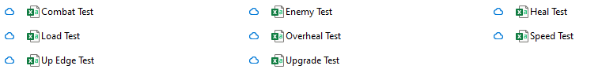
The custom levels folder before these tests
Similar to testing the editor, I will also test the functionality of the controls in the editor – such as testing the different modes, or changing the tile – alongside testing the requirements above
We now start by testing with normal data (Video 7):
Req | Description | Input Data | Expected Result | Actual Result
1 | The player can create custom levels | Editor_Test as the name of the new level | A new level is created in the editor, with the Editor_Test.csv file being added to the custom levels folder | 0:15
2 | The player paints tiles to a grid | Left click, Editor_Test.csv | The screen reflects the painted tiles | 0:35
3 | The player can save the levels they create | Editor_Test.csv | Editor_Test.csv updates to store the painted tiles | 0:45
4 | The player can load custom levels into the editor | Editor_Test.csv | Editor_Test from above is recreated in the editor | 0:45
4 | The player can edit custom levels | Left click, Editor_Test.csv | The player can paint over the recreated Editor_Test | 1:00
5 | The player can play custom levels | Load_Test.csv | Load_Test can be played as though it were a normal level. The player should start with 1 life and 10 health | 1:15
5 | Beating a custom level | Load_Test.csv | Beating a custom level just reloads it | 1:20
5 | Dying in a custom level | Load_Test.csv | Dying in a custom level just reloads it | 2:15
6 | Elements can be placed anywhere on the grid | Left click | The player can place any element at any position in the grid | 2:50
7 | The program should check for the existence of a player object | No player object exists | The program stays in the editor and prints “You need both a flag and a player” | 3:25
7 | See above | Player object exists | The program loads the level into an instance of the game | 3:20
7 | The program should check for the existence of a flag object | No flag object exists | The program stays in the editor and prints “You need both a flag and a player” | 3:35
7 | See above | Flag object exists | The program loads the level into an instance of the game | 3:20
--- | Selecting a tile in the palette changes the active tile (White box test) | Editor_Test.csv | Clicking on a tile changes the active tile variable | 3:45
--- | Pressing the erase button sets the mode to “erase” (White box test) | Editor_Test.csv | Clicking on a tile sets the mode variable to “erase” | 4:00
--- | Pressing the draw button sets the mode to “draw” (White box test) | Editor_Test.csv | Clicking on a tile sets the mode variable to “draw” | 4:00
--- | The player can change the active palette | Editor_Test.csv | Clicking the purple arrows changes the active palette (palette order is circular) | 4:15
--- | The player can scroll through the level | Editor_Test.csv | Clicking a black arrow scrolls the screen in that direction | 4:20
--- | The player can hide the save and play buttons, as well as the palette for a clearer view | Editor_Test.csv, h key | Pressing h hides non-grid UI elements. The player can still draw in this state. Pressing h again shows non-grid UI elements | 4:30
--- | The player can use key binds to edit faster – hide shortcut | Editor_Test.csv, h key | Pressing h hides/shows non-grid UI elements | 4:30
--- | The player can use key binds to edit faster – mode alternate shortcut | Editor_Test.csv, m key | Pressing m alternates between the mode variable between “erase” and “draw” | 4:45
--- | The player can use key binds to edit faster – draw shortcut | Editor_Test.csv, d key | Pressing d sets the mode variable to “draw” | 4:55
--- | The player can use key binds to edit faster – erase shortcut | Editor_Test.csv, e key | Pressing d sets the mode variable to “erase” | 5:00
--- | The player can use key binds to edit faster – tile palette shortcut | Editor_Test.csv, 1 key | Pressing 1 sets the loads the tile palette, with the active tile becoming “Floor” | 5:10
--- | The player can use key binds to edit faster – entity palette shortcut | Editor_Test.csv, 2 key | Pressing 2 sets the loads the entities palette, with the active tile becoming “Walker” | 5:10
--- | The player can use key binds to edit faster – mod. palette shortcut | Editor_Test.csv, 3 key | Pressing 3 sets the loads the tile palette, with the active tile becoming “Small Heal” | 5:10
--- | The player can use key binds to edit faster – scroll left shortcut | Editor_Test.csv, left arrow | Pressing left scrolls the screen left 1 tile | 5:25
--- | The player can use key binds to edit faster – scroll right shortcut | Editor_Test.csv, right arrow | Pressing right scrolls the screen right 1 tile | 5:25

We now test erroneous data (Video 8):
Req | Description | Input Data | Expected Result | Actual Result
1 | Player creates a level with an existing name | Editor_Test used as a name | The editor doesn’t load, and the name is rejected | 0:00
1 | Player creates a level with a whitespace name | “ “ (3 spaces) used as a name | The editor doesn’t load, and the name is rejected | 0:10
1 | Player creates a level with no name | None | The editor doesn’t load, and textbox becomes active to prompt an input | 0:15
2 | Player tries to paint off-screen* | Editor_Test.csv, Left click | The editor only considers clicks which occur on the screen – so these are rejected | 0:25
7 | Player tries to add a second player object | Editor_Test.csv, Left click | The editor deletes the old player object and creates a new one at the click position | 0:50
7 | Player tries to add a second flag object | Editor_Test.csv, Left click | Same as above but for the flag | 1:00
7 | Player places a crawler without a platform to crawl around | Editor_Test.csv, Left click | On play, the crawler does not spawn | 1:10
7 | Player places a crawler trapped inside 4 platforms | Editor_Test.csv, Left click | On play, the crawler does not spawn | 1:25
--- | The player tries to scroll out of bounds | Editor_Test.csv, left arrow | The editor won’t scroll past the first column. | 1:35
*The pygame mouse object tracks the mouse position relative to the window even if it leaves the window. This can lead to array indexing errors where we try to access the grid array in a row which doesn’t exist.
Finally, we test extreme data (Video 9):
Req | Description | Input Data | Expected Result | Actual Result
1 | Player tries to create a level called NEW LEVEL | NEW LEVEL used as a name | The editor loads and creates a file called NEW_LEVEL.csv. Returning to the file select screen will have two instances of NEW LEVEL | 0:00
2, 7 | Player draws over the player object, then tries to play | Editor_Test.csv, left click | The editor doesn’t play the level, as there is no player object | 0:30
2,7 | Player draws over the flag object, then tries to play | Editor_Test.csv, left click | The editor doesn’t play the level, as there is no flag object | 0:35
2, 7 | Player erases the player object with “player” as the active tile for drawing (White box test) | Editor_Test.csv, left click | The editor should recognise that the player wasn’t drawing, so the player flag becomes empty | 1:20
2, 7 | Player erases the flag object with “flag” as the active tile for drawing (White box test) | Editor_Test.csv, left click | The editor should recognise that the player wasn’t drawing, so the flag-object flag becomes empty | 1:20
2, 7 | Player erases another tile with “player” as the active tile for drawing (White box test) | Editor_Test.csv, left click | The editor should recognise that the player wasn’t drawing, so the player flag stays empty | 0:55
2, 7 | Player erases another tile with “flag” as the active tile for drawing (White box test) | Editor_Test.csv, left click | The editor should recognise that the player wasn’t drawing, so the flag-object flag stays empty | 1:05
6 | Elements can be placed in the corners of the level | Editor_Test.csv, left click, left arrow | The elements are drawn, as they are still in bounds | 2:30

4.6 Test Videos

4.6.1 Video Links
Playlist: https://www.youtube.com/playlist?list=PLvlRDaHBGqXzaLUNgbPEz-aO85EU6Lo1t
Video 1: https://www.youtube.com/watch?v=PX4k7AjZ9ic
Video 2: https://www.youtube.com/watch?v=66k6vUhQ2_4
Video 3: https://www.youtube.com/watch?v=Ce1NBffZQrQ
Video 4: https://www.youtube.com/watch?v=FpkK5zH1YAs
Video 5: https://www.youtube.com/watch?v=IOKkboAyaGI
Video 6: https://www.youtube.com/watch?v=7VHhFJWoOqY
Video 7: https://www.youtube.com/watch?v=9JRZUnRvKcw
Video 8: https://www.youtube.com/watch?v=5ig2oAMLBAI
Video 9: https://www.youtube.com/watch?v=C29bGh1Y-mU

4.6.2 Video-Document Discrepancies, Errors and Notes
Repeated Discrepancies:
1) Underscores in level names are used to indicate spaces, as the text input system used in the project rejects underscores
2) Video numbers have been added to the document after recording
3) Timestamps for a test may not include the entire test, such as in video 1, I have timestamped a test at 4:50 so you don’t need to watch 100 seconds of doing nothing, and can just see the aspect relevant to the test
Video 1 Discrepancies:
For the test starting at 2:30, I used 1.csv instead of Load_Test.csv.
For the tests starting from 5:20 – 5:55, I forgot to reset the lives value to 5. Everything works as intended, just relative to 4 lives instead of 5.
Video 1 Note:
I repeated the test at 4:40, as in the original test I died due to the shortened timer from 2:05.
Video 4 Error:
The test at 3:40 is not a white box test.
Video 5 Error:
The test at 0:35 is not an erroneous test – it is a normal test.
Video 9 Discrepancy:
For the tests at 0:55 and 1:05, I did not erase an existing tile, but rather, erased an empty space. The test is still successful, as it was a white-box test which recognized that I wasn’t drawing a new player/flag.
Video 9 Note:
The tests at 1:20 were repeated, as in the original test I did not delete the player/flag tile.

5 Evaluation

5.1 Overview
The system meets all of the program requirements, with some extra quality of life extensions such as keyboard shortcuts in the level editor. The object oriented approach was definitely the right decision, allowing me to produce clearer structured code which can be by used dynamically at runtime – especially useful for the level editor, where a user could create anything.
To produce the system, I used a mix of waterfall and agile methodologies. I used the waterfall methodology to understand what the system would fully entail, and design a coherent solution accordingly. This also allowed me to perform research on existing systems and common algorithms, saving me time in development where I could reach a bottleneck due to a dispute between two components. I then used the agile methodology to develop my system, coding each element by itself and testing in dummy environments before integrating into the final system. This allowed me to test each component by itself before trying to fit it into the system. It also allowed me to produce milestones during development, such as “UI system works”, “File handling works”, etc, which helped improve productivity as I can see progress in action.
My system uses three types of file handling. The simplest is the save_data.txt file, treating each line as a save file – nothing complicated here. The second is literal file handling, creating .csv files for each new level and using the file names as entries in a listbox. Finally, I have used .csv files for my levels, which require the data to be tabulated – which I did using 2D arrays. As mentioned above, the csv files require the first entry to be used, otherwise it ignores rows until it finds one in use – not massively complicated to fix, but required trials to identify.
The use of the object-oriented paradigm has also helped my produce a complex system, with the game assets being built on inheritance of parent nodes in a class tree rooted at the Sprite class, allowing me to produce progressively more complicated classes without repeating a function across every asset. As the driver code is stored across 3 classes (MAIN, GAME, EDITOR), the system uses interfaces to interact with one another, allowing me to keep the game logic separate from the editor, and the editor separate from UI management. I have also used polymorphism in my solution, such as with the player class overriding the Dead() method of its superclass Combatant, or the platforms each having a polymorphic touched() method to implement their unique behaviours.
I have also used some complex algorithms to produce my solution, such as the A* algorithm for flyer pathfinding, and abstract data types like finite state machines and queues.

5.2 Review of Program Requirements
Req | Description | Review
The Game
1 | The player can move left and right using A/D respectively, or using the relative arrow key, as well as being able to jump by pressing W or the Up Arrow Key | As shown in many of the tests, the player can move their character using either of the control schemes
2 | Include Mario’s movement improvements (see 1.2.2) | Though slight, the player does experience acceleration and drag when they start/end movement, and the player can vary their jump height and perform coyote jumps
3 | The game screen should scroll to keep the player on screen | The game will start to scroll once the player enters a margin at the edge of the screen
4 | The game must contain the following tile types:  Floor/Wall, One Way, Honey, Spike | All the tiles are present and have flawless collision. The special tiles also all function as described
5 | Levels are loaded from a file, and are accurately assembled to be played | Levels are stored in a consistent format in a .csv file, which can be loaded and converted into a level at runtime
6 | Beating a level causes the next level to begin | If there is a next level, the game does include level progression
7 | Levels must be beaten in one hundred seconds | The game contains a 100 second timer which resets each level. When the timer reaches 0, the player dies, and the level resets
8 | The player must be able to save | Beating a level or losing a life causes the game to automatically save
9 | The player must be able to create a save (if space allows) | The game contains 3 save file slots, which can be assigned to if empty
10 | The player must be able to delete an existing save | The game has a delete form to delete an existing file (done by setting the level value to -1)
11 | The game must correctly load the relevant form (see 2.3) | All the forms are connected, as described by the finite state machine in 2.3
12 | Contain the above health system | The player starts the game with 5 lives and 10 health
13 | The player can attack enemies to lower their health (and the inverse) | If an enemy collides with the player’s attack hitbox, that enemy loses 1 health. If the inverse happens, the player loses 1 or 2 health depending on the enemy’s strength
14 | Levels contain diverse enemies which can mutate between playthroughs | The game contains 3 different enemy types, which use completely different algorithms to move. Two enemy types are their own hitbox, whereas the other attacks like the player. Upon generation, they are randomly assigned stats from a given range
15 | The player can restore health by using healing items | The game contains 3 tiers of healing items, which heal 1, 2, and 5 heal each. They are single use, and can only be used by the player
16 | The player can update their movement options using consumable items | The consumable system for healing was reused for upgrades. The game contains 5 upgrades, 4 which alter movement, and 1 which alters attacks. The player can only have 1 upgrade at a time, and all the effects function correctly
UI
1 | Menus respond to mouse input – buttons do a function when clicked, but images do not | As stated, only clickable elements respond to clicks, and each element responds to a click in the intended manner
2 | Menus connect to one another | The player can move between one menu and another using only the buttons in the system itself
3 | Menus can be dynamically updated at runtime | The menus generate their contents when they are loaded, and they are reloaded each time they are needed
Editor
1 | The player can create custom levels | The player can create a custom level .csv file, so long as that file does not already exist
2 | Levels are created by painting tiles onto a grid | By holding down click and dragging the mouse, the selected element is added to the screen – and to the grid structure in memory
3 | The player can save the levels they create | At any time, the player can save their level
4 | The player can edit the levels they have saved | In the LEVEL SELECT screen, the player can choose a custom level, and edit its contents
5 | The player can play the levels they have saved | In the LEVEL SELECT screen, the player can choose a custom level, and play it
6 | Elements can be placed anywhere | There are no restrictions on where an element can be placed, other than the element must be in the level
7 | The game should check to make sure the level is playable | The level will not be loaded if the player does not add one flag and one player object

5.3 User Feedback
I sent the program to John to review on Friday 21st of March 2025. I then conducted an interview with him on Friday 28th of March 2025, which went as follows:
“Firstly, how do you feel about the gameplay?”
John - “The gameplay is very fun, with a generally intuitive control scheme. I like the enemies that have been implemented, all being very distinct from one another, and the randomisation of their health and damage helps to make a replay more enjoyable. There are unfortunately too many tutorial type levels, which makes the start of the game way too easy, and massively slows down the difficulty curve. An alternative could be to add signs to these levels to explain what everything does, allowing you to create more complicated tutorial levels and get into proper gameplay sooner. Also, the lack of sound design is really apparent, and its inclusion could allow for more advanced feedback than just visual updates – for example, a sound effect to indicate that an attack has connected with an enemy”
“What is your opinion on the file management I have made for the game?”
John - “Your file select screen is perfect. Creating a save file is easy, and the ability to have multiple saves improves the replayability of the game. I will say, the captcha is a bit too extreme of a method to prevent accidental file deletion. I think a simple confirmation screen would have been better, as it can be quite annoying to fail the captcha and have to reload the delete screen.”
“Moving away from the game side of the system, how would you review the UI?”
John - “The system provided functions perfectly and does what it needs to do. To turn this into an actual product, we would need to rework the graphics side of the system. The colour scheme makes buttons distinct from one another, but lacks a consistent theme. In this vein I really like the level select screen, which alternates the colours of the entries in the Listbox. The buttons are a bit too flat, and could benefit with some feedback while the mouse is down. The scrollbar really should have an indicator to show how far the user is into a listbox – though the ‘jump to’ feature is very handy. Overall, while the system functions logically, it is in desperate need of dynamic graphics.”
“Finally, what is your review on the editor?”
John - “The editor is exactly what I wanted, and adds an extension to the system. The controls are easy to use, and levels are simple to create and test. I would comment that limiting scrolls to one tile per press is good for fine adjustments, but makes it really annoying to modify the other side of the level. It would be beneficial to have a system similar to holding backspace with the textbox, where you can hold the scroll button down to scroll multiple tiles.”
“So overall, how would you review the system?”
John - “The system as a whole is great. The gameplay is fun, but let down by early level design. The UI works amazingly, but needs a graphical overhaul. The editor is excellent, only needing a slight modification to scrolling. So altogether, this is a system I will be happy with after I swap out the graphics.”

5.4 Improvements

5.4.1 Suggested Improvements
In this final interview, John mentioned a few extensions I could make to the system to improve it.
The major improvement would be an overhaul of the graphics system, and the graphics used. This was not considered much during development, and the project was just a demo. I would first update the sprite class to dynamically update the image each frame. This would allow buttons to provide visual feedback when pressed – namely by darkening the image. Next, I would determine a consistent colour palette for the game, which would probably centre around purple, brown and black to indicate the “magical monster-infested tower” theme to the game. Similarly, the images I use for the game assets would be updated to better fit into a world – as opposed to mono-chromatic squares. The final update (which John explicitly stated) would be to add an indicator to the scrollbar, which shows how deep into the scrollbar the user is. This would just require another class to act as the pointer, with some methods to determine the pointer size and position. With the dynamic system, the listbox could also automatically update as you drag the mouse on the scrollbar, making navigation much easier.
The next major improvement would be to include sound design into the project. Such a system would include background music and sound effects. This can be done using the pygame.mixer() object, which is a pre-built sound library. From there, I would just need to create the music files, which can then be played when certain events take place in the game. This would require a global event listener, but that can easily be implemented into the MAIN class as a method. Some example sound effects I would add would be: button clicked, player hit, player jump, enemy hit, and enemy dead.
John has also selected some quality of life improvements. The first of which is a simpler captcha system, due to the tedious nature of a full-on 5 character captcha. He suggests using a confirmation screen, which gives the player time to review their decision. I agree that this is a better method, and can be implemented by just creating another screen – an easy task due to the modular nature of my system.
The second quality of life change would be to allow unlimited scrolling from one arrow press in the editor. John suggests a system similar to holding backspace with a textbox. To implement John’s solution, I would need to lift the backspace code from the textbox and into the button.clicked() method. More specifically, I would need a subclass for these scroll buttons which overrides the clicked method to solve this problem.

The difficulty curve
We then have the adjustment of reducing the number of tutorial type levels, which John notices have drastically slowed the difficulty curve. He suggests adding signs which explain what everything does, which lets you move onto proper gameplay sooner. I think it could be beneficial to see what existing systems do solve this problem, as walls of text can distract from smooth gameplay.
Looking at the level design of the New Super Mario Bros games, Nintendo doesn’t include tutorial levels. Instead, they use the first screen or two to silently explain the mechanic of the level, and then a screen or two to get the player comfortable with the mechanic. The rest of the level is then dedicated to small challenges which utilise that mechanic. A mechanic for a level could be as simple as introducing a new enemy, or it could be more complex, like an interaction between a power-up and a tile, or a completely gimmick level like a maze.
By using this methodology, I could design better levels by deciding the mechanic of each level first, then building a little playground around that mechanic for the player. A level curve I then easy to implement, as later levels can either be just harder implementations of an earlier mechanic (like more enemies on screen), or I could use more complicated mechanics for later levels – starting with just introducing the enemies one by one, then later on introducing mechanics such as sticking to the bottom of a honey tile to hang from a platform.
This design would also improve the level editor, as player’s are more aware of the mechanics that they can create levels around.

5.4.2 Personal Improvements
One thing I would do if I were to revisit the project is to make an abstract latching function that can be called in Common_Fuctions, as latching ended up appearing a lot even outside of the UI, such as for shortcuts where you only want the action to take place once per shortcut. This would help clean up some areas of code, and in the process provide a more complex solution, due to an abstract latching function using reference parameters.
I would also review my implementation of the A* algorithm, which (while correct) is definitely a performance bottleneck when there is a large quantity of flyers on screen. Whilst this isn’t a problem for most gameplay, it is an issue as it restricts the kinds of levels a user can create in the editor – even if a level of just flyers is evil.
If I were to implement sounds, I would also include an options menu to alter the volume. Such an addition could also include screen resolution options, as currently the program is restricted to 768 by 512, with no option to full screen. I would also include an option to modify the key binds for the game.
As well as the suggestions John provided for improving the UI, I would also add a search bar to let the user search for a custom level by name, saving a potentially long search if the device has many custom levels and improving user experience in the process.
A final improvement I would make, would be to include checkpoints. A checkpoint is simply a tile which – when reached – lets the player start there instead of all the way at the beginning. To implement this, I would need a new tile type for the checkpoint, and from there, I can just keep track of the current start-point in the GAME class.

